

SEPTEMBER 2014
PP 2012

Pres Says:

In this issue is the long awaited promised essay from our wonderful sophomore/junior who won our essay contest award. Many thanks to all of you who worked on this throughout last year.

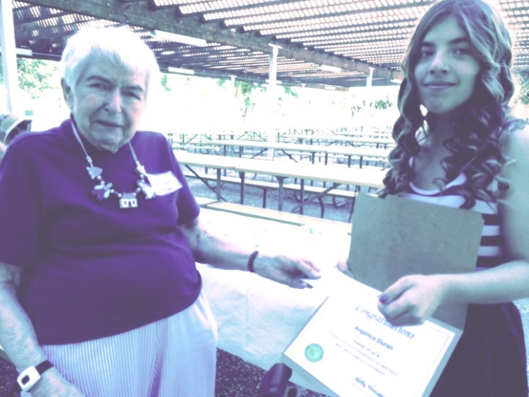
Marilyn Kregel and Angelica Duran

We began September with our feet on the ground running…..On Saturday, Sept. 6, we were in charge of the original Beamer House on Palm Ave. in the Stroll Through History. Thanks to all of you who participated.

The Board will meet in West Sacramento on Wednesday Sept 10 at 1:00 in West Sacramento at the Arthur Turner Library in West Sacramento. We have lots to discuss and talk about…..history of course!

On Sunday October 12 we will hold our annual Cemetery Tour. I am excited about this one because we are focusing on the military dead in the Woodland Cemetery. You will see men portray soldiers from the Mexican War in 1846 all the way to the World War II.
It has been an exciting research project that has kept
me busy. I am working with Barbara Sommer, our website designer, to add a Facebook page for this event. We are also going to use Craig’s List for advertising. Vince Olvera from the American Legion is also working with me to obtain uniforms and individuals who are willing to portray the soldiers. It promises to be an exciting day. More later……

When you get a chance, please visit the Woodland Public Library on First Street. The Board voted to authorize $1,000.00 to help fund the new/old lights in the Rotunda and on the old county side of the library. They are up and are lit! What a wonderful sight. For me it is a dream come true. I have wanted to accomplish this goal when I was the President of the Friends of the Library. It is now a reality…Go visit and see what we can accomplish when we work with other groups. Thanks go to David Wilkinson, one of our members, The Friends of the Library, The Rose Club and Greta Galindo, our City Librarian. And thanks to Denny Long who worked with the City to make the electrical all happen.

Remember, History Rules!
Kathy Harryman

❖

Hattie Happenings: Ups and Downs
By MaryLee Thomson

Unexpected but very welcome progress was made late last month on the WPA Museum Annex. The City had agreed to the removal of the ugly gray shade structure from the front and side of the building and lo and behold, it happened! It was expensive ($5300 from our Annex Fund) but the building looks so much more attractive.

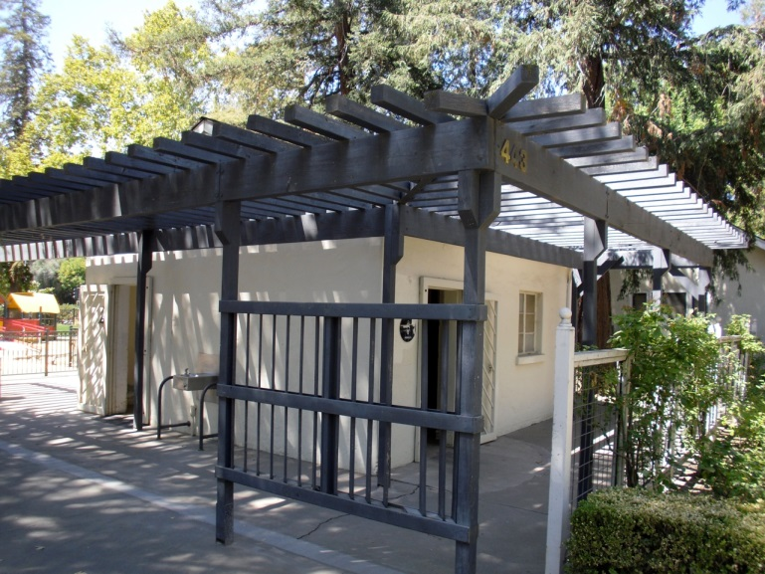
Before

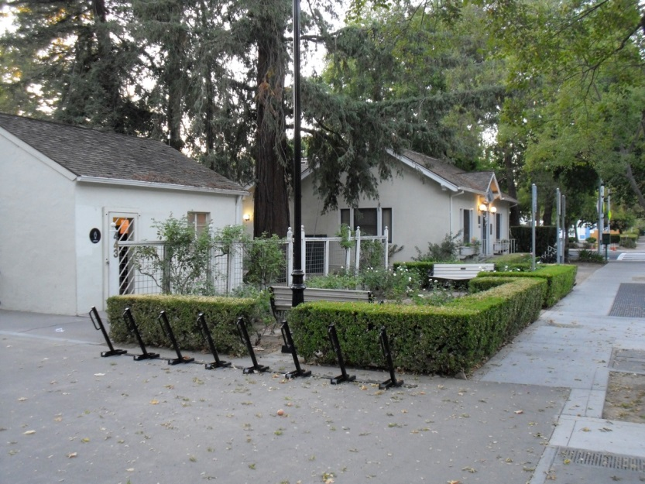
After

On the downside, we have still not been able to meet with City staff to discuss the architect selection process. We have not yet had an architect plan proposal acceptable to both us and the City. But we’re not giving up!

We were all saddened by the loss of Leroy Ford this month and our hearts go out to BJ and her family.

After a long delay due to the construction of the new playground in Central Park, we were able to dedicate the 2014 bricks in the Hattie Weber Rose Garden on September 6th. Director Dingemans and Assistant Director Gabriel presided over a
ceremony which included tributes to those honored
on the bricks by the brick donors. The heartwarming comments were followed by a reception in the Museum where a special exhibit honored mothers, grandmothers and other exceptional women remembered on the bricks.

As the school year began, we invited Davis third grade teachers to bring their classes to tour the Museum to enrich social studies lessons on our community. We are also happy to provide Museum tours to scouts, seniors and other groups on Wednesdays. Pease feel free to contact Dennis Dingemans or Mary Lee Thomson at the Museum (530-758-5637) to arrange a tour. Of course individual Society members are welcome to visit us any Wednesday or Saturday between 10am and 4pm.

❖

Business Buddies

The following businesses in town have financially supported the Yolo County Historical Society. We would like you to support them and keep your money local:

L & S Printers, Main St.
The House Dresser, Main St.
The Gifted Penguin, Main St.
Corner Drug, Main St.
Dahlin & Essex, Inc., Davis
Zamora Hills Ranch
Richard Berteaux

If you know of any business that would like to join our support list, contact me. Businesses pay $50.00 per year for advertising.

❖

Yolo History Member Hears Last Call

We are very sad to lose a valued member of our historical society-- LeRoy Ford. Our thoughts and prayers are with BJ and her family.

Searching for a past article from our newsletter? Go to Yolo County Historical Society web address: http://ychs.org/

Hispanic Influence in Yolo County
By Angelica Duran

Many ethnic groups have contributed to the improvements of Yolo County, but one group that has had a significant role is the Hispanic community. This community has worked in areas ranging from agriculture to education. However, the primary area in which Hispanics have contributed in Yolo County is community leadership. Hispanics are strong community leaders in Yolo County. There isn’t a certain date when they arrived, but, they began making several contributions in the field of leadership around the mid-late 1900’s with the emergence of groups like MECHA AND TANA and individuals like Malaquias Montoya.

In 1969, MECHA started when students from UC Davis, and other counties held a conference in Santa Barbara in the hope of creating a network of students who could fight oppression on their campus and in their communities. This outcome of the meeting was MECHA. This club organized, so that every Chicano and every Mechnista can obtain leadership. One of MECHA’S roles is to have opportunities for members to provide service to their communities. Woodland High teacher Sandra Olszewski said, “It doesn’t only have to be Hispanics, but most of the Mechistas are. In the past we have even had African Americans and anyone who wants to join is welcomed.” From the interview she also told me the club was good because it teaches one about their culture and gives them an opportunity to explore their identity. Sandra Olszewski also said, “What I enjoy the most about MECHA are the conferences, the community service and the unity.” MECHA is a great club to be involved in. It is a great way of expressing yourself for what you believe in and it is a great opportunity to learn more about your culture. Joining MECHA could also be an opportunity to explore things one has never been taught about and an opportunity to embrace one’s ethnic and cultural history.

TANA stands for Taller Arte de Nuevo Amanecer and is a joint partnership between the Chicana/o Studies Department at UC Davis and the City of Woodland. The center is located in Woodland but UC Davis and Woodland Community college students collaborate in making sure the center is manned. At UC Davis and in TANA they offer silk screening. The TANA classes demonstrate culture and artistic life through exhibition, printings and teaching. Anything you use when making a silk screen is free. Besides silk-screening they have a theater and dance performances, lectures, conferences, and community meetings. They also have poetry and fiction reading and film festivals. They offer between four to six exhibitions per year in addition to hosting a variety of community events, such as Dia de los Muertos. Their program is all year long, but the different programs are separated according to seasons. Any community member can take advantage of going to the center to create their own piece of art.

There have been many leaders in our community that have contributed to Yolo County. Someone who is alive and continues to show leadership is Malaquias Montoya. He was born in New Mexico and raised in the San Joaquin valley of Mexico. His entire family had to work as farm laborers for survival. His three older brothers didn’t continue their education beyond seventh grade, but he continued and graduated in 1969 from the University of California, Berkeley. This shows if you work hard on something, you can accomplish it. Since 1980, he has worked on painting murals. In 1989, he began workshops along with silk-screening posters and his classes have painted murals throughout Yolo County. Each mural they painted has a story or deep meaning behind it. There is even a mural painting by Malaquias Montoya at Woodland High School. It was painted in 1999. The mural is very colorful because it depicts crops, graduating students, field, and factories. Also, on the corner there is a script writing that says, “Unlocking doors to the future”. This tells us that to him education is important for the future.

According to the US Census, the Hispanic community in Yolo County has grown in population. It is the second highest population in

Yolo County. MECHA is still available to students; it has been here in Yolo County for forty four years. The overall impact of MECHA is to have meetings to make changes in their community. The overall impact of TANAS is where people and students are able to express themselves through art.

❖

Thanks to the following for generously supporting the Society…………. You too can be a Patron by donating $100.00 to help us run our projects

2014-2015 Patrons
- Jeff & Starr Barrow
- Alice Wong & Ryan Baum
- Donald & Pat Campbell
- Michele Giguiere
- Bernard & Lynne Gough
- Betty Van Lew Haines
- John & Kathy Harryman
- Joan Hogan
- Jim & Donna Peoples
- Roger & Ann Romani
- Lon Springer
- Tom & Meg Stallard
- Valerie Vann
- Steve & Lydia Venables
- Marilyn Kregal
- Clair Childers
- Michael King
- Jeanie Sherwood
- Virginia Schwarzgruber
- Albert Plocher
- Richard & Evelyne Rominger
- Robert & Judy Simas
- Richard & Joann Larkey
❖

Who Knew!
Cemetery Tour to Honor Woodland’s Military Dead

Did you know that the Woodland Cemetery has graves from soldiers from the Mexican War in 1846 to the present day! What a remarkable place filled with men who lived history.

On Sunday, October 12 beginning at 1:00 – 4:00 The Yolo County Historical Society will hold it’s annual Cemetery Tour fundraiser with the focus on our military dead from 1846 to World War II. The Legion of Honor will begin the afternoon with a ceremony honoring these veterans.

The tour begins with Jason Watkins who fought in the Mexican War. He later came to Woodland and was the Sheriff of Yolo County. The next two individuals fought in the Civil War: one Yankee, Erastus Farnham, and one Reb, John Winters, who later became pioneer farmers in Yolo County. Erastus was 16. Then we have Brooks Johnston, a colored soldier, who fought in the Spanish American War. World War I focused on Johnnie Schaupp from Hungry Hollow and then we get to hear a mother’s perspective of the death of her son, William Oliver. Finally we will highlight two soldiers from World War II: George Nakamura, a Japanese who was classified an ‘enemy alien’ and then went on to win honor as a member of the 442nd Regimental Combat team and finally Margaret Nicholson , who was a nurse in Europe during WWII.

When I began to research these individuals I was pleasantly surprised to find that many of these men fought under great generals: General John J. Pershing, General U.S. Grant, General Robert E. Lee, General Stonewall Jackson, General Winfield Scott. One individual fought with the future Senator from Hawaii, Daniel Inouye.

The other surprise was the locations that these men fought: Battle of Shiloh, Harper’s Ferry, Battle of Antietam, Argonne Forest in France, the German Gothic Line in Italy.

Even the Underground Railroad played a part.

Who knew??? What a surprise! I think you will be surprised too.

Come and spend an afternoon learning about these remarkable men and women of our community. The cost is $10.00 per person, $2.00 for children under 12.

Yolo County Historical Society
P O Box 1447
Woodland, CA 95776

Address Service Requested

Dated Material

Vision Statement The Yolo County Historical Society strives to preserve, protect and acknowledge
the diverse history of Yolo County through education, communication and advocacy

