September 2011

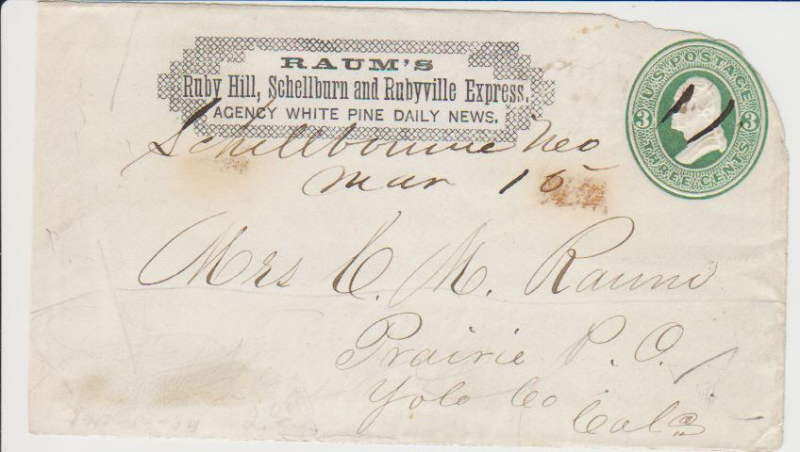

A MYSTERIOUS COVER WITH A MYSTERIOUS CONNECTION TO YOLO COUNTY

While most people think of only Wells Fargo when it comes to stagecoaches and early California express transportation, there were over three hundred express firms between 1849 and the close of the nineteenth century. While some were large organizations with many offices and formal structure, some smaller firms were as little as one person traveling between two towns during a single season with a single horse or donkey.

One such smaller express company operated in eastern Nevada in the 1870’s yet has a mysterious connection to Yolo County. Mell Raum operated Raum’s Ruby Hill, Shellburn, and Rubyville Express. The primary area of his coverage was in White Pine County, Nevada, the central county on Nevada’s eastern border with Utah. White Pine’s county seat is Ely.

In 2002, the Western Cover Society published a book by James Garnett that profiles the primary express companies that operated in Nevada. It has a chapter on Raum’s Express which lists the census of known surviving envelopes. Amazingly several of the envelopes were addressed to our own Yolo County and a person who appears to be a relative of Mr. Raum. The Yolo County envelopes were addressed to a Mrs. C. M. Raum at Prairie Post Office, Yolo County. Clearly the last name is the same as the express man.

In researching possible Raum’s in Yolo County, I encountered a challenge in that names are sometimes shown as Raum, sometimes Ruan, and sometimes Rahm. I found an E. C. Raum who was born in Harrisburg, PA, in 1818, and spent a few years outside of Woodland around 1862 before moving to the Carson Valley in Nevada. He and his wife, Louisa, had five children. One of these children could have been F. M. Raum or F. M. Rahm, Yolo County Sheriff between 1879 and 1882. Could another son have been Mell who could have followed his father to Nevada in the late 1860’s and then continued east?

Clearly Mell Rahm, the express man, had a connection and relative with Yolo County since he corresponded several times with Mrs. C. M. Raum. Who was Mrs. C. M. Raum? Could this have been a sister-in-law? Could this have been his wife with Mell actually having been his second name but the one used in business?

Unfortunately this envelope can’t reveal its tale. But maybe one of our members can share some history on the Raum family and Prairie Post Office. I look forward to next month’s newsletter with any update! – Ryan Baum

PRESIDENT’S MESSAGE

Summer is past. The Yolo County Fair is behind us. It is now time for paying your yearly dues. If you have a red dot on your newsletter then it means you have not yet paid for the 2011 – 2012 year. Without checking, I think maybe I can look forward to a red dot, so I better write my check and mail it to the Treasurer.

To be a member of the Society is quite reasonable. Checking into the dues for other Society’s, as well as other non-profit groups, we are perhaps one of the most reasonable. Check the back of the newsletter for information.

In past years we have been able to give grants to further the knowledge of Yolo County History. With the demise of the Lemonade Stand, which we had for years at the Fair, money is tight. A joint venture with the Nugget Market, i.e.; they sold wine and we sold lemonade, resulted in our booth being destroyed. Even after several years, people visiting the Schoolhouse wanted to know why we were not selling lemonade and baked goods.

Elsewhere, in this newsletter, you will read that David Wilkinson’s book, “Hollywood Comes to Woodland”, is finished and will soon be available. We will be having a book signing in the near future. It is by selling books which we have published will we be able to build up our treasury. With the purchase of books, stands from Border’s, which is going out of business, we will be able to display and sell books in several venues throughout the County. Books will also be for sale at our Monthly Membership Meetings. Remember, Christmas is coming. Books make nice but not too expensive gifts.

We have a Monthly Board Meeting scheduled for Monday, September 12th starting at 7 p.m., which you are invited to attend. The meeting will be held at the Hattie Weber Museum in Davis.

Peace,

BJ Ford, President
Yolo County Historical Society

HOLLYWOOD COMES TO WOODLAND

The Yolo County Historical Society (that’s us!) is happy to announce that David Wilkinson’s new book, “Hollywood Comes to Woodland” has been published and is now for sale. David’s book describes the fascinating history of the movies in Woodland, beginning with the very first “silents”.

Woodland once had an amazing number of different movie theatres. The movies they showed not only entertained people, they informed, horrified, and worried them.

David’s book describes our different local theatres, the people who built and ran them, and the influence that the movies had on local opinion. His book has many wonderful pictures, courtesy of Bill Hollingshead, of the many theatres Woodland has had over the years.

YCHS members will get a discount of two dollars off the $19.95 price. And if you don’t already have your copy of “Crafting a Valley Jewel”, you can buy them both for thirty dollars. Stock up for Christmas!

Mary Aulman

MISSING VIRGINIA

By now, most of the members of the Yolo County Historical Community know that one of our most endearing members has died.

A celebration of the life of Virginia Isaacs will be held on Saturday, September 17th, at 1 p.m. in the multipurpose room of the Senior Citizens Center in Davis. For those who don’t know, it is located at 646 A Street.

Virginia’s passing leaves a big hole in the many organizations to which she belonged and always gave her all. She left behind many many friends.

For years she was the Secretary of the Yolo County Historical Society. She very seldom missed a meeting and even when Bob Sommer substituted as Secretary, she was, until near the end, still at every Board Meeting.

The Friends of the Yolo County Archives, with the endorsement from her family, has established the Virginia Isaacs Memorial Fund, with the understanding that all monies placed in the fund will be used exclusively to support the Archives. Anyone wishing to donate to the fund may send their donations to the Friends of the Yolo County Archives, 226 Buckeye Street, Woodland, CA 95695, earmarked for Virginia’s Fund.

As stated by others, “There won’t be another Virginia Isaacs. She was one of a kind.”

News from the Hattie Weber Museum

It is with great sadness that we note the passing of two great friends of the Museum last month. Virginia Isaacs was our senior docent with over 3,000 volunteer hours at the Museum, (and another 3,500 at the Archives and who knows how many at the Gibson House). Her wit and great fund of knowledge are sorely missed. Maggie Kautz was one of the last members of the Library Club and worked with Phyllis Haig in the early days of the Museum. She donated many Gordon family treasures, including an extensive collection of early valentines and some beautiful dresses we have on display. Her good spirits gave us a jolt of enthusiasm every time she dropped in to see what was happening at the Hattie.

Our newest exhibit, “Davis Industry: Windmills to Robotics, Phase II”, opened with a wine tasting reception on August 27th. It features 22 Davis industries (who knew?) from hi-tech bio-pesticides and genetically engineered plants and seeds to hand carved miniature landscapes for model railroads. Hand made racing bikes, a flying car, machine tools, wine, beer, and ceramics are some of the other Davis products featured in the exhibit. Also included in the exhibit are lists of business licenses issued by the City of Davis in the 1920’s, which provide an interesting glimpse into the life of the town in those years. In contrast to today’s listing of downtown Davis businesses, there are no psychiatrists, psychologists, or psycho-therapists shown and only one lawyer!

John Lofland’s continuing exhibit shows the evolution of a downtown block from residences to retail. John’s view on the fate of the Hunt-Boyer mansion tank house is included in the exhibit.

The University exhibit has been moved and enlarged. It now includes a timeline of the amazing development of UC Davis from Farm School to full-scale University.

Our newest treasure is a 1936 Smith-Corona typewriter which was used by a Davis woman to type many doctoral dissertations for UC Davis. The typewriter makes a great companion to our office Dictaphone from the same era, although the manual carriage return and the lack of a key for the number “1” puzzle some. If someone has a typing table they would like to donate, please contact Jim Becket.
Mary Lee Thomson

