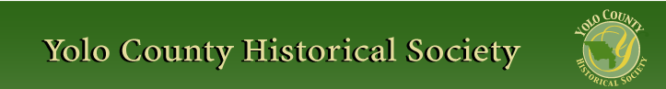

AUGUST 2015

PP 2012

Pres Says:

Summer is almost gone…..Wow…..The Historical Society is in our annual membership drive. If you have not filled out your membership envelope, please do so as quickly as possible. We have enclosed a form at the end of the newsletter for those who have misplaced the envelope. We have the most reasonable membership in the county…it is still $25.00 per year. You still have the option of paying more and focusing your money on a specific area: The Schoolhouse, Hatti Weber Museum, Winters History Project, and General. We welcome all additional contributions.

We have been very fortunate to receive a donation from the Women’s History Month Committee in honor of our past president, BJ Ford. As most of you know, BJ has moved and is now living in Pleasanton to be near her family. The Women’s History Month Committee stated that “BJ has distinguished herself as a leader in community service; her many years as an advocate for the advancement of local arts, to women’s issues, to historical preservation, BJ has demonstrated a tireless commitment and devotion to our Yolo County Community”. I shared this letter with BJ and she was very touched. The Society will use this money to honor her in the future.

The Yolo County Fair begins on Wednesday August 19 through August 22. The Spring Lake Schoolhouse will be open. We will, with the help of our school marms, have a live demonstration for adults, on Saturday at 1:00. This is in response of many adults who have asked what it was like to be in a one room school house. We will also be open early on Thursday, August, 20 for Senior Day. Call Al Plocher if you would like to help staff the schoolhouse. His phone number is 668-1927.

Remember, History Rules!
Kathy Harryman

Business Buddies

The following businesses in town have financially supported the Yolo County Historical Society. We would like you to support them and keep your money local:

L & S Printers, Main St.
The House Dresser, Main St.
The Gifted Penguin, Main St.
Corner Drug, Main St.
Dennis Dahlin
Zamora Hills Ranch
Richard Berteaux
Historic Woodland Downtown
Business Association
The Home Improvement Group
Chamberlain Farms

If you know of any business that would like to join our support list, contact me. Businesses pay $50.00 per year for advertising.

❖

Thanks to the following for generously supporting the Society…………. You too can be a Patron by donating $100.00 to help us run our projects

2014-2015 Patrons

- Jeff & Starr Barrow
- Alice Wong & Ryan Baum
- Donald & Pat Campbell
- Michele Giguiere
- Bernard & Lynne Gough
- Betty Van Lew Haines
- John & Kathy Harryman
- Joan Hogan
- Jim & Donna Peoples
- Roger & Ann Romani
- Lon Springer
- Tom & Meg Stallard
- Valerie Vann
- Steve & Lydia Venables
- Marilyn Kregal
- Clair Childers
- Michael King
- Jeanie Sherwood
- Virginia Schwarzgruber
- Albert & Lynn Plocher
- Richard & Evelyne Rominger
- Robert & Judy Simas
- Richard & Joann Larkey
- Bobby Jo Ford
- Dennis Dingemans & Robin Datel
- Steve & Teri Laugenour\
- Johnathan & Barbara Durst
- Victor McCullough & Nancy Hatcher McCullough
❖

Winters History Project

The Winters History Project reports that it has received a major donation of photographs and memorabilia relating to the Robinson and Hodge families of Winters. The Robinson brothers owned a large ranch northeast of the intersection of Grant and Railroad avenues in what was originally the Buckeye District. The Hodge family includes the internationally known hat designer, Howard Hodge. Tom Crisp of the Winters History Project Committee is currently inventorying this important collection.

An exhibit of framed photographs from the WHPC collection can currently be seen in Intero, the new real estate office of Jean Deleonardi at 18 Main Street. The Winters Visitors Center and Winters District Chamber of Commerce office is also located in this space.

In conjunction with the Yolo County Archives, the Committee has also been assisting a resident of Cedar Rapids, Iowa who is researching relatives who have resided in Winters since the 1880s.
Woody Fidae, Nicki Chapman, Joann Larkey and Rob Coman, a new member of the Winters History
Project Committee have spent the summer reviewing, inventorying and creating a digital record of all objects, photographs and maps so that further exhibits and historical events can be created.
❖

Hattie Happenings
“GREETINGS FROM DAVISVILLE” - Early Postcard Views and Messages from the Collection of Jan and Carroll Cross.
By Dennis Dingemans and Merrily DuPree (Director and Researcher, Hattie Weber Museum of Davis)
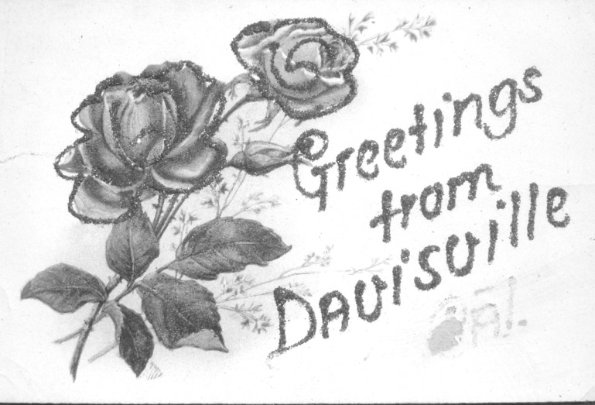
This kind of “greetings” card with a decorative drawing was common until around 1904 when inexpensive Kodak postcard-format cameras and pre-printed postcard paper first became available. The name of “Davisville” was changed to “Davis” around 1907
The Hattie Weber Museum of Davis is now exhibiting a selection of black and white photographic postcards loaned to the Museum from the collection assembled by Jan Cross and Carroll Cross of Davis. The Cross family, including their two young children, began collecting postcards in the 1970s and by 1978 their “local history” cards of Woodland, Davis, and the University Farm were put on display in the Woodland Library. Jan and Carroll selected 36 cards for that show from the 1900 to 1940 “golden age of American photographic postcards” and the Daily Democrat’s review of that show headlined that “Postcards Assist Study of History.” A majority of their cards depicted the downtown business districts of the two towns. Images showed train stations, trackside industry, and “Main Street” commercial buildings. Big buildings were featured: stone fronted structures, three-story hotels, ornate banks, stables and garages, steepled churches, and schools. On the campus, the Creamery, the 4-story water tower, the livestock judging pavilion, North and West Hall dormitories, the quad, and the shops were depicted (as expected) but images also showed “wild and romantic” Putah Creek and “students at play” swimming in the irrigation tank.
Cattle are depicted on two fascinating cards. One is of a Grand Champion (purple ribbon winner) cow named Lula Mayflower from the campus that wowed the judges at the 1921 Chicago International Livestock Exhibition. The other is the most rare and valuable card in our show: a 1906 image of the Sparks Ranch houses and barns with a herd of 25 black cattle in the foreground. No campus buildings had yet been built on the campus that was soon to occupy that spot. The photo is by the Woodland professional photographer Shinkle who used his Kodak 3A Postcard Camera and “Real Photo” paper to produce the card.
For the Museum’s show, Jan and Carroll Cross have generously loaned the 36 cards from that 1978 exhibit and added 50 more cards that have additional early photographs of Davis and the UC Davis campus.
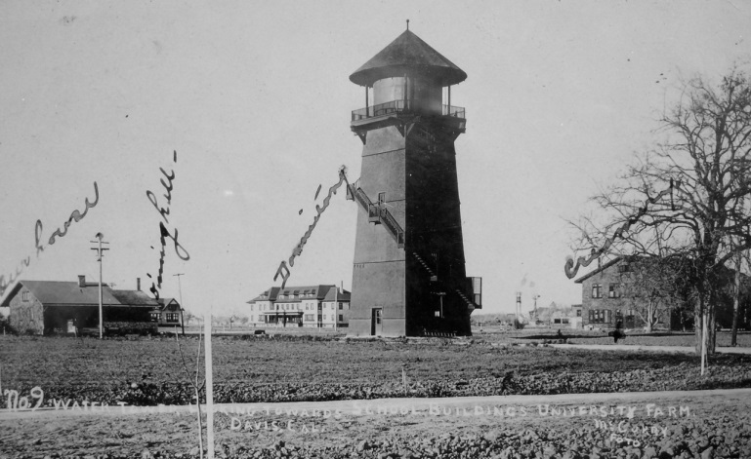
The new University Farm around 1910 already has a impressive cluster of large and tall structures that is effectively captured on this McCurry Photography Company (of Sacramento) card
Jan found it useful for her occupation as a teacher (and teaching supervisor) in Woodland and Knights Landing schools to possess cards that depict local history. Carroll collected cards of old sanatoriums to illustrate his UCD Medical School courses on tuberculosis. Their boys collected cards of the Lake Tahoe and the Fallen Leaf Lake area where they vacationed. The family has many cards that help them remember their mutual hometowns of Pittsburgh and Cleveland. They collect cards that depict dogs and their favorite sport of tennis.
The senior Crosses wryly comments on the wild inflation of prices for rare postcards, whether they are bought at yard sales, flea markets, or at weekend postcard-collectors exhibits. Back in 1978, it was reported that when Carroll once paid $8 for a single card, “it was much to his wife’s consternation.” Today’s prices for vintage postcards often reach the $50 to $100 level. The Crosses 40 years ago attended a twice annual postcard collectors sale in the Bay Area. Those sales have proliferated. Sacramento now has its own annual postcard sale. The hobby of collecting postcards is said to be equally popular today with the big two collection hobbies – collecting stamps and collecting coins. Since the 1940’s the term for the card collection habit has become “deltiology,” a word derived from the Greek for little writing tablets.
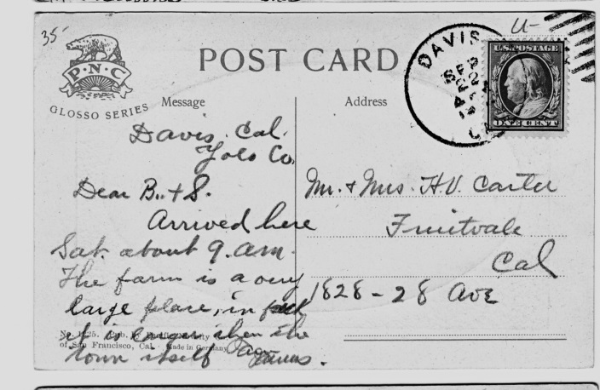
This “made in Germany” card around 1910 shows the then-standard two-part side for address and for message. Not until shortly after 1900 did the U.S. postal service allow the “address and stamp” side to also contain the sender’s hand-written message. At that time,Germany’s biggest cities and the London area were home to producers of most of the world’s best artistic postcards
The Museum’s exhibit puts the Cross Family collection, which includes about 200 black and white cards with photo images of Davis, in perspective. Local historian John Lofland has a quantitatively similar collection of Davis cards. His three Arcadia Publications photo-history books contain a good many postcard images from libraries and archives as well as images from his own collection. Local jewelry and metals dealer, Pete Richards, has many hundreds of Davis-area images; he collects cards for profit as well as for his own appreciation of depictions of local history. The undisputed king of postcard collectors in Yolo County is David Herbst of Esparto, who has amassed thousands of old black and white postcards of the towns in our county. Dennis is also a small-time collector of postcards; his deltiological centerpiece is a single album of 90 cards that were sent between his grandparents while courting in 1910 or were sent from him and his 5 siblings to his mom during their national and world travels between 1962 and 1982. Write to the newsletter or to the Museum to tell us about your postcard collections.
The Museum’s exhibit includes a short history of postcards and of deltiology. In 1861, the first post cards mailed in the U.S.A. had a decorative border and a stamp box on a single side. Shortly after, Congress authorized “official” Post Office postcards that could be mailed for one cent while requiring a two-cent stamp on all privately printed cards. Elaborately decorated cards were sold as souvenirs at the 1893 Columbian Exposition, setting off the “golden age of postcards” between then and 1940. By 1907 regulations allowed the address and the message to share the stamped side while an image (increasingly a photograph) occupied the other full side. A national craze for sending postcards was aided greatly by the Eastman-Kodak “3A Folding Pocket Camera.” That ingenious innovation of 1904 was sold with Kodak’s “Real Photo” paper that had the address/message side pre-printed. Amateurs as well as professionals now could easily make photo postcards. “Linen cards” were in vogue during the 1930s, printed in color on textured paper. Color “photo-chrome cards” after World War II looked very much like the vividly colored postcards you still see in souvenir outlets.
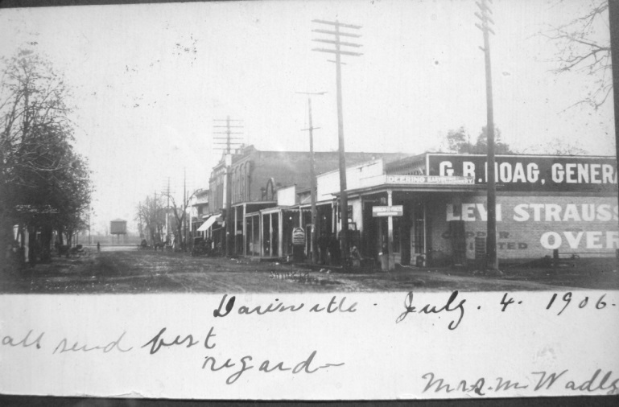
Downtown Davis looks unimpressive in scale on July 4th, 1906, just before the University Farm stimulated an investment boom. The photo and card were among the hundreds of skillfully done urban scenes produced at Shinkle’s Photography Studio in Woodland
The Museum’s postcard show discusses the content of the messages added by senders. One theme emphasizes the good jobs and economic boost provided by the new college campus: “we are living here now . . . it is better work and it is so nice here;” “Harry is trying to get a ranch job here, he has a couple of jobs in sight;” “this is the dormitory on which Otto has been working . . . he is now receiving $3.50 a day and his boss has raised his wages;” “Davis is expecting great things to happen since getting the farm . . . there will be nice buildings erected and great improvements made.”
The good news of well paying University jobs is in contrast to a spirit of pessimism and criticism of the town of Davis: “the Farm is a very large place, in fact it is larger than the town itself;” “well, I am back among the hayseeds again . . . we play at Richmond next Sunday . . . I see that Antioch, Martinez, and Crockett will be in the league next year;” “well here is a card to start with and as soon as I can scrape together enough news in this one-horse town to fill one page in a letter, I will write you one;” “it is not much of a Main Street but it is growing . . . we have a fine up to date dry goods and grocery store combine started last fall. . . we have 2 older grocery stores, a gents furnishings store, hardware, harness shop, bakery, 2 barber shops, 2 hotels, and no saloons.”
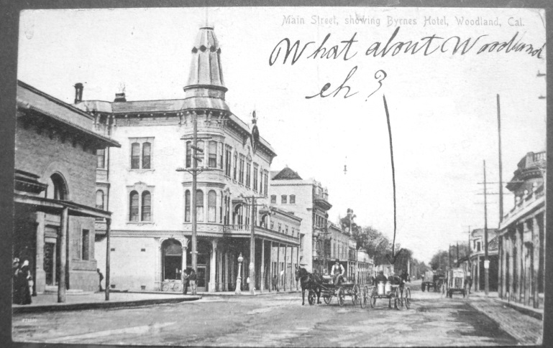
This view of Downtown Woodland at the same time (around 1906) shows taller buildings and a more thriving Main Street scene. Before long, Woodland’s Main Street would be paved, a decade before G Street in Davis also removed its potholes
The Hattie Weber Museum of Davis is open 10 to 4 on Wednesdays and Saturday’s. The postcard show will be on display at least through the summer. We thank Jan and Carroll Cross for responding so promptly to our “brainstorm” request for them to loan cards for this exhibit.
❖

WHERE IT ALL BEGAN: YOLO CITY BECOMES WOODLAND

Historic Marker Dedication and Downtown Tour September 12th, 2015

In 1856, near Court and Sixth streets, Henry Wyckoff built a small dry goods store he named “Yolo City.” The store served farmers and ranchers living in the area and people traveling the trail between the small Yolo County towns of Washington (West Sacramento) and Cacheville (Yolo). A blacksmith shop was located near the store creating a small commercial hub. In 1857 Frank S. Freeman, a 49er who farmed north of Cache Creek, bought the Yolo City store from Wyckoff and built a nearby house (still standing) at 1037 Court Street. When Frank Freeman applied for a post office for the small village, Gertrude named it “Woodland” instead of Yolo City. The name was inspired by the Valley Oak forest out of which the town arose. Mr. Freeman was appointed postmaster in 1861 and established the first Woodland post office in a brick building he constructed at 539 Main Street (still standing). It was the first commercial structure built in the center of the new town of Woodland, which Freeman surveyed and plotted as part of his 160 acre homestead. Yolo City, meanwhile, faded into history.

Beginning at Freeman Park (named in honor of the town’s founder) we will dedicate the new historic marker for the Site of Yolo City and recount the earliest history of Woodland. Then, we will stroll along Court Street and view early Woodland buildings as we approach the Carnegie Library, where we will discuss its history and architecture before going inside to see the ongoing historic lighting project.

11 AM Tour starts at Freeman Park on Main Street (between Fifth and Sixth streets) and ends at the Public Library
Docent: David Wilkinson

❖

TO FIX OR NOT TO FIX
By Kathy Harryman

Summer is such an enjoyable time for me…..no pressures to do anything….I am still in my teacher mode…will that ever end I wonder….Long summer days, cool, for the most part, evenings, wonderful fresh food that you pick from the garden; tomatoes that surpass all descriptions for taste and complexity, corn that is so sweet that sugar is not an option, apricots that drip with flavor, peaches and nectarines that are filled with syrupy sweetness that rolls down your chin when you bite into the fruit, cantaloupes and watermelons that defy perfection. What a wonderful time of the year that we who live and reside in this county can enjoy the bountiful harvest that this county provides. And the best part for those of us who love history is that we are experiencing what the residents of the past experienced during the summer in Yolo County. We often forget that Yolo County has a rich history rooted in agriculture. We have led the nation in crop production, had many prize winning animals, experimented with new crops, and shipped our goods world wide before the ‘global market’ existed. We, who live in the cities throughout this county, have learned to live side by side with agriculture. We all know that what affects agriculture, affects us. That lesson has been learned throughout the long history of the county.

Now you are probably wondering what the previous paragraph had to do with our society…..I have been very concerned with the attempt of individuals throughout this country to ‘fix’ history. It seems as though there is a country wide attempt to change history. We have heard of individuals who do not like the names of places, do not like the flags that are flown, do not like the historical figures that have had an integral part in the history of the state and do not like the choice of mascots. When I took history in college, we called it ‘revisionist’ history. History majors cringed at ‘revisionist’ history. I think the new term for the kind of ‘fix’ we are seeing now should be ‘apologetic’ history. We seem to want to ‘fix’ history to make it more agreeable to our ‘modern’ world. Yet, both you and I know, that history teaches us about the present and the future. Edmond Burke wrote “Those who don't know history are doomed to repeat it.” We need to acknowledge that events occurred, but we also need to recognize that those events allowed us to make the changes necessary to address the issues. History does not happen in a vacuum. It is the product of the time period. And for those of us who know history, we know that there were pretty ugly periods of history; The Inquisition, the slave trade, Indian Wars, World Wars, discrimination, etc. Yet, we, according to Edmond Burke, need to know the context of history, so we don’t repeat it. If we allow these changes to occur, are we losing the historical context of the event? In 10 years, 20 years, 30 year, etc., will anyone be around to remember the reason why things were ‘fixed’. Our print media will have declined; we won’t be able to find articles in the archives. Those individuals who were instrumental in the decisions will be gone. Who will remember?

Just like we in Yolo County have learned to live side by side with agriculture, the residents of this country should learn to live side by side with history, learning from the past, but moving towards the future. “Apologetic” history makes people feel good. But it doesn’t teach about the past. IF we continue in the way we are going, in 100 years, will someone want to ‘fix’ our generation? I guess I still am in my teacher mode…..

Looking for an old article published in the newsletter or upcoming events? Check it out on our website. www.yolo.net/ychs

❖

Thanks to the following for generously supporting the Society …………. You too can be a Patron by donating $100.00 to help us run our projects

2015-2016 Patrons

- Robert & Lynn Campbell
- Donald & Pat Campbell
- John & Helen Daniels
- Jonathan & Barbara Durst
- Judy Simas
- Ron & Marilyn Scholz
- David & Ann Scheuring
- Claire Childers
- Jeff & Starr Barrow
- Michael & Debra Truitt
- Alphe Springer
- Steve & Teri Laugenour
- Richard & Joann Larkey
- Ramon & Karen Urbano
- Thomas risp
- Ryan Baum & Alice Wong
- Richard & Evelyne Rominger
- Lynn & Penn Wilen
- Steve & Lydia Venables

❖

If you have a story you would like to share that relates to Yolo County, send it to rbarzo@yahoo.com and we can include it as space is available. Photos are also encouraged! Our members enjoy reading about the memories that have been shared in the newsletter in the past.

Membership Renewal Form

Yolo County Historical Society

Please make checks payable to: Yolo County Historical Society
P O Box1447 Woodland, CA 95776
Gifts are tax deductible to the extent allowed by the law

Name: ___________________________________________

Address: _________________________________________

City: _________________ State: _______ Zip: _________

Email: __________________________________

Enclosed is my donation to the Yolo County Historical Society general fund:

- Household $25.00
- Business $50.00
- Patron $100.00
Additional Contributions:
- General Contribution: $_______
- Schoolhouse Program: $_______
- Hattie Weber/WPA Project: $________
- Winters History Project: $________

Please use the above form to renew your subscription if you have not yet done so.

Yolo County Historical Society
P O Box 1447
Woodland, CA 95776

Address Service Requested

Dated Material

Vision Statement The Yolo County Historical Society strives to preserve, protect and acknowledge
the diverse history of Yolo County through education, communication and advocacy

