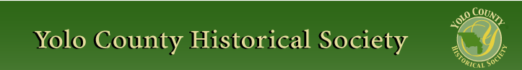

AUGUST 2013
PP 2012

Pres Says:

In 1920, Perci Hurst, a columnist for the Woodland Daily Democrat, extolled the virtues of living in this county.

“Under the genial skies of Yolo County comfortable and happy HOME are created in a shorter period of time than any other spot on earth. Another selling point was that “every… resident of Yolo County is within reach of paved highways.” Imagine that!! Close to roadways taking us anywhere we want!

Simplicity made people happy back then. That could be the reason why we like history. We search for ‘simpler’ solutions to our problems. I read these comments and smile and think…Wow…is that what their dreams and aspirations were about? Are they so different from what we want today? I don’t think so. As I research Yolo County History in the Yolo County Archives, I am continually amazed to discover that people then and now want the same things: simpler lives, security, fairness, and a better life for themselves and their children.

We are in the midst of a massive membership campaign. Please submit your membership as soon as possible. We will only send newsletters to those who have paid their dues. If you would like to receive the newsletter via e mail, please note on your envelope. For those of you, who have already sent in your money, thank you.

I am very excited about the upcoming Cemetery Tour on Sunday October 20. As you know, after the Stroll dropped the Cemetery Tour, we took it over. This year, we are focusing on the “Epidemics of Woodland and the Men and Women who Cared”. I am excited to be working with the Yolo County Health Department, the Rotary Club, and the History Club at Dingle Elementary School. Look for more information in the next newsletter.

Remember, History Rules!!

Kathy Harryman, President

❖

YOLO COUNTY HISTORICAL SOCIETY
BOARD OF DIRECTORS 2013-2014
President Kathy Harryman 662-0952
Vice Pres Dennis Dingemans 753-5959
Secretary Bob Sommer 756-7553
Treasurer Reva Barzo 867-5800

Directors
Mary Aulman BJ Ford
Roberta Stevenson Enid Williams
Beth Wettergreen Joann Larkey
Jeannette Molson Al Plocher
Pat Campbell Dennis Dahlin

Getting to Know Your Board

Jeannette L. Molson lives in Woodland and has been on our board for 10 years. She has held various positions during that time. She worked for the State of California, Davis Joint Unified School District and UC Davis. She has been living in Yolo County for 20 years and has been her family’s historian for 30 years. Jeanette will represent Capay/Guinda area.
Dennis Dahlin has lived in Davis for seven years. He is a consulting architectural historian. He is a new board member and has a special interest in architectural history, with a particular focus on Davis Community Church. Dennis will be our official photographer.

Mary Aulman lives in Woodland and has been in Yolo County for 36 years. She is a designer who works at home. She has been on the board for the past 10 years. She is interested in the personal histories of local people and loves adding the personalities of individuals to historical accounts. Mary will be selling our books.

Al Plocher has lived in rural Woodland for 60+ years. He is a retired farmer/engineer. Al is a new member to our board. He is interested in the origins of his family history and the American Civil War. Al will represent the community of Yolo.

Pat Campbell lives in Woodland and has been in Yolo County for 60+ years. She is retired banker and is often known as “Mrs. Bank of America” by her friends. She is a new member to the board. She is interested in collecting Knights Landing pictures and history and in collecting ILEX yearbooks from Woodland High School. Pat will represent Knights Landing.

Reva Barzo lives in Woodland and has been in Yolo County for 30 years. She is retired. She enjoys being active in the community and was the driving force behind the City of Woodlands’ Dog Park being built. She has enjoyed being on the board of the Stroll Through History for many years and has been the Treasurer of the YCHS for the past five years.

Bob Sommer, the board secretary, retired from UC Davis where he chaired four departments (Psychology, Environmental Design, Rhetoric and Communication, and Art) although not all at the same time. His books include Personal Space, Street Art, and Field Guide to Mushrooms of Western North America. He has written columns for the Davis Enterprise and Mushroom the Journal, and articles for local and national periodicals.

❖

Events of Importance:

- A Day in the Country – Yolo Land Trust, Sunday, Sept. 8 yololandtrust.org/dayincountry.php
- Stroll Through History – Woodland, Saturday Sept. 7 www.strollthroughhistory.com
- Gibson House Museum – Ongoing display entitled “Amazing Women of Yolo County”
- Hidden Stories conference focusing on California’s Latino/a History Oct. 2-3 in Los Angeles calparks.org/hiddenstories
- Fair Oaks opened up a History Center. Go to www.fairoakshistory.org for more information

❖

Fair Report
Dennis Dingemans is our Yolo County Fair Trooper this year. He has reported that there were 620 visitors to the Schoolhouse even during our limited hours. Congratulations to Dennis and those who sat in the Schoolhouse and represented the Society.

❖

Hattie Happenings
Submitted by MaryLee Thomson

The newest exhibit at the Hattie Weber Museum of Davis at 445 C Street in Central Park is a set of dozens of family photographs. The photographs were discovered almost 30 years ago (in 1984) in a drawer in a donated dressing table sold at a fundraiser at International House in Davis. No record of the donor was kept. A few of the photographs were later published in the Davis Enterprise, but none were identified.
They are obviously family photos – babies, families, servicemen, new cars, what may be the “Old Homestead” in Missouri and grave markers for individuals born in the 19th century from the Lane, Swank and Armstrong families.
The cemetery pictures and some others are stamped on the back “Steward’s Studio, Carthage, Missouri”. There are also some studio pictures taken in a studio in Pasadena, California.
One of the Pasadena studio portraits is of a lovely young woman of the 1920’s sporting “finger waves” in her hair. Two other photos feature young men in WWII uniforms. There is also a family portrait photograph with a youngster in a ribbon bow tie and large lace collar obviously dating from the 19th century.
Visitors to the Museum are invited to view the exhibit and provide any clues to the identity of the family that they observe.
The Museum is located at 445 C Street in Central Park. It is open from 10am to 4 pm on Saturdays and from noon to 6pm on Wednesdays during the summer. Admission is free; donations are accepted with gratitude.

The Fight Goes On

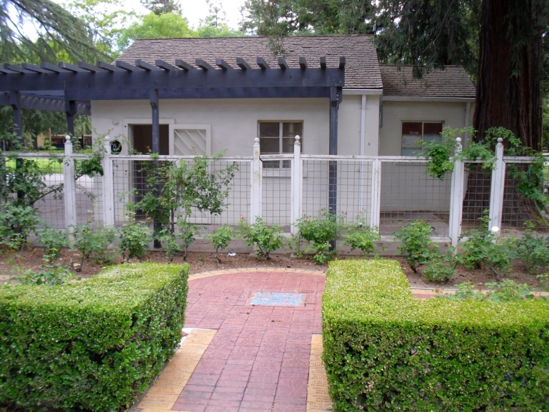
This is a photo of the WPA Bldg as is now looks

The Hattie Weber volunteers are still trying to save the 1937 WPA restroom building in Central Park. It is the only Works Public Administration (WPA) building in Davis and, along with the surviving redwood trees, the only remnant of the Park created by WPA workers in the midst of the Great Depression.

On Sunday, August 18th, an Op-Ed article by Jim Becket with a picture by Kate Morss was published in The Davis Enterprise. Jim argues for the preservation of the building (not the rest rooms - there are new ones in the Park) because it is historic, would make an excellent Museum annex and could be the centerpiece of a true Davis history plaza. He also notes that the presence of apparent homeless people near the building (a concern expressed by some because of the proposed adjacent playground) is no longer a factor. They are gone.

The volunteers have prepared a written proposal for the renovation and restoration of the building and the construction of a real Davis History Plaza. The proposal was given to City staff on July 1st. It has been endorsed by the Society and a number of community leaders in Davis. In May of 2012, the Davis City Council directed staff to prepare a report on the cost and possible challenges of retaining the building for use by the Museum. That has not yet happened, although the volunteers obtained an informal cost estimate from a respected local contractor and shared it will staff. Staff now predicts the matter will come before Council in October. Meanwhile the volunteers will continue to collect signatures on a petition to save the building; to date, more than 600 visitors to the Museum have signed the petition. We are also encouraging people to write letters to the editor of The Enterprise expressing support for retaining the building.

Davis is not famous for historic preservation. With a few repurposed exceptions, such as Dresbach home, the old City Hall (now a restaurant) and the old High School (now the City Hall) and the original library, now the Hattie Weber Museum, the community has been largely indifferent to preservation. The demise of the Terminal Hotel was ably chronicled by John Lofland. More recently, the tank house from the Dresbach property was exiled and the original orange grove destroyed. The historic Pena House was offered free of cost and with financial assistance in moving it. There were no takers. Nonetheless, the Hattie Weber volunteers are determined to save the WPA building for future generations to appreciate.

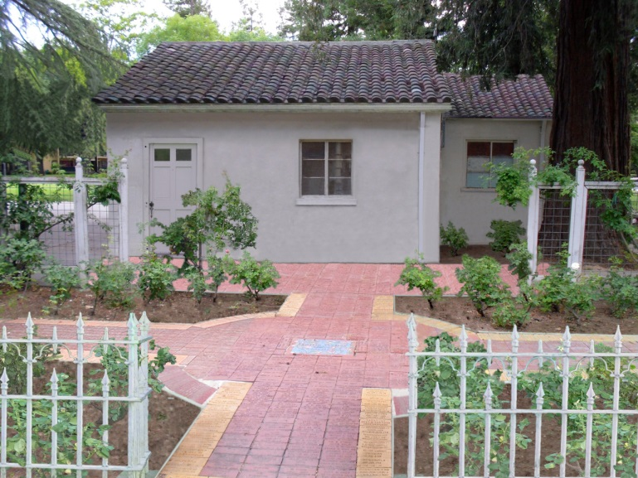
WPA Bldg as it is envisioned after restoration

❖

Celebrating 50 years….
Second installment of
Remarks by Joann Leach Larkey
At the 50th Anniversary gathering of the Yolo County Historical Society
Yolo County Historical Museum, June 23, 2013

Dr. Blanchard spoke about historical resources located in the University Library at the October meeting. The November meeting was cancelled due to the tragic death of U.S. President John F. Kennedy, a research committee was appointed, a $25 prize was offered to a high school student submitting the best essay on Yolo County History, and plans were underway for more public meetings and tours to historic sites.

A gala charter dinner meeting was held on January 28, 1964 in the Home Arts Building. It was a potluck and boy were there some good cooks in that group! Keynote speaker was Dr. Joseph A Baird, professor of Art History at UCD who gave an illustrated talk on “Historical Perspectives of Yolo County Architecture.” As reported in the press, “he took the audience on a journey of the architectural history of the county via slides and dialog.” Featured were the Gable mansion in Woodland, the Snowball mansion in Knights Landing, the Dunnigan Hotel, the Farmers & Merchants Bank, the Woodland Opera House and a number of Victorian residences. In conclusion, Dr. Baird stated, “There are many attractive buildings such as these in Yolo County. They are worthy of being saved. Whether or not depends on YOU.” Apparently the audience got the message.

In 1966, the Yolo County Board of Supervisors appointed and did its part by appointing a Historic Landmarks Advisory Committee, which continued to do good work into the mid 90s.

The historical society initiated its ongoing publication program in 1969, with an illustrated pamphlet on the Woodland Opera House. This, in turn, promoted interest in preserving this 1895 historic building which had been closed to the public since 1915. Publication of books, calendars and pamphlets encouraged local scholarship and continue to be a main source of income for the society today.

The Northern Electric Depot, the Julian Hotel and the Farmers and Merchants Bank went down in accordance to what was then Woodland’s redevelopment plan , but when it came to demolishing the Woodland Opera House in 1972, the Yolo County Historical Society took affirmative action! Supported by the Yolo County community, the society was able to purchase this historic theater from the Hershey estate for $12,000. Many fundraisers later and with numerous federal and state grants for restoration, the Woodland Opera House became California State Historic Landmark, which is still operated as a theater by a local board of directors. How many attended the Grand Opening to see “The Phantom of the Opera?”

Then, with the urging of the historical society, the Historic Landmarks Advisory Committee and Yolo County Librarian Louise Stephens (Dewall), a systematic effort to catalog all of Yolo County’s records was initiated in 1970. This led to the creation of the Yolo County Archives in 1985, an invaluable asset for those doing historic research.

The historical society’s longtime goal of locating a permanent Yolo County Historical Museum continued until 1974-75, when the Yolo County Board of Supervisors was able to purchase the historic William B. Gibson house and the surrounding 2 ¼ acre site for $19,800. It was dedicated, along with the county’s bicentennial celebration, on May 17, 1976, the first of 37 annual May Festivals that have since been held at the museum.

Meanwhile, the all volunteer historical society has continued to support the museum. It has also placed a number of historical plaques throughout the county, planned tours to historic sites, supported the preservation of cemeteries and it continues to present educational programs relative to the county’s long history.

I encourage each of you, and the general public, to continue supporting the Yolo County Historical Society. Members can be justly proud of the organization’s fifty years of service.

❖

UPCOMING PROGRAMS FOR 2013-14
All programs will begin at 2:00 p.m. unless otherwise noted

Date Title & Location
October 27 Amazing Women of Yolo County Gibson Museum, Woodland

November 24 Davis Community Church County Library, Davis

January 26 Native Americans Hattie Webber Museum, Davis

February 23* Black History in the Capay Capay Valley Grange, Guinda

March 30 Progress at the Railway Museum Railway Museum, Woodland

April 27 Knights Landing Knights Landing

June Annual Meeting- 6:00 p.m. Gibson Museum, Woodland
*May be changed depending on site

MEETING DATES FOR 2013-2014
All meetings will begin at 10:00 a.m. unless otherwise noted

Date Day & Meeting Place
Sept 12 Thurs. Hattie Webber Museum Davis, Ca

Oct. 8 Tues Winters County Library
708 Railroad Ave., Winters

Nov. 5 Tues Clarksburg County Library
52915 Netherlands Rd., Clarksburg

Jan 9 Thurs Yolo County Library
37750 Sacramento St.., Yolo

Feb. 4 Tues Esparto County Library 17065 Yolo Avenue, Esparto
March 5 Wed Knights Landing Cty Library 42351 3rd St., Knights Landing

April 3 Thurs Mary L. Stephens Library 315 E. 14th St., Davis

May 6 Tues The Arthur F. Turner Community Library 1212 Merkley Ave., W. Sacramento

❖

Have you checked out our website lately?
www.yolo.net/ychs/

Winters History Project
- Joann Leach Larkey

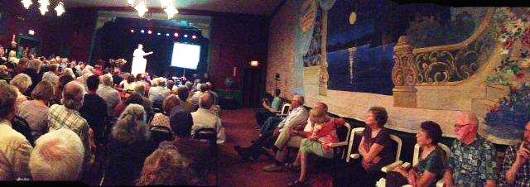

On August 8 some 200 people gathered at the historic Winters Opera House (now The Palms Playhouse) to hear a talk by historian David Vaught on "Settling Putah Creek After the Gold Rush."

This event was hosted by the Winters History Project Committee in collaboration with co-sponsors: Yolo County Historical Society, Friends of the Yolo County Archives, Putah Creek Council and Winters Friends of the Library. Special guests were current farmers on Putah Creek ranches in Yolo and Solano counties.

Joann Larkey, chair of the Winters History Project Committee, welcomed the enthusiastic audience, intoduced the chairs of co-sponsoring organizations and thanked Dave Fleming, proprietor of The Palms and Marc Wilson who offered to video-tape the program. She then introduced Putah Creek farmer Craig McNamara who is chair of the California State Board of Food and Agriculture, board member of the American Farmland Trust and the Solano Farmland Trust.

McNamara then introduced the featured speaker, Texas A & M University History Professor David Vaught, claiming that he had been so impressed with his first reading of Dr. Vaught's 2007 book, After the Gold Rush: Tarnished Dreams in the Sacramento Valley, that he now owns the record for purchasing the most copies and giving them to friends whom he thought would also enjoy the book. McNamara praised the depth of the author's research and documantation of the text and then turned the podium over Dr. Vaught.
During his illustrated talk Vaught gave special thanks to Archivist Mel Russell and dedicated volunteers at the Yolo County Archives Howard Moore, Shipley Walters and the late Virginia Isaacs, to whom he dedicated his narrative. He acknowledged making over 175 visits to the Archives over a four-year period, and said, "this book could not have been written without the help of these people and the Yolo County records that are preserved there." He also acknowledged John Skarstad, archivist at the Special Collections Department of the University Library at Davis, where he had extensively researched The Pierce Family Papers, including diaries dating to the early 1860s.

The Jerome Davis ranch, the George Pierce ranch and the "Big Ranch" of Chanpion I. Hutchison and Charles E. Greene, as well as three Mexican Land Grants on Putah Creek: Rancho Luguna de Santos Calle, Los Putos and Rio de Los Putos figure prominently in the text the author discussed.

Farmers dealing with uncertain land titles, recurring floods or droughts and high interest rates (sometimes 4% per month), he noted, caused failures for some pioneer families while others perservered and made a success of their agricultural enterprises.

In conclusion, Dr. Vaught invited questions from the audience and an interesting discussion ensued, followed by book signing and further socializing.

Before and after the talk, the Winters History Project projected a power point presentation of Putah Creek Maps and Photographs dating from 1833 to the present.

The Winters History Project Committee wishes to thank the attendees from Davis, Dixon, Vacaville,Winters and Wodland who generously donated nearly $1,200 to help defray expenses (Vaught's travel and rental of The Palms). The balance will be used to further the goals and mission of the Winters History Project.

Future plans include a historic photo preservation and scanning workshop,
another Buckeye history program in the late fall and a springtime Agricultural Symposium, to be held in conjunction with UC Davis faculty associated with the Wolfskill Experimental Orchards on Putah Creek Road.

Making History Happen

A big Thank You goes to Marilyn Kregel and Clare Childers for their generous donation to begin a new project sponsored by the Society. Working with Beth Wettergreen, one of our talented directors, we are now offering an essay contest open to all sophomores in Yolo County. For this topic, the student will pick one ethnic group that has had an influence in the history of Yolo County at any period between the years 1852 and 2002. The essay must address the following points:
- At what historical point did this group arrive in Yolo County in sufficient numbers to have an impact on county history
- In what primary areas did this group have an impact
- Length of time the group has had an influence
- What affect did this group have on the overall impact of the County

The information is on our website. We would also like to thank Avid Reader in Davis, and the Sugar Mill in Clarksburg, for participating and offering to co-sponsor the contest with more awards. If you have a child, grandchild, niece, nephew, etc., who is a sophomore in the county, they can participate. Spread the word.

Yolo County History Essay Contest
- For sophomore high school students only.
- Submissions accepted from November 1, 2013, to January 10 2014, at TheScholar2@hotmail.com
- Grand Prize: $200, Second Prize:$50, Third Prize: $40 gift certificate
- Topic: Ethnic influences in Yolo County History
Sponsored by the Yolo County Historical Society, Yolo County Educators, Sugar Mill Winery in Clarksburg, and the Avid Reader in Davis.
Details on the topic and specifics for essay submissions will be provided to all sophomore students via principals / history teachers at all Yolo County high schools (public and private).


Patrons

Thanks to the following for generously supporting the Society for 2013-2014. You too can be a Patron by donating $100.00 to help us run our projects
- John and Helen Daniels
- John and Kathy Harryman
- Pamela Pearl
- Frank and Virginia
Schwarzgruber
- Stella Dinger
- Robert and Lynn Campbell

Yolo County Historical Society
P O Box 1447
Woodland, CA 95776

Address Service Requested

Dated Material

Vision Statement The Yolo County Historical Society strives to preserve, protect and acknowledge
the diverse history of Yolo County through education, communication and advocacy

