

AUGUST 2012
PP 2012

PRESIDENT’S MESSAGE

By now you should have received your reminder that dues are due. I encourage you to continue your support of the Society. We have kept our dues the same while other historical organizations have raised theirs for a myriad of reasons. Yes, this is the same paragraph i started with in July 2011 BUT we will always need member support as we continue to work for the preservations of the historical riches of Yolo County.
Please check out the three events listed elsewhere which are opportunities for members to participate while supporting the Society.

Peace,

BJ Ford, President
Yolo County Historical Society

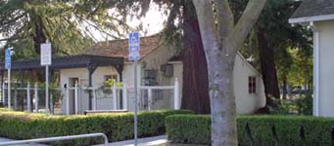

The Hattie Weber Museum of Davis
Annual Report 2011-2012
The following is submitted to the City of Davis describing various aspects of the operation of The Hattie Weber Museum of Davis (Museum) for fiscal year 2011-2012 by the Yolo County Historical Society (YCHS) pursuant to its contract with the City.

Visitors:
The total number of visitors recorded at the Museum: 3,476 - an increase of 956 over last
year. Pig Day in March set the single day record at 161.
Visitors who signed the guest book (not all do) came from 60 California cities other than Davis, 28 states other than California, plus the District
of Columbia and 14 countries other than the United States. Mexico, China, Taiwan, Korea, India, Slovenia, Thailand, Brazil, Israel, Japan, England, France, Canada and Italy were recorded.
Four Scout troops and two classes of third graders also visited and enjoyed presentations by Assistant Director Adrian Gabriel and Director Dingemans. We hope to increase our outreach to Davis third graders next year.

Volunteers:
As of February 2012, our volunteer staff included:
Jim Becket, PhD, Director Emeritus
Dennis Dingemans, PhD, Director
Adrian Gabriel, Assistant Director
Stella Dinger, Collections Manager
Mary Lee Thomson, Exhibit Coordinator
Roberta Stevenson, Librarian, Senior
Docent
Gerri Adler, Tour Director
Merrily Dupree, Researcher, Exhibit
Assistant, Docent
Barbara Sommer – Webmaster
Lorna Robles , Docent in Training
Mary Ann Harrison, Special Events
Coordinator
Margaret Hill, Special Events Assistant
Bruce Gallaudet will soon join us as fundraiser. Hatley Rose Thompson joined us in June as a Summer Intern.
Together the volunteers contributed more than 1,700 hours of service to the Museum.

We were saddened by the passing of Virginia Isaacs and Margaret Kautz, both of whom contributed immeasurably to the development of the Museum. We remember them fondly.

Exhibits
In addition to maintaining the permanent exhibits, the following temporary ones were mounted:
2011
Aug. – Davis Industry: Windmills to Robots, Phase II
- Mothers, Grandmothers and other Exceptional Women
Sept. – Early Office Machines
Nov. – Precious Potty: Much Ado About a Loo
- Works Progress Administration Projects in Davis
Dec. – Antique Family Bibles
- Christmas in Davis 1898

Jan. – Martin Luther King
- 1930’s Davis: Challenges ,Progress and Artifacts
Feb. – Antique Valentines
March – Suffrage Movement in Davis and Woodland (Courtesy of Davis League of Women Voters)
April – Tiny Davis: From 1870 to 1940 (Courtesy of John Lofland)
May – Memorial to Bud Henle (Courtesy of Henle family)
June – Davis Votes: Measures, City Council, School Board elections
- Chiles-Gyorke 1948 Wedding Attire
Events
2011
Aug. - Brick Dedication and reception
Oct. - Halloween Treats and Count the

Pumpkins Game
Dec. – Goodie Bags similar to those in 1898 distributed to children
2012
Jan. – Book Signing by authors of Woodland book
Feb. – Celebration of Jim Becket’s 83rd birthday and his becoming Director Emeritus
March – Pig Day, Pig Collections displayed, record 161 visitors
- 20th Anniversary of Museum Opening Celebrated
April - Easter Egg Hunt for children
May –Booth at Celebrate Davis
June – Booth at Gibson House Spring Fair

Tours:
Geri Adler continued her history tours of downtown Davis. She did four tours this year – spring and fall and two special ones for the University Farm Circle. She generously donates all proceeds from the tours to the Museum.
Dennis Dingemans did a special tour in May for spouses of attendees at a UCD convention. A generous contribution resulted.

Bricks:
We sold 46 red and summer wheat bricks this year. At $50 per brick, the gross proceeds were $2300. Unfortunately the brick company was unable to deliver the bricks on time. We are just now getting the final ones and will schedule a dedication/reception in the near future.
On a brighter note, we have a beautiful new centerpiece for the patio, created and donated by Susan Shelton, a nationally known Davis ceramicist and a very gracious lady.

The Hattie Weber Museum, located at 445 C Street, Davis, Ca. is open to the public on Mon. & Wed. from 10:00 a.m. to 4:00 p.m.

~

Winters History Project

Members of the Winters History Project Committee have been busy contacting families whose ancestors settled near the pioneer town of Buckeye between 1855 and 1875, with the plan of sponsoring a photographic Buckeye Exhibit in 2013. To date, two meetings with descendants of these families and a successful fund-raiser have been held.

Among the identified family names associated with the town of Buckeye, which preceded Winters by 20 years, are those of: R.C. Briggs, William Campbell, George W. Chapman, H. Craner, Henry Cooper, Lorenzo Dexter, Benjamin Ely, Henry Fredericks, Joseph Griffin, Joseph H. and J. L. Harlan, M. O. Harling, Rev. Shadrack Harriman, J. O. Maxwell, James McMahon, Lorenzo Moody, George W. Scott, Aaron J. Wilgus and M. R. York.

George Griffin, chairman of a volunteer Buckeye Exhibit Committee, is grateful to those who have who have shared old maps, photographs, stories and artifacts and would welcome access to more,which could be used or copied. The committee would welcome the names, addresses and telephone numbers or e-mail addresses of pioneer Buckeye families who could be contacted and invited to subsequent meetings. Anyone willing to help with the exhibit or wishing more information may contact Nicki Chapman at 795-2676.

~

NEWSLETTER ARTICLES DEADLINE: Articles for the newsletter will be accepted until the 20th of each month. Please either email B J Ford at: bjford@pacbell.net or mail to the YCHS at P.O. Box 1447 Woodland, CA 95776

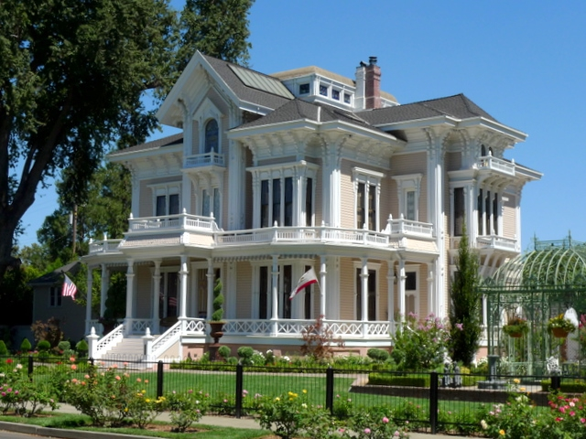
Gable Mansion

Society members have a unique opportunity to be part of Woodland’s Stroll Through History on September 8th in that they have been invited to be docents at the historic Gable Mansion at 659 First Street in Woodland.

Docents will receive a ticket to visit the other open homes. The orientation date has yet to be set. If you would like to volunteer, please give me a call at 662-0952 or e-mail me at bjford@pacbell.net. Shift times have yet to be set, however we do know they will be for two hours.
~

Searching for a past article from our newsletter? Go to Yolo County Historical Society web address: http://ychs.org/

~

Society publications available for sale at a variety of locations. For more information on book sales, contact Mary Aulman at 666-0743.

~
Don’t forget – if you have not already renewed your annual membership, please do! It’s members like you who keep our endeavors going!!

Yolo County Historical Society
P.O. Box 1447
Woodland, CA 95776

Address Service Requested

Dated Material


“SHEEP THRILLS AND MUDDY WHEELS”

Wednesday, August 15th to the 19th
It is that time again. The Spring Lake School House will be open for public viewing during the Fair. That means that we have to have volunteers who can welcome our visitors. Our school House Coordinator, Kathy Harryman, continues to add, and change a few things, but generally speaking it is just as it was in 1869. Information is available to answer people’s questions and it is always a joy to see a student who has visited during the school year drag

parents in to show where he or she sat when their class visited.

Now here is where you come in. Please, don’t wait to be called about donating some time at the School House during the Fair. Save Jeanie Sherwood a phone call AND contact her. Jeanie can be reached at 530-574-1660 or email at jeaniesherwood@sbcglobal.net

Needed shifts are:
Wednesday: 6 to 8:30 or 8:30 to 11 p.m.
Thursday - Saturday:12 to 2; 2 to 4; 4 to 6; 6 to 8:30; 8:30 to 11P.M.
The School will be closed on Sunday

Kathy Harryman will open the School House at noon each day, and BJ Ford will close the School House at 11 P.M.

Volunteers can pick up a parking pass at the office upon their arrival so that they can park at the School House. The pass must be returned at the end of your shift.

