

APRIL 2015

PP 2012

Pres Says:

We are almost half way through April…..time goes so quickly. There is a lot of activity happening in the Society. We have been very busy doing ‘historical’ stuff. Dennis Dingemans and I have met with 4 of the 5 supervisors in the county. We introduced them to the Society and left them a newsletter and an application to become a member. We have received membership from one of the supervisors. We are asking for Courtroom #3 in the old Courthouse. Acting on a recommendation from one of our members and upon further discussion from board members, we are proposing that we run a living history program for students in grades 8, 11, and 12. We would work with teachers throughout the county to develop curriculum and also work with retired judges and lawyers who would help run the program. We are using the model of the Spring Lake Schoolhouse living history program. We are excited and the supervisors seemed to share our excitement. We also asked for a room to display our incredible history. If you have any influence with the supervisors, contact them with your support.

We are finally seeing movement in Davis with the WPA building renovation. There has been an incredible amount of ‘red’ tape that had to be followed. We all need to be thankful to Dennis Dingemans and Mary Lee Thomson who have diligently been working on that project. There is an article in this newsletter giving you information about how you can support that project. Please look at it and if you can help, please do so.

On St. Patrick’s Day, Mardi Began and I went to the Community/Senior Center. Mardi proposed that we identify each of the historical pictures that are hanging in the building.
She felt that it was important to get our name out in the community. So we met with the administrators and were very pleased. So, we will provide information for each of the pictures and then they will display the information next to the picture. Way to go Mardi. Sharing history with others is our mission.

On Sunday, April 26, at 2:00 in the afternoon, the Society will be treated to a special monthly
lecture/meeting. The San Pedro Board of Directors will let us meet in their private Park located at 708 N. Hobson Avenue in Bryte.(West Sacramento) There is a small chapel that serves as their Museum with lots of documents and photos. The presentation will focus on the Portuguese influence in Yolo County. The presentation will include the Portuguese Festas including the Holy Ghost Festivals held in the county. It will also include presentations by the Cabrillo Club of Woodland and other important information about Portuguese traditions. In addition, there will be Portuguese food. What a treat! Plan on attending this once in a lifetime event.

Schoolhouse Thanks!
Many thanks to all who make the school house program work: Marilyn Sholz who schedules teachers, Martha Brashear who schedules schools, Jackie and Jim Scott who take care of the outdoor equipment and Pat Campbell and John Harryman who cleaned, swept, and dusted to make the school ready for the students. Many thanks!

Cemetery Fence
Some of our members have expressed dismay at the condition of the fence surrounding the Woodland Cemetery. Watch the Daily Democrat for an opportunity to help paint the fence. The City of Woodland will provide the paint and the brushes on Saturday April 25. This is an opportunity for all of us to help. See you there.

Remember, History Rules!

Kathy Harryman
Business Buddies

The following businesses in town have financially supported the Yolo County Historical Society. We would like you to
support them and keep your money local:

L & S Printers, Main St.
The House Dresser, Main St.
The Gifted Penguin, Main St.
Corner Drug, Main St.
Dennis Dahlin
Zamora Hills Ranch
Richard Berteaux
Historic Woodland Downtown
Business Association
The Home Improvement Group
Chamberlain Farms

If you know of any business that would like to join our support list, contact me. Businesses pay $50.00 per year for advertising.

❖

Thanks to the following for generously supporting the Society…………. You too can be a Patron by donating $100.00 to help us run our projects
2014-2015 Patrons

- Jeff & Starr Barrow
- Alice Wong & Ryan Baum
- Donald & Pat Campbell
- Michele Giguiere
- Bernard & Lynne Gough
- Betty Van Lew Haines
- John & Kathy Harryman
- Joan Hogan
- Jim & Donna Peoples
- Roger & Ann Romani
- Lon Springer
- Tom & Meg Stallard
- Valerie Vann
- Steve & Lydia Venables
- Marilyn Kregal
- Clair Childers
- Michael King
- Jeanie Sherwood
- Virginia Schwarzgruber
- Albert & Lynn Plocher
- Richard & Evelyne Rominger
- Robert & Judy Simas
- Richard & Joann Larkey
- Bobby Jo Ford
- Dennis Dingemans & Robin Datel
- Steve & Teri Laugenour\
- Johnathan & Barbara Durst
❖

Hattie Happenings

Good News! We finally have a close to final plan for the WPA building/Museum Annex and a working estimate of construction costs! The plan from architect Ty Smalley is more elaborate than we envisioned for the interior, but it is also much more workable for storage and projects.

The construction estimate brings the total cost of the restoration/renovation to $93,000. The City tells us the reason the cost is so high is that this is a public building project. Prevailing wages (higher than for private work) and more detailed specifications than for private projects push up the cost.

The bottom line for us is that, considering what we have paid for preliminary costs ($18,000), what the City will contribute ($14,000) and what we have (about $16,000), we will need to raise about $45,000 in the next six to nine months to make this project happen. The City will not proceed to bids until we have deposited the full estimated construction amount.

We’re working on it. We’re signed up for the Big Day of Giving internet fundraising event for local nonprofits on May 5. We’ve applied for funds from a couple of grant agencies and will do more and we’re planning how best to reach out to the community for contributions.

We’re counting on support from society members and other historically minded folks to make this happen.

How you can help:
-spread the word. We need to reach as many people as possible with the message that the only WPA building in Davis and a reminder of the dark
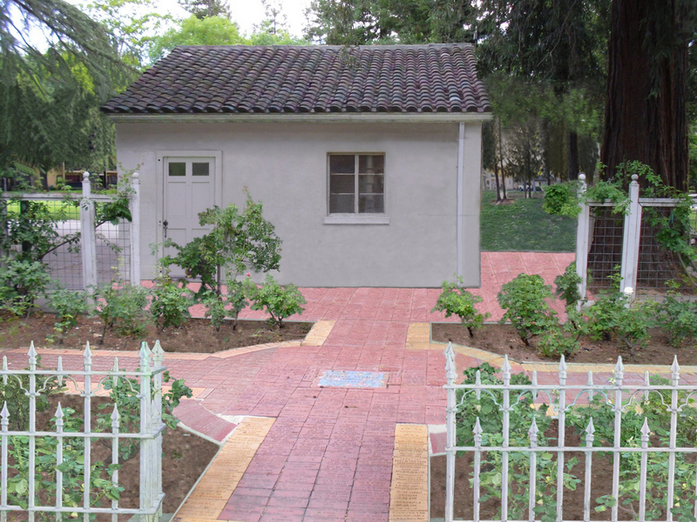
WPA Building as we hope to see it
.
days of the Great Depression needs saving. Also, the additional space will allow us to move artifacts so that we can host larger school, scout and senior groups in the Museum, change out exhibits more often, continue to collect artifacts and documents and have space for research and other projects. Word of mouth is an excellent vehicle.
-make a contribution if you are able, either by
check made out to YCHS and mailed to the Museum at 445 C Street, Davis, 95616 or by credit card on the internet (bigdayofgiving.org) between midnight on May 4th and midnight on May 5th. Contributions are tax deductible.
-plan to come to our “Rent Party” when the date is announced. Rent Parties were common in Harlem in the 20’s and 30’s when rents were high and people were invited to hear music, buy booze and contribute to the rent of the residents.
-buy a hand knit market bag at the Museum or at Lasting Impressions on 4th Street in Davis. All proceeds go to the Annex fund.
-let us know if you have fundraising ideas. Our e-mail is hattieweber@yahoo.com.

Together we can do this!

❖

A Mysterious Package From The Past:
150 Letters By Leila Hecke Of The Yolanda
By Dennis Dingemanns

A few weeks ago President Kathy Harryman asked me to look over and recommend a disposition for a five-pound package of letters and a few associated items. They had been mailed to her from an anonymous source in Washington State. A caller previously had asked if the Historical Society would be interested in receiving some things of possible historic value that were originally from Yolo County. The items had been found unexpectedly inside a newly purchased trunk and were mailed to us from a person named “Jackson” in Fox Island, WA.

The package contained a dozen minor objects of antique texture related to businesses in Woodland, some business and social cards from the 1880s and 1890s, and a petticoat. What we had was mainly a set of about 150 letters sent between September of 1918 and May of 1919 from young Leila Hecke to her parents. Leila (1898 - ) was a first year student at Mills College in Oakland. Her mother was Elizabeth Welch Hecke (1867-1939, a lifelong resident of the county with family connections to pioneers from the 1850s and 1860s, many from Kentucky. Her father was George Hecke (1870-1953), a German immigrant who since 1892 worked for the San Francisco inventor/entrepreneur Byron Jackson at Jackson’s 160-acre fruit ranch. The Hecke family bought the ranch in 1908 and renamed it The Yolanda. The impressive cluster of the main house and associated structures is a landmark that can be seen today on Road 99 a mile south of Woodland.

The letters were filed in chronological order. Handwriting was very readable. Most were dated and paginated. They are, on the surface, most useful for revealing a very precocious student with a flair for writing letters that document daily life and with an adventurous social life to complement her considerable academic prowess at a very good college.

What they are not, unfortunately, is any major addition to our knowledge of the Hecke family’s economic life or of the household later formed
when Leila married Charles Hardy (1898-) in 1928 and eventually took over the Yolanda. George was for a score of years the first head of California’s Department of Agriculture.

Charles was Yolo’s Agricultural Commissioner from 1936 to 1964 and he and Leila contributed greatly to the Yolo County Fair, other County Fairs, and to the operation of the California State Fair.
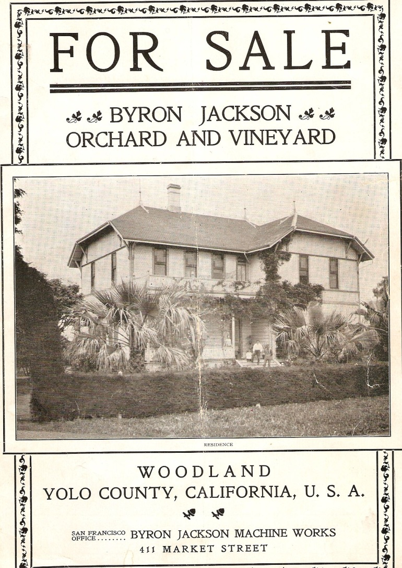

There is already an excellent biography of the families: published in 1980 by prodigious history author Shipley Walters, “The Men and Women of the Yolanda” is a 128 report on oral history interviews with Leila Hecke Hardy and other family members. Copies are rare, but the UCD Library’s Special Collections Room is the most reliable place to find the book. The next step in assessing the future for these letters should be the obvious: offer Shiply Walters a chance to review the letters. The eventual disposition might well be the Yolo County Archives or the UCD Library. Or, Mills College might find value in these detailed depictions of student life.

Some examples of the content of the letters deserve to be cited.

Leila writes most letters to her mother and her sister and she seems quite direct about sharing stories about the five named boyfriends who she writes to, attends dances with, and meets under various circumstances.

Leila has a sometimes-rowdy dormitory life. A bucket of cold water is poured over her in the middle of one spring night – as was also done to many of the first year girls in an act of hazing by the sophomores. Money is stolen from Leila’s room twice. Her room-mate got into a physical altercation with another girl where blows were exchanged, beds overturned, drawers emptied, and closets ravaged. Leila has to defend her decision not to intervene on the side of her roommate.

Leila travels widely around the Bay Area and in social space terms. She spends a night in San Francisco at the home of a friend with parents that own City of Paris department store. She, on short notice, backs out of plans to attend the Picnic Day event at Davis in order to go to Palo Alto and tour Stanford University. She attends films at theaters and dines and dances at Oakland and Berkeley hotels.

Leila is not thoroughly happy with Mills College and eventually does her last two years as an Agriculture major at Berkeley, a stint that requires her to do a semester at Davis (during which she lives at the Yolanda). Several letters late in spring semester decry the rotten food they are served. She condemns the overly “democratic” spirit at Mills which randomly assigns the best dorm rooms instead of rewarding the best students with their choice of rooms.

Leila is the rare first year student who writes articles for the student paper. She also competes in track events, doing well in the 70 yard dash, in relays, and in the broad jump.

Notably, Leila is on excellent terms with the President of Mills College, Aurelia Reinhardt. A great number of the letters contain mention of what the president has said at Chapel or at the dining room table where Leila often sat at the head table to have conversation time with the distinguished educator. When Leila’s father is celebrated in the S.F. Chronicle for being appointed Secretary of Agriculture, Aurelia sends personal congratulations via Leila to her friend the new cabinet officer. In a February letter, Leila quotes Reinhardt as telling Leila her private observation that the University farm at Davis is too “political” and too “Democratic.” Overall, Leila’s idolization of Reinhardt is summarized in another letter where it is said that compared to Reinhardt, the other Mills College faculty “are like a mule is to an automobile.”

One final thought: the mystery of where these letters have been for years might bear following up on this clue. Leila had a daughter who married a Sacramento attorney with the last name “Jackson.”

❖

Highlighting Woodland
By Kathy Harryman
6th in the Series
The late 1930’s was a difficult time for most people. The country was in a major depression. Times were hard and jobs were scarce. Yet during those times of hardship a group of children and adults from Woodland left town on a train headed for Treasure Island. They were going to play their accordions at the 1939-40 Golden Gate International Exposition, a World’s Fair event. This exposition was held on a man-made island anchored to Yerba Buena Island by a small isthmus. This event showcased San Francisco’s two new bridges: The Golden Gate and the San Francisco-Oakland Bay Bridge. The group of accordion players was part of the accordion band led by Mrs. H. L. Woolworth. Helen (Taylor) Daniels remembers that event. She was seven years old and played her accordion. She shared that she went with her parents on the train to Treasure Island to perform with the rest of the band. When asked if she remembered what music she played, she responded in the negative. She does remember the character Mr. Peanut! She said he was very tall—14 feet was her estimate.
Although her accordion is no longer in her possession, her red cape and white hat are housed at the Gibson Museum. Bill Dahler, another accordion enthusiast, still has his outfit.
Mrs. Woolworth was an important person in this community. She was a music teacher who opened a Music Studio and Accordion Shoppe at 420 First St, next to Paul Hollingshead’s Photography Shop. Jennie Houge was born in Nebraska in 1887. She married Hugh Woolworth, an insurance agent. They had one child, June. Jennie Woolworth was a musician extraordinaire. She taught piano, ukulele, accordion. She placed an ad in the Daily Democrat August 27, 1936, where she advertised that she taught all band and orchestra instruments. In the book, Reflections of Yolo County, a photo shows a group of children who were part of her band. We have included a photo from the Archives and have tried to name the players. As you look at the photo, see if you can recognize anyone. If you can, please contact Pat Campbell at 666-3021
But why were accordion bands famous? What motivated Mrs. Woolworth and the parents and children to support an instrument that has almost disappeared from the musical scene?
The piano accordion (as it was called) came into popularity in the world in the 1930’s and remained a vital part of the musical scene until 1960’s. Known as the ‘squeeze box’, it became a popular instrument for both indoor and outdoor concerts. There was even a magazine in the 1930’s called The Accordion Times. This magazine was taken over by the New Musical Express in 1952. Replacing the popular ukulele, it allowed everyone to enjoy playing their own personal miniature organ. Many towns all over the world competed with each other to produce the best band. www.accordions.com//articles/bands/aspx
According to Marion Johnson in the book Squeeze This: A Cultural History of the Accordion in America, the accordion movement revolved around themes of self-improvement, wholesomeness, and elevation…it paralleled the development of suburbanization and industrialization in America. “Accordion playing was motivated by a commitment of core community values creating national and local communities of accordion players.”

Times change, lives change, but music remains with all of us. Through the enthusiastic efforts of women like Mrs. Woolworth, music continues to hold an important cultural place in communities.

❖

Looking for an old article published in the newsletter or upcoming events? Check it out on our website. www.yolo.net/ychs
