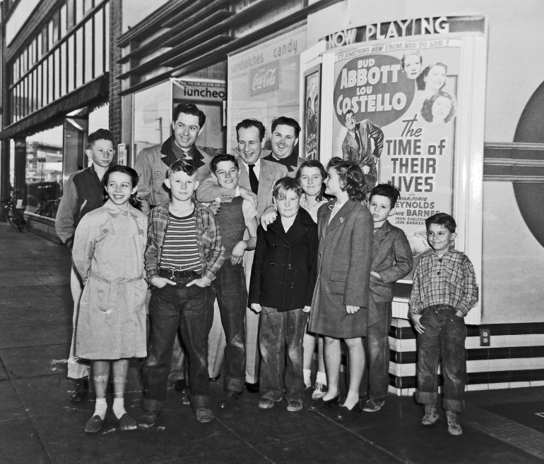

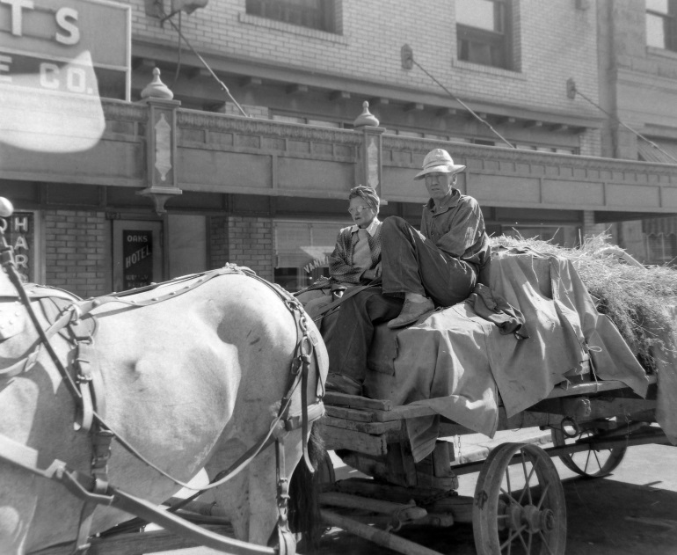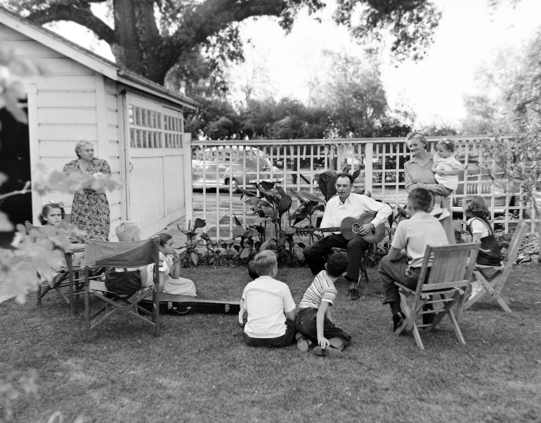

Bud Abbott is shown visiting Woodland's State Theater upon the opening of his Abbott and Costelo 1946 film, "The Time of Their
Lives"

A horse and wagon are parked opposite the Hotel Woodland. The rustic man and woman in the wagon are not dressed for a parade and
the horse is no pony. One imagines a hard-scrabble farm couple come
to town via their household's sole mode of transportation

A man plays a guitar to assembled friends and family in a
back yard. This, remarkably, is a decade before the folk music revival.

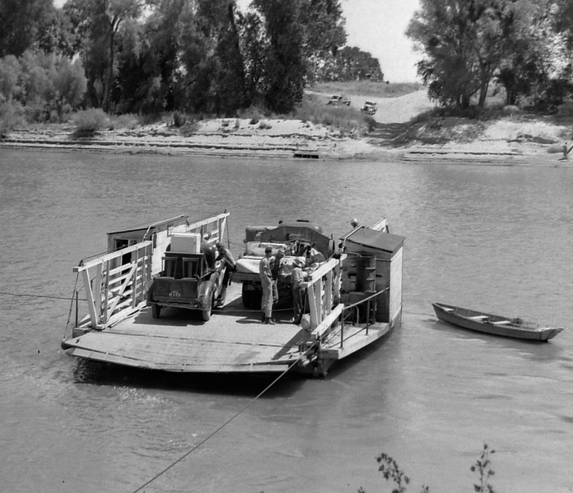

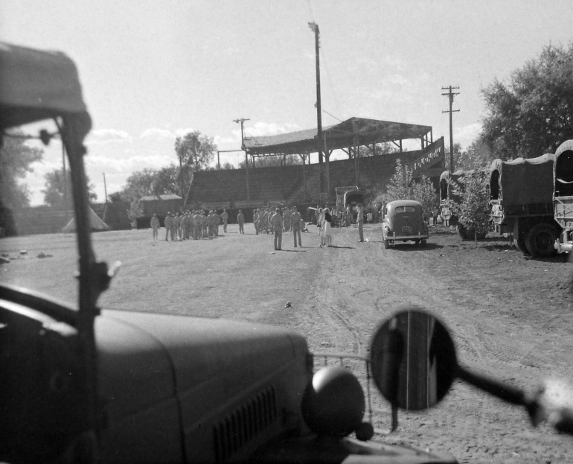

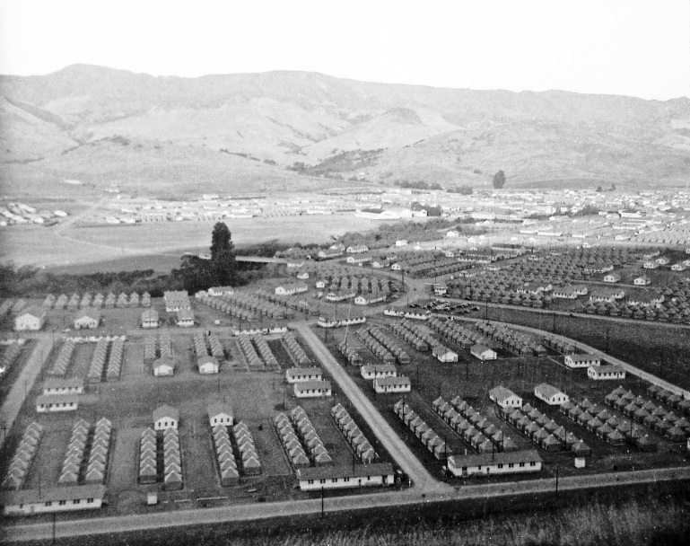

The Sacramento River ferry crossing at Elkhorn (near today's I-5 bridge) is shown with a truck carrying a refrigerator
among other items. This photo by Eddy is also part of the small Eddy
Collection at the County Archives

Clark Field is here used for military activity,
presumably in WW II or the Korean War.

A military base tent city is impressive in its scale and its rigid layout. This is unidentified and undated but a clue is that
"San Luis Obispo" is the address stenciled on an ammo box under a bunk
in another photo.

