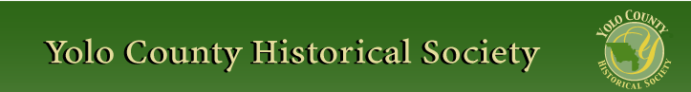

April 2014
PP 2012

Kathy Harryman gets the month off and your vice president gets to report on the continuing run of successful talks and exhibits featuring the history of Yolo County. The trend was set with our January 26th Sunday session at Mary's Chapel. The place was filled (100+ attendees) for Lynne and Bernard Gough as they talked about pioneering members of the Morris, Sharpnack, Riley, and Read families.
They then offered a tour of the original Morris home which the Goughs now own.
The great talks and good attendance continued on February 23rd when Jeannette Molson filled the chairs at the Hattie Weber Museum of Davis for a review of the findings from her 35 years of tracing her ancestors. She brought and discussed 22 books and articles and artifacts that illustrated fascinating details of her maternal and paternal relatives. Highlights were her comments on the high-achieving Molsons (none of whom were ever slaves), the schoolteachers on her mother's side, the connections to Liberia and several who migrated there from the U.S., and the links between the Oakland community of her youth and the Summit District in the hills above the Yolo County community around Capay. Her own career featured a dozen years in California State Government (where she later learned that her fellow workers were asked before her hiring if they would object to having an African-American co-worker), a dozen years at the Davis School District, and a dozen years working at UC Davis.
Sunday, March 30th, again saw all the chairs occupied at the Woodland Historic Southern Pacific Depot. It was "all aboard" for the Officers of the Sacramento Valley Historical Railways. President Mike Adams reviewed the history of the town's four stations and announced that a photograph of the original depot near College Street and Main finally
had been located (it is in the files at the State Railroad Museum) and would soon be on display. Vice President A. Van Hoosear took the podium to talk about the challenges and triumphs of the restoration efforts that have followed the saving of the current (3rd depot, built in 1911) in 1992 by moving it westward to its current site. Secretary Mike Evans and Treasurer Terry Schmidt led groups of the 26 attendees around the four depot rooms. A highlight was the collection of a half
dozen baggage carts, one of which was rescued from the Davis Depot and the most recent of which came from a farmer's field and awaits repair. At the end of the meeting B.J. Ford showed our appreciation for the speakers and presenters and their authentic restoration by handing over a 1911 postcard of the Depot which had been donated recently along with a dozen others to the Historical Society by a former Woodlander now living in the Sierra Foothills.
Two more events are on the schedule and await the same enthusiastic response by lovers of Yolo County history. Sunday, April 27th at 2:00, at the Hattie Weber Museum of Davis there will be a talk about the history of Central Park in Davis and some comparative historical details about equivalent early parks in Woodland, Winters, and Esparto.
The other up-coming local history event is sure to be the greatest aesthetic contribution of the
year. Photographs of Yolo County by long-time Woodlander Paul W. Hollingshead will be on display at UCD's Nelson Art Gallery from April 7th to May 4th. Curated by Paul's son Bill, the exhibit is sure to be a stunner in the quality of the photos and the prints and the authoritative and informative captions. Thoughtfully, a sample board of photos and captions featuring the depot was placed on display at the March meeting.
Vice-President
Dennis Dingemans

❖

Hattie Happenings

Despite two (welcome) rainy days, the Museum recorded 314 visitors for March. The best day, as usual, was Pig Day with 83 visitors.
On March 22nd, we opened a new exhibit, “A Force for Good” featuring Davis Women’s organizations and their role in shaping the community.

In 1905 the Women’s Improvement Society was formed to help lure the University Farm School to Davis and was largely responsible for creating the famous Davis Arch on Second Street. The Bachelor Girls Club (1911) was formed to create and support the first stand-alone free public library in town. This group morphed into the Library Club in 1924. That Club continued to support the F Street and then the 14th Street library. In 1988, members of the club convinced the City to rescue the original library building and move it to Central Park for a City Museum. The Club ran the Museum until 2009 when the Yolo County Historical Society took over.

These early efforts included the University Farm Circle which supported female students and faculty wives at the Farm School and UCD. In more recent times the Soroptimist International of Davis and the League of Women Voters have made major contributions to the community.

Another new exhibit celebrates 100 Picnic Days in Davis with early photos, program covers and photos of the colorful 1981 Parade by Don Martinich.

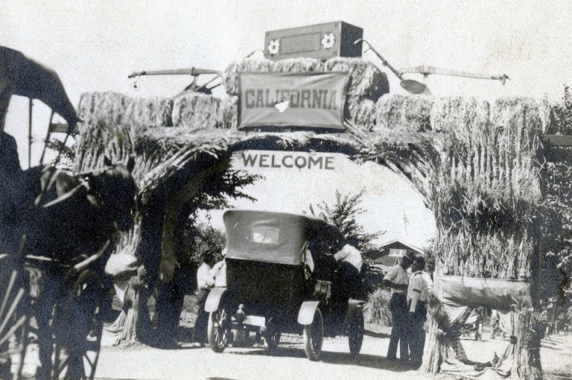
An Entry Arch built for Picnic Day

Brick sales ended at the end of March and contributed more than $1,000 to the WPA/Museum Annex fund. It appears that Richard Berteaux, who designed the Museum building, will be our architect. We may soon have a construction estimate which will allow us to switch to full fundraising mode. Stay tuned!
❖

The Board of Directors (YCHS) held an unusually productive and interesting monthly meeting on March 5th at 10:00 at the Knights Landing branch of the Yolo County Library. Following Kathy Haryman's suggestion that we hold our meetings at various places around the County, this was in the series arranged by Roberta Stevenson that
includes also the County Branch Libraries in Winters, Yolo, Clarksburg, Davis, Woodland, and Esparto. The response in Knights Landing was terrific as four current or former locals joined us to talk about the history of their town, show photographs, and thank us for publishing Shipley Walters' book on K.L.. At the end of the meeting the on-duty librarian was caught up in the enthusiasm for local history; she declared that when she retires soon she will be volunteering to serve on the YCHS Board! Pat Campbell had encouraged her friends to show up and show off, and for this we thank her. Highlights were images of the large bank building anchoring the thriving Main Street scene in the 1930s, the depot photos, and the many riverboat and riverfront scenes. Pictured from the left are Janet Wardlow (with our K.L. book), Jim Gibson (center-right--a well-informed former local who joined our conversation when he just happened to be in the library), and Mary Edson (in the white sweater) who passed around two score of pictures from her personal collection of historical prints.

❖

Business Buddies

The following businesses in town have financially supported the Yolo County Historical Society. We would like you to support them and keep your money local:
L & S Printers, Main St.
The House Dresser, Main St.
The Gifted Penguin, Main St.
Corner Drug, Main St.
Home Improvement Group, Main St

If you know of any business that would like join our support list, contact me. Businesses pay $50.00 per year for advertising.

❖

36th Annual May Festival
May 4th 10:00 – 4:00
Free Admission
Yolo County Historical Museum GIBSON HOUSE
512 Gibson Road, Woodland
(530) 666-1045

100 Years Ago in History

The Very First Commercial Flight Took Off 100 Years Ago — It Cost $400 And Lasted 23 Minutes
Just a few weeks after marking the 110th anniversary of the Wright Brothers' first flight, the aviation world has another historical moment to celebrate. A century ago, commercial aviation was born. The St. Petersburg-Tampa Airboat Line operated the first scheduled airline flight, a 23-minute hop across Tampa Bay that covered 18.6 miles.
The first customer was the former mayor of St. Petersburg, Abram Pheil, who paid $400 at auction for the ticket. He wore a raincoat.
Tony Jannus piloted an airboat built by Thomas Benoist, flying just 15 feet above the water, according to an account by the Florida Aviation Historical Society.
Today, 52 commercial flights take off every minute. The commercial aviation was a $12.9 billion industry in 2013, carrying 3.1 billion passengers. By 2016, the International Air Transport Association predicts that number will rise to 3.6 billion.
St. Petersburg will mark the anniversary of the birth of commercial aviation by recreating that first flight, using a reproduction of the original plane, built by Kermit Weeks of Fantasy of Flight, a collection of vintage aircraft.
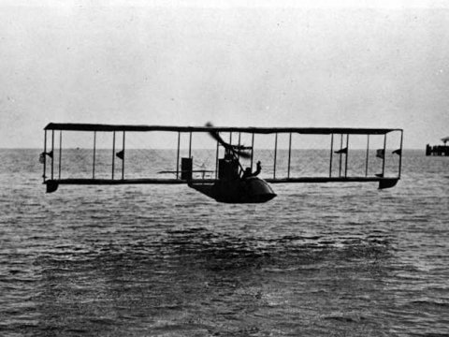
Woodland in the 1940s:
Photographs by Charles Lester Eddy, Jr.
(1919-1990)
By Dennis Dingemans
In mid-March the YCHS received a package containing a DVD disk of 630 photographs with the label "Woodland Photos From the 1940s as
photographed By Charles Lester Eddy, Jr., 1919-1990". It had come to Kathy Harryman a week after she got an e-mail from Eddy's son, Ray, in which he explained that his father's "hand written will" had directed that his photographs be donated to the YCHS. Ray explained that he delayed (24 years) because he wanted first to see the photos before sending them. When they finally arrived, they were given "with no restrictions on their use or publication." A copy of the disc of images will be given to the Yolo County Archives. Dennis Dingemans has the original disc and can share images or a copy of the disc. But what can be said about this potential historic treasure and about the maker? Most of the photographs were taken with a Speed Graphic 4 x 5" camera, and they are of the quality that wonderful camera can produce when digitized as 5 megabite files. Charles had skills, perhaps linked to his early career which is described in his military
discharge papers as "Motion Picture Projectionist." Charles was active in the Woodland Camera Forum (chair of the Historical Projects Committee), as we know from newspaper reports of his participation in 1947 in the Forum's effort to discover and document the former town of Fremont (our first county seat). Charles seems to have lost interest in his photography hobby by the end of the 1940s less than a decade after his first pictures documented his 1943 to 1945 military service (a radar operator in the Aleutian Islands).
The Eddy family, Charles's great-grandfather, first came to Woodland in 1875. Charles himself first became a grain buyer/broker, in business with his father (Charles Eddy, Senior). By 1960 the city directory lists his father as "Weigh-master" for Adams Schwab & Adams. From the living room of their 1947 ranch house home at 1314 Homewood
Drive the father and son could see the Adams grain silos just a block to the east. Previous addresses for the Eddy family in the directories have family members living at 645
First, 710 First, 321 Lincoln Way, and San Diego. In December of 1957 a newspaper clipping from "Greensboro" pictures him and his wife Genevieve and his son Raymond (age 6) at work on their "metal enameling hobby". That article says the Eddy family had just moved from Arizona and Charles (our photographer) was working as an electrical engineer with Bell Telephone Laboratories in New Jersey. In 1963 the Democrat reports (in his father's obituary) that Charles was employed by Aerojet in Folsom as an electrical engineer. Let us know more if you are familiar with the Eddy family.
The son, Ray who lives in the San Fernando Valley, organized the photographs into two dozen subjects. In his order, they include the following titles. Train and Car Wrecks.
Farms and Farm Machinery. Portraits. Family Activities. Models (including 5 nudes). Landscapes (including Fremont, Dillon Beach, redwoods, and Tahoe). River Ferry. Airports (including UCD's), Airshows, Air Photographs. Scouts. Military Years. Buildings. Wedding. Baby. Rick and Ray, 1959. Technical Drawings. Documents. Genevieve, Ruth, and Laurie.
Unfortunately, there are just short titles and no dates or further explanations. Six sample photographs are reprinted here with my captions to give a sense of what the Eddy Collection contains.

The Making of Central Park in Davis: With Comparisons to the History of Other City Parks in Yolo County
By Dennis Dingemans

Sunday, April 27th, 2:00 – 3:30
At the Hattie Weber Museum (445 C Street, Davis)
This lecture is part of the regular monthly meeting of the Yolo County Historical Society. Refreshments will be served. Dennis is a retired UCD professor who taught urban geography and served on city commissions when the park was augmented in the 1980s and 1990s. Central Park was a late addition to the urban fabric of Davis, as the 1868 grid plan that established Davisville neglected to set aside any land for public uses. Despite a strong Iberian tradition of laying out a plaza at or near the center of town, the four largest towns in our county each lacked either a plaza or a close-in central park. Only Esparto has a central park conceived from its 1885 beginning. However, during the Progressive Era of the previous century large and successful parks were added to Woodland, Winters, and Davis. Parks were also prominent in the 1913 layout of West Sacramento. The Davis park was included in 1923 as part the town's first General Plan. An elaboration of the proposal was then part of an overly ambitious 1927 "City Beautiful" plan for Davis by Charles H. Cheney. The final design and implementation in 1937 with WPA funding was considerably more humble than the 1927 plan for a civic center cluster of public buildings around a park. The Woodland and Winters "central parks" have been upgraded on several occasions but the Davis park has experience the most spectacular subsequent transformation one might imagine. The park's re-making following a referendum in the 1980s included creating a synergistic setting for the Farmer's Market and much, much more
(including the Hattie Weber Museum of Davis).

Patrons

Thanks to the following for generously supporting the Society for 2013-2014. You too can be a Patrol by donating $100.00 to help us run our projects.

John and Helen Daniels
Virginia Schwartzbruger
Leroy and BJ Ford
Jeff and Starr Barrow
Cecilia Kwan
Phyllis Levers
John and Kathy Harryman
Stella Dinger
Jon and Barbara Durst
Donald and Pat Campbell
John Hoover
Pamela Pearl
Robert and Lynn Campbell
Dennis Dingemans and
Robin Datel
Albert and Lynn Plocher
The Laugenour Family


❖

Looking for an old article published in the newsletter or upcoming events? Check it out on our website. www.yolo.net/ychs
There is also a list of publications available and information on how to become a member or patron.

Yolo County Historical Society
P O Box 1447
Woodland, CA 95776

Address Service Requested

Dated Material

Vision Statement The Yolo County Historical Society strives to preserve, protect and acknowledge
the diverse history of Yolo County through education, communication and advocacy

