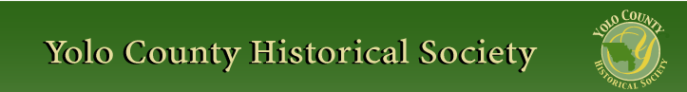

March 2016

PP 2012

Prez Says:

As I write this column, the rain is beginning to beat on the window awnings. This is such an appropriate time to share a rain poem ….. and not ‘rain, rain, go away”!

Let the rain kiss you
Let the rain beat upon your head with silver liquid drops
Let the rain sing you a lullaby
The rain makes still pools on the sidewalk
The rain makes running pools in the gutter
The rain plays a little sleep song on our roof at night
And I love the rain.
- Langston Hughes

This is a quiet month for the Society. Because Easter is so early, we cancelled our monthly presentation. We are saving David Wilkinson’s presentation on the Architecture
of Woodland for our yearly meeting in June. More about that later….

On Sunday, May 1, the Gibson Museum will hold its 38th May Festival. As many of you
know, the Society always provided goodies in the past for the bake booth. If you would
like to share your homemade whatever, you can still do so. Please bring it to the Museum
in the morning. The Festival begins at 10:00 a.m. I am sure they will appreciate all you
can contribute. It’s always fun with lots of wonderful booths.

For those of you who missed the presentation on postcards, you missed a great afternoon.
Thanks again to Dennis Dingesman and Merrily DuPree and to the Cross Family for
sharing their postcards and their knowledge. I went out and bought my daughter 10
Yosemite postcards!

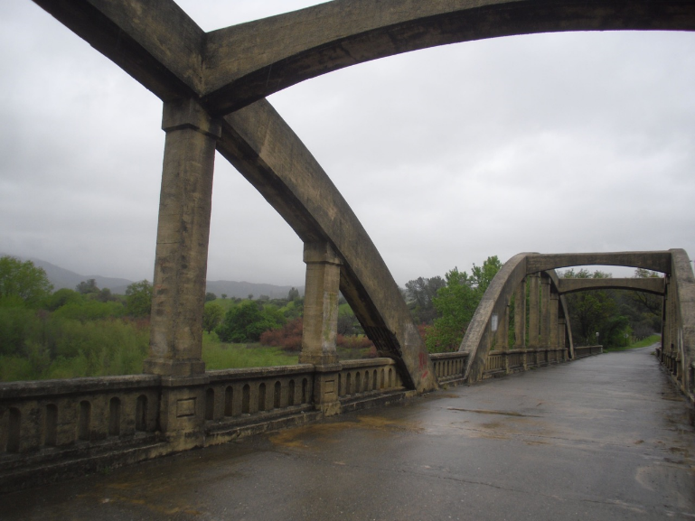

Just a short bit about the Rumsey Bridge….As many of you know, the bridge is facing some controversy. We are always asked, as a historical body, to comment on the building, demolition, alteration, etc of items on historical properties. I received a letter from JRP Historical Consulting, LLC regarding the Rumsey Bridge. My comment
follows…

To whom it may concern:
I am writing in response to the letter received on Feb. 9, 2016 regarding the demolition of the Rumsey Bridge. First of all, I would like to clarify a few points and ask questions regarding some other issues.
In my record of Yolo County Historic Resources Survey complied in 1986, The Rumsey Bridge is listed on page 56 as being built in 1915 &
1949. The bridge is a lot older. Also, is this bridge a Works Progress Administration Project (WPA) from the Great Depression? This page
was compiled by Les and Thomas Associates and Howard Moore. If it is a WPA project then that information should have come to the forefront. Secondly, I would like to know how many ‘concrete tied arch bridge constructions’ are left in California. That is a significant question. If there are only 2 and you destroy one..then where are we historically both in the state and in the county. (Just a note: In the book Historic Highway Bridges of California, on page 182, Rumsey Bridge is “one of 3 bridges of its type known to exist in California”. )

I understand the need to improve the bridge. The Yolo County Supervisors have already chosen Alternative 3 which is to install a new bridge further upstream and then tear down this bridge. I do not see why the bridge has to be torn down. Could it be used as a bicycle path or a walking bridge with historic information posted on it? I think that solution is a reasonable one and will insure that the ridge remains historic especially in a county that treasures its history.

Kathy Harryman
President of the Yolo County Historical Society

So we will wait and see……
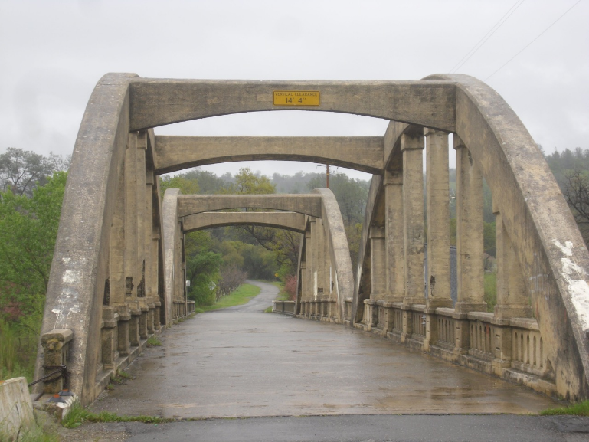

Have a great Easter, enjoy the green grass, flowers and the rain.

Remember, as always….

History Rules!
Kathy Harryman,
President

❖

Business Buddies

The following businesses in town have financially supported the Yolo County Historical Society. We would like you to support them and keep your money local:

L & S Printers, Main St.
The House Dresser, Main St.
The Gifted Penguin, Main St.
Corner Drug, Main St.
Dahlin & Essex Inc.
Chamberlain Farms
Bill Marble
Michele Giguiere
Bernard & Lynn Gough
Larry Shapiro
Tom & Meg Stallard

If you know of any business that would like to join our support list, contact me. Businesses pay $50.00 per year for advertising.

❖

Hattie Happenings
By Dennis Dingemans, Museum Director

March has continued February’s pattern in having variable attendance that peaks on sunny days and falls with rains. We are still waiting for the City’s Public Works unit to put out to bid the “WPA Restroom Renovation” project that will give the Museum some 500 square feet of storage space conveniently adjacent to our overflowing building. It has been almost five months now since we gave the City its check for the full amount of the remaining estimated price of the renovation — a bit over $40,000. Shortage of staff at PW is cited as a reason for the slow progress.
The Museum has posted an exhibit of 131 cards taken from our inventory of postcard albums. The theme is “Seasons Greetings — Holiday Postcards From Our Collections.” Postcards became a popular mode of communicating via “penny postcards” sent through the postal service in the last third of the 19th Century. The trend featured “greetings” that mentioned the schedule of seasonal holidays. These holiday cards haven’t received as much attention as the cards that contained photographs of places; “place” themed cards served as historical records as souvenirs of travel and depictions of urban and rural landscapes. Volunteers Merrily Dupree, Margie Blake, and Kate Morss created the exhibit.
Most of the messages printed on the colorfully decorated holiday cards are short and a bit banal. However, a significant minority contained more complex sentiments that were often in the form of amusing rhymed verse. Here are some examples displaying creativity of expression.
There are 22 New Year’s “Greetings” cards but few elaborations on “Happy New Year.” One anomalous sentiment expressed is “May your heart know no sorrow.”
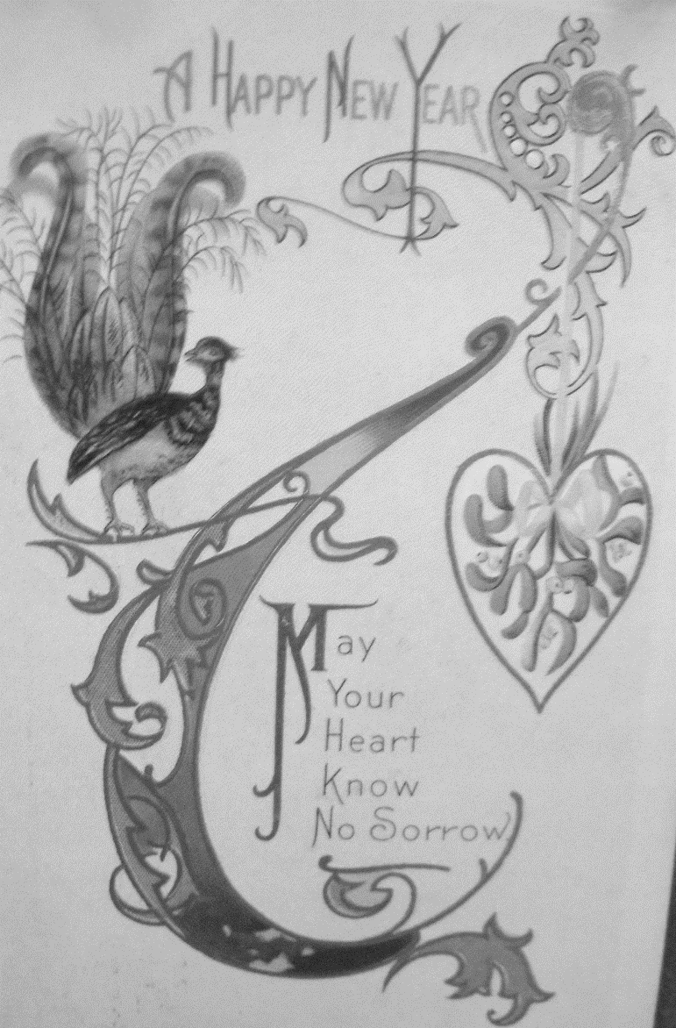
There are 20 valentine cards. In addition to simple messages such as “Valentine Greetings” and “Valentine Thoughts” here are the poems. “It doesn’t take a pair of specs to see I’ve always like your pecks (kisses)”. “I like you so sincerely, My head is acting queerly, And I’m afraid my heart will break If your don’t on me pity take.” “If this world you cut in two you’d find it filled with love for you.”
The 24 Easter cards feature the cross (10 cards), angels (2 cards), flowers (6 cards), and animals (5). One verse says “Join we with the angel throng — Keep the feast, Upraise the song. Alleluja!”
There are 6 “4th of July” cards. A flag or clothing in flag colors and flag stripes and stars appears on each.
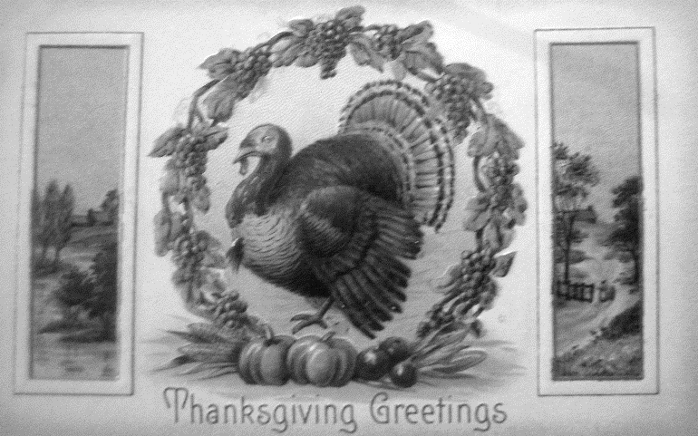
The 8 Thanksgiving cards feature turkeys and Pilgrims. One with verse says “To see our Father’s hand once more reverse for us the plenteous horn of autumn filled and running o’er with fruit and flowers and golden corn."
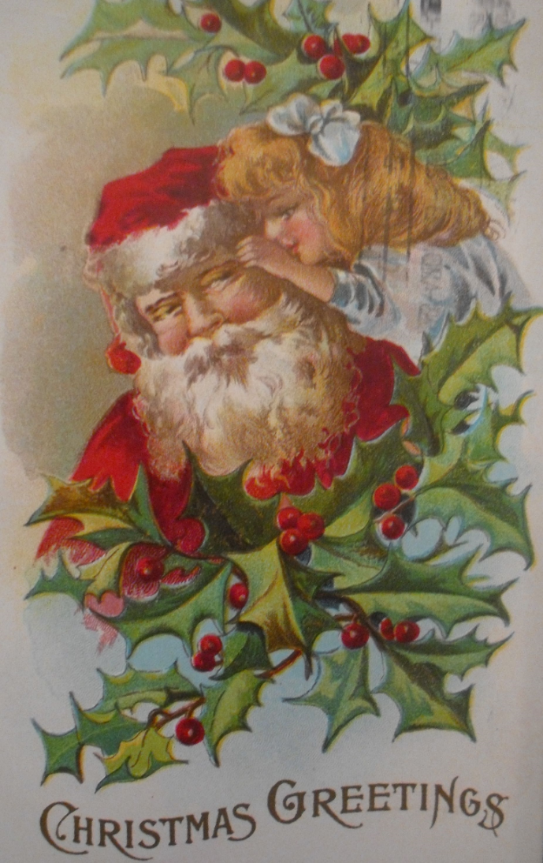
The 25 Christmas cards contain no attempts at inspiring verse. Polymorphous Santa Claus appears in five versions, any one of which could be on a contemporary card. Ivy is featured on 11 cards and snow is emphasized on 8.
Birthday Cards are also included in the exhibit. Seventeen of the 20 birthday cards have flowers as the primary decorative element. Only two have verse: “Carnation is thy birthday flower, of truth that’s sweet the token, By the ruby Heaven’s spark of love to happy youth is spoken, thy star still sparkling golden bright makes happy day from doleful night.” “A glad and bright day I wish you, and more, May happiness surround you, good fortune forever near.”
Six “novelty” cards have messages that might also put them in the Valentine Card category, although that holiday isn’t mentioned. “Cheer Up!! When you feel blue — if you’re a blonde it’s becoming, if you’re a brunette it is dye.” "He sipped the nectar from her lips and ‘neath the moon they sat. And he wondered if any other man ever drank from a mug like that.” Below a couple 'necking’ with a waterfall background: “The scenery here is beautiful; the change seems to be doing me good.” The couple holding hands beneath the moonlight: “I’m afraid to go home in the dark.”

The majority of the images in the exhibit are dated 1910 and few are before 1908 or after 1912.
❖

Thanks to the following for generously supporting the Society …………. You too can be a Patron by donating $100.00 to help us run our projects

2015-2016 Patrons

- Robert & Lynn Campbell
- Donald & Pat Campbell
- John & Helen Daniels
- Jonathan & Barbara Durst
- Robert & Judy Simas
- Ron & Marilyn Scholz
- David & Ann Scheuring
- Claire Childers
- Jeff & Starr Barrow
- Michael & Debra Truitt
- Alphe Springer
- Steve & Teri Laugenour
- Richard & Joann Larkey
- Ramon & Karen Urbano
- Thomas Crisp
- Ryan Baum & Alice Wong
- Richard & Evelyne Rominger
- Lynn & Penn Wilen
- Steve & Lydia Venables
- Cleve Baker
- Louis & Jane Niehues
- Charles & Claudia Owens
- Marilyn Kregel
- John & Kathy Harryman
- Roger & Ann Romani
- Patricia Nickell
- Jim & Wilda Shock
- John Hoover
- Dennis Dingemans & Robin Datel
❖

World War One Update

For those of you interested in World War 1 information, below is listed the offerings of the Sacramento Public Library under the direction of James Scott, their archivist. They look interesting and will certainly add to your knowledge of the War to End All Wars!

Sunday, May 29, 1-2:30 p.m. Sykes-Picot's Century of Imperialist Blowback: How WWI's Secret Treaty Still Haunts Us Today, presented by CSUS Associate Professor of History Michael G. Vann. Central Library.
Sunday, June 4, 1-5:00 p.m. A showing of the 1962 classic Lawrence of Arabia, starring Peter O’Toole and Mar Sharif. The movie will be introduced by local historian Joseph Spink and a discussion will follow the film. Central Library.
Sunday, June 5, 1-2:30 p.m. Mata Hari and Her Sisters: Women and Espionage in WWI, presented by author Carrie Sessarego. McClatchy Library.
Sunday, June 12, 12-1:30 p.m. This Unending War: 1916 and the Year of the Big Battles, presented by WWI Historical Association President Sal Compagno. Tentative for Sac Room at Central Library.
Sunday, June 26, 3-4:30 p.m. The 1916 Battle of the Somme: As It Was Fought and As It Is Remembered, presented by History Channel contributor, military history editor, and publisher Michael Hanlon. Central Library.
Sunday, July 10, 1-2:30 p.m. The Great War's Impact on Aviation: The Third Dimension Ascends, presented by WWI writer and scholar Colonel (USAF ret.) Terrance Finnegan. Central Library.

He also co authored a book entitled World War I and the Sacramento Valley. I just purchased a copy at COSTCO.

Happy Reading….

❖

Looking for an old article published in the newsletter or upcoming events? Check it out on our website. www.yolo.net/ychs

❖

Take me out to the ball game,
Take me out with the crowd;
Just buy me some peanuts and Cracker Jack,
I don't care if I never get back.
Let me root, root, root for the home team,
If they don't win, it's a shame.
For it's one, two, three strikes, you're out,
At the old ball game.

Everyone has either heard or sung this song. But you might be wondering what this has to do with the Yolo County Historical Society. Well you are in for a treat.

On Sunday, April 24 at 2:00, we will hold our annual meeting in Davis at the Hatti Weber Museum. Our presentation will focus on the baseball teams in Yolo County and our presenter will be Tom Crisp.

Just a little bit of history about the song…..The Tin Pan Alley song originated in 1908. (Tin Pan Alley was located in New York City and was where music publishers were located.) It became the unofficial anthem of baseball in North America. According to Wikipedia, it was selected by the National Endowment for the Arts and the Recording Industry Association of America as one of the 365 top “Songs of the Century.” In 1934, It was played at a ballpark for the first time at a high school game in Los Angeles. So, when you go to the ball game or watch it on television or listen to it on the radio and the 7th inning comes around, you can impress your friends with your new found historical knowledge.

Play ball and come to the presentation.

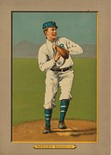

❖

School Days are Coming….

Our School house will open up in April and May for our 3rd grade classrooms. Thanks so much to Martha Brashear and Marilyn Scholz for arranging the classes and the teachers. We are truly lucky to have these wonderful volunteers.

❖

We are always looking for historical articles to publish in our newsletter. If you have something you think would be appropriate, please let us know. Call Kathy at 662-2189
Yolo County Historical Society
P O Box 1447
Woodland, CA 95776

Address Service Requested

Dated Material

Vision Statement The Yolo County Historical Society strives to preserve, protect and acknowledge
the diverse history of Yolo County through education, communication and advocacy

