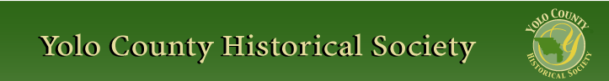

MARCH 2014
PP 2012

Pres Says:

We have had so many wonderful comments about our newsletter. Thanks to all of you for being part of this group. All of the Board is working hard to make sure that you get the best information possible.

This newsletter is dedicated to Kathryn Lucille “Pete” Hare and to all the ladies who have worked to make our county a healthier place. As you know, Kathryn asked that the Yolo County Historical Society be one of the recipients of monetary donations. The society has received $540.00 so far. We are very lucky and very grateful. Thank you Kathryn and the Hare family. The donors are listed in this edition.

Our next presentation will be at the Woodland Depot. Mike Adams will update us on what is happening there. There is a lot going on. The presentation will be on Sunday, March 30 beginning at 2:00. Save that date!
History Rules!
Kathy Harryman, President

❖

Hattie Happenings

Antique valentines and pigs shared center stage at the Hattie Weber Museum in February and early March this year. On February 14th, the Museum hosted a Second Friday “HeArtAbout” with a reception and a selection of more than 100 of the Museum’s antique valentine cards. Most of the cards were received by brother and sister Vernon and Violet Raabe in the early 1900’s. They were donated to the Museum by the late Maggie Katz, Violet Gordon’s daughter.
Noted Davis pianist Dick Livingston played the
Museum’s 1908 Weber piano at the reception while guests sipped champagne and nibbled on chocolate goodies. Vernon and Violet would have felt right at home.
The reception was the kick-off for formal fundraising for the renovation of the 1937 WPA building in the park (dubbed the “Precious Potty” by KCRA-TV). The building will become the Museum annex and be used for storage and additional exhibit space (no bathrooms!). More than a thousand dollars in contributions were received at the event.

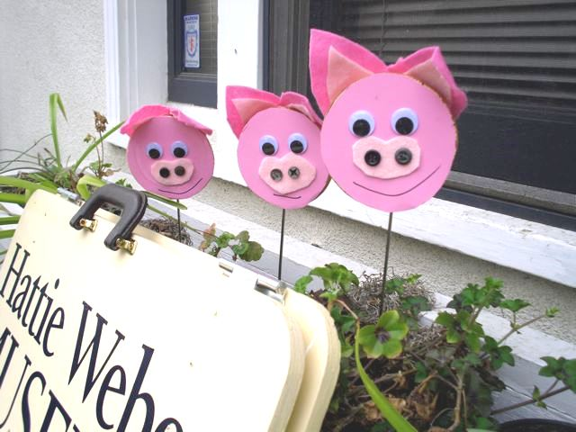

The pigs took over the Museum on March 1st (Pig Day at the Farmer’s Market). Almost six dozen pigs from Roberta Stevenson’s collection adorned the inside of the Museum while “pigsicles” beamed at passers-by from the Museum’s window boxes.
Roberta’s pigs are gone but there remains a special “Pigs in America” exhibit presenting an illustrated history of “bacon” and “lard” pig breeds in the USA and explaining the impact of WWII on the lard industry in this country. This exhibit will soon be replaced by one featuring the contributions of women’s groups to the Davis community over the years in honor of Women’s History Month in March.

Brick sales for inscribed bricks in the Hattie Weber Rose Garden next to the Museum will close on
March 22 this year. Order forms are available at the Museum (445 C Street in Davis) on Wednesdays and Saturdays from 10 to 4 or from Mary Lee Thomson at 530-756-0517. The cost is $50. Proceeds benefit the Museum Annex fund.
Meanwhile, the City is preparing to solicit three local architects to submit estimates of the cost to prepare a plan for the Museum Annex. The City estimates the total cost of the project will exceed $50,000. It is contributing $14,000 (the cost of demolition of the building); the rest will be raised by the volunteers at the Museum. Construction of the new playground next to and behind the Annex and Museum buildings has already begun. Contributions to the Annex fund can be made by check made out to YCHS and mailed or brought to the Museum at 445 C Street, Davis, CA 95616.
Thanks everybody!

❖

Thank You

Thank you to the following that have made a donation in Pete’s memory:
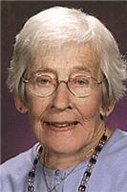

Paula Gimenez
Frieda Hanke
Edna Schlosser
Carol Rose
Carol and Charles Travis
Norma Berrettoni
Joe and Marie Muller

Kathy and John Harryman
Bill and Lola Morgan
Keith and Lorraine Kimura
Ann Busta
Michael and Janice King

❖

Business Buddies
The following businesses in town have financially supported the Yolo County Historical Society. We would like you to support them and keep your money local:
L & S Printers, Main St.
The House Dresser, Main St.
The Gifted Penguin, Main St.
Corner Drug, Main St.

If you know of any business that would like join our support list, contact me. Businesses pay $50.00 per year for advertising.

❖

A Legacy of Caring
By Kathy Harryman

The dictionary defines “nurse” as a person formally educated and trained in the care of the sick or inform. We are very lucky to have that legacy in Yolo County. The following celebrates the nurses who have made contributions to this county.

The Past
Kathleen McConnell graduated from St. Luke’s Hospital in San Francisco and along with her two sisters who were also nurses came to Woodland in 1905 and established The Woodland Sanitarium at 110 College Street. Kathleen realized the importance of a safe and clean place for surgery.

The second floor of the house was dedicated for surgery. The nurses cleaned the area with alcohol, removed the drapes, scrubbed walls and floors with Lysol and carbolic acid. Using kerosene lamps for light, they assisted the doctors in surgery. They then provided beds and private rooms for the patients. They had to boil water with disinfectant to sterilize the sheets. Mrs. Ella Hershey stayed in the

hospital. Her bill follows:

Ward Room – 7 days $15.00
Ward Room – 5 days $10.00
Use of Operating Room $ 5.00
Total bill $30.00 for 12 days

Later the hospital was moved and the nurses followed.

Nurses were present at the University Farm School as early as 1913. Nurse Flora H. Starn came. In 1915 after her marriage to Mr. James Koeber, Flora had to resign and the University Farm hired Miss Josephine Blinn to be the nurse.

Another historical event occurred in 1946 after the war ended. Six young women arrived in Woodland to staff the then new Yolo County Hospital. These nurses came from all over the Midwest: Lois Johnson, Muriel Enos, Lee Long, Bette Rademaker, Rosemarie Plocher and Katie Townsend. They had enrolled in the Army Nurse Corps and after basic training, had been stationed just outside Manila to a field hospital in northern Luzon on Linguyen Gulf. They lived in conditions that were very similar to the M.A.S.H. television show. When the war ended, they returned home. Eileen Rocksvold, one of the nurses, returned to Woodland with her husband. She gave the names of the other nurses to her supervisor who wrote the nurses in the Midwest and invited them to work in the ‘new and sparkling’ building. The nurses came. Two additional nurses had been through the government’s cadet nurse program and came to Woodland in the early fall. They were Elaine Scott, and Kathryn Hare, who came in response to an ad in the American Journal of Nursing. They were paid $175.00 per month and that included housing in the ‘attractive nurses’ residence, meals, and maintenance of the nurse’s uniforms. They worked 8 hour days with 2 days
off. Life wasn’t all work for these ladies. There were trips to Sacramento and San Francisco, dances at the American Legion Hall and many weddings. Being away from home, the nurses formed their own family. How lucky we were to have these dedicated women be a part of our history.
Above information from Phyllis Levers, contributing editor to Daily Democrat Supplement April 27, 2002.

Present
Kathryn Lucille “Pete” Hare attended nursing school at St. Joseph's in St. Paul, Minn. She made fast friends with her fellow nurses in training and those friends gave her the nickname that would stick with her for life; "Pete," short for her last name "Petrich."
After two years practicing general nursing in St. Paul, she answered an ad in the American Journal of Nursing soliciting nurses to work at the Yolo County General Hospital, which had just been built. Her first four years in California were spent as a nurse for Yolo General Hospital, the Woodland Clinic, and the Yolo County Health Department. She married Jim Hare in 1949. She put her nursing career on hold to raise their family while also devoting countless hours to Holy Rosary Church, School and the community of Woodland. She always had time to listen to anyone and had a reputation for dispensing sage advice when asked. She returned to work in 1968 and spent 22 years as a nurse for Woodland Memorial Hospital's psych unit. Although she officially retired from nursing, she never quit volunteering and helping others.

Thanks to all the nurses who continue to minister to the needs of this county. We really appreciate you.
❖

Winters History Project

The Winter History Project Committee is pleased to announce the date of Thursday, May 1st for the 2014 Agricultural Symposium. This event will include a morning tour of the Wolfskill Experimental Orchards, hosted by UC Davis faculty associated with the Department of Pomology and the USDA's National Germplasm Repository. A catered lunch and afternoon program will follow at the nearby historic William Pleasants Ranch in upper Pleasants Valley, which dates from 1850.

Watch area newspapers for further details about cost and reservations.

Yolo County Historical Society
P O Box 1447
Woodland, CA 95776

Address Service Requested

Dated Material

Patrons
Thanks to the following for generously supporting the Society for 2013-2014. You too can be a Patron by donating $100.00 to help us run our projects

John and Helen Daniels John and Kathy Harryman Pamela Pearl
Virginia Schwartzgruber Stella Dinger Robert and Lynn Campbell
Leroy and BJ Ford Jon and Barbara Durst Dennis Dingemans and Robin Datel
Jeff and Star Barrow Donald and Pat Campbell Albert and Lynn Plocher
Cecilia Kwan John Hoover The Laugenour Family
Phyllis Levers

Vision Statement The Yolo County Historical Society strives to preserve, protect and acknowledge
the diverse history of Yolo County through education, communication and advocacy

