

FEBRUARY 2017

PP 2012

Prez Says

Well, little did I know that after I published Part 1 of The Flood of 1861 that we would be inundated with rain; flooding would occur, dams would fail, and rain would continue to pound California. Wow! In this issue is Part 2 of The Flood of 1861. I hope the worse of the rains will be over after this is publicized.

I would like to share some information about R.P. Wallace as told in the Nov/Dec issue of 1975 in the Yolo County Historical Society newsletter. Mr. Wallace based his tale on the experiences of Tom Cummins, a pioneer settler of the Sacramento River District. Mr. Cummins told Wallace about his experience while the men were gathered in the Yolo County Sheriff’s Office in Woodland, during the flood of 1907. Cummins said he believed that the flood of 1861 was the worst ever experienced by the river people.

The Nov/Dec. issue also has information about the Knights Landing Flood of 1909, but I think I am done with floods.

On to other business…..it looks like the WPA building in Davis is going to be redone. Dennis Dingesmann and his fabulous crew at the Hatti Weber and I met with the city last week and talked about the next steps. Yeah Team…Many, many kudos to the Hatti Weber team for their dogged diligence. Wow! You are all awesome!

Roberta Stevenson who has been on the board of the Yolo County Historical Society has had to step down. She has moved to a retirement facility. Many kudos to Roberta for all her dedication to the Society throughout her many years. You are a treasure!

Remember, as always…
History Rules!

Kathy Harryman
President, Yolo County Historical Society

❖

Upcoming Lecture Cancelled

Our February lecture on Feb. 26 at the 2nd Baptist Church has been cancelled. Marilyn will speak to our group later in the year.

❖

The Flood of 1861 – Part 2
By R. P. Wallace

It was a small frail boat, very similar to those in common use among duck hunters, called ‘duck boats’. During his residence of several years on the river, Cummins had had frequent occasion to use it, and had acquired considerable skill in its management, but it required his utmost effort to paddle the boat around the house against the wind and the waves. Despite the cold wind, he was all aglow with the warmth of exercise when he at last brought the boat safely back to its mooring. It was an easy matter barring the rocking of the waves, to step into the craft from the doorstep. Still, the good man hesitated as he thought of the dangers of the trip he was about to undertake with his family. Mrs. Cummins, however, left him no chance to change his mind. She was ready with the babies and stood waiting for the moment to embark.
“It’s risky, Dea, but it’s our only chance,” said Cummins as he set about making preparations for the journey. He seized a large bundle of bed clothes, which he placed carefully in the bottom of the boat, then assisted his wife to enter it. The children were handed in and wrapped snuggly in the bundles of the bedding which had been reserved for that purpose. Mrs. Cummins, , at the bidding of her husband, sat upon the floor of the boat, as near the middle as she could get, which her husband placed himself in the stern, seized the paddle and released the ‘painter’.
Then began a battle of strength and endurance against the elements. Cummins was a young man in the prime of his strength. Inured to hardship all his life, and having spent most of it in the open air without those luxuries and health-undermining excesses often indulged in by the city born and bred, he was certainly a splendid specimen of physical manhood as he skillfully plied the paddle and gazed anxiously out into the darkness to guide his course through the heavy waves. Progress was exceedingly slow and hazardous. Cummins kept the nose of the boat quartering to the waves so that their full force would not break upon it. One moment, the craft would be lifted to sickening heights upon the crest of some mighty wave, and next it would plunge into an abyss of dark depts., as it rose and fell in the trough of the inland sea. It seemed many times that the destruction of the small boat was inevitably by the weight of some huge wave which rose threateningly above it. But the gallant little shell struggled bravely on as through it, too, realizing the great responsibility of its precious cargo, was determined to fight and win against its natural ‘foes,’ the wind and water.
The children, frightened and drenched, cried piteously and the brave little woman in the bottom of the boat had all she could do to soothe them. She was soon burdened with another and more hazardous duty—the boat was filling with water dashed over the side by the waves. Mr. Cummins had all he could do to keep the boat on its course against the wind and waves. Already tired and sick at heart, Mrs. Cummins began the monotonous dipping with a small tin can kept in the boat for that purpose, realizing that upon her constancy depended the lives of the little group. After what seemed hours of strenuous toil, her arms grew numb with fatigue, and she felt that she must either relinquish her hold upon the babies which were clasped against her breast with one hand, or suffer the boat to fill which she ceased her torturing toil with the other. Mr. Cummins tried to cheer her, although his heart ached in sympathy, as he witnessed her apparent anguish and distress. But he could not, even for a moment, cease his constant paddling lest the boat turn broadside to the waves, which would prove fatal to all aboard, and his own strong arms were aching with excessive toil.
Straining his eyes, Cummins could see no signs of the habitation he so eagerly and anxiously sought, although he reckoned that sufficient time had elapsed to bring the boat within hailing distance. To complicate matters, all the old landmarks that might have assisted him in shaping his course were under water, and he was compelled to rely upon instinct and luck. By this time, his efforts had become merely mechanical. His faculties were benumbed, and his muscles ached. His poor wife had not ceased her bailing, and the children, long since exhausted by weeping, lay sleeping in the bottom of the boat. Cummins knew how his wife was suffering, and as he watched he saw her head droop and her form sway. With an effort, she seemed to rally and resume her agonizing toil, only again surrender to the benumbing fatigue which crept over her.
Finally, with an audible sigh, she sank to the bottom of the boat. Blessed oblivion brought her relief and rest.
Cummins was glad, even which he despaired. There was some consolation in the thought that if they were destined to meet a watery grave, it would come without the agonizing struggle of desperate hope. He prayed that his wife would meet it still un -conscious and the babies—God bless them—would not awaken. Cummins himself felt an all-powerful desire to sleep, but, with an effort, he roused himself and peered again into the impenetrable gloom which surrounded him.
As he looked, his heart ceased its beating and a low cry involuntarily escaped him. He rubbed his eyes to make sure. Yes, there could be no mistake—a light gleamed out upon the water not a long distance from him. The sight gave him renewed strength, and he plied his paddle desperately. As he neared the light, he could distinguish the outlines of a house, and he knew that he was at last approaching the haven of safety he had fought so desperately to gain—the house of Mrs. Crenshaw. By the light he knew the occupants were astir. Hope dawned in his breast and he thanked his Savior.
Not many minutes afterwards, Mrs. Cummins and her babies were lifted from the boat, which was by then nearly full of water. They were put to bed between warm and dry sheets.
On the following day, the storm broke and the wind abated considerably. With a skiff borrowed from a river steamer moored in the river a short distance below the Crenshaw place, Mr. Cummins and a man employed by Mrs. Crenshaw set out to rescue some families up the river whom they knew to be without a boat. They were all brought safely away, and in one instance the rescuers were just in time. ………
Mrs. Cummins found only one of his many hundred head of hogs. An old sow had found a roosting place on the top of a tall stump with rose above the water. …he took her back to the ranch where she became the mother, grandmother, and great-grandmother of his new herd.

❖

Business Buddies

The following businesses in town have financially supported the Yolo County Historical Society. We would like you to support them and keep your money local. If you know of any to join our support list, contact me. Businesses pay $50.00 per year for advertising.

L & S Printers, Main St.
Zamora Hills Ranch
Larry Shapiro
Bernard & Lynn Gough
Dahlin & Essex Inc.
Alderson Convalescent Hospital

❖

Gibson House Issues

The Gibson House Museum and the Yolo County Historical Society have always been aligned with the purpose of saving the history of this county. Because of the cost of running the museum, the county has suggested that the Yolo Arts Council become part of the Gibson Museum and take on a leadership role. Information is going to the supervisors with this suggestion. On your behalf, I have written an e mail and sent it to all the supervisors. This issue is not a done deal! The supervisors need to have your input. I have reprinted the e mail for you…

My name is Kathy Harryman and I am currently President of the Yolo County Historical Society and on the Board of Trustees of the Gibson Museum. Yesterday, Thursday, we heard a plan involving the future of the Gibson Museum. It will now go before you, the Supervisors of the county to determine the future of the Gibson House. Regardless of what you decide, I think the real question here is the future of a Yolo County Museum. This county has a fabulous history of its own. It mirrors the history of California with the residents of the past taking part in conflicts that determined the rights of individuals that we all cherish today. The number of items that were shipped worldwide in the late 1800's boggles the mind, and this is all before the establishment of The Farm. Our history is rich and this county has a story to tell its inhabitants and visitors. Right now, the story is being told in small, local city venues: Davis, West Sac, Winters. We need a plan for the establishment of a Museum that will tell the county's story. I would like to see a plan that moves us towards that goal. We have an historical County Courthouse that is, for the large part, vacant. I urge you to direct staff in that direction. I will be at the meeting on Tuesday. Thanks so much for all you do for the county.

❖

Thanks to the following for generously supporting the Society. You too can be a Patron by donating $100.00 to help us run our projects
2016-2017 Patrons

- Donald & Pat Campbell
- John & Helen Daniels
- Jonathan & Barbara Durst
- Robert & Judy Simas
- Ron & Marilyn Scholz
- Claire Childers
- Jeff & Starr Barrow
- Michael & Debra Truitt
- Steve & Teri Laugenour
- Richard & Joann Larkey
- Ramon & Karen Urbano
- Thomas Crisp
- Ryan Baum & Alice Wong
- Richard & Evelyne Rominger
- Steve & Lydia Venables
- Charles & Claudia Owens
- John & Kathy Harryman
- Edmund & Margie Blake
- Katharine Cobb
- Marc & Gerda Faye
- Corner Drug
- Valerie Vann
- Sandra Wright
- Roger & Ann Romani
- Jeanie Sherwood
- John Hoover
❖
Carnegie Library Lighting Update

It is a great honor to have two original Carnegie Libraries in our county: one in Woodland and one in Yolo. Did you know that California is second only to Indiana in the number of grants to construct Carnegie library buildings? Of the original 142 Carnegie grants given to cities throughout California, only 36 are still operating as libraries. //www.carnegie-libraries.org/about.html These are dismal statistics.

As an historical society, we are interested in preserving the Carnegies. The Society, along with other groups who support the Library has donated money to help restore the original lighting-look in the Carnegie portion of the library. We have been working with Greta Galindo and David Wilkinson. We would like to finish the project, but we need your help. We are looking for individuals or families who would like to donate. If you can, please send a check to The City of Woodland and designate the Woodland Public Library.

The County Library in Yolo is also on our radar…It will be 100 years old next year and because the county has grown, the facility is inadequate to serve the needs of the community. The county is undergoing a process of looking at renovating and or improving the library facility. They have asked for an Environmental Review to look at their options. They are in a ‘wait and see’ mode. Hopefully, we can save this facility and keep the Carnegie legacy alive. Stay tuned……

Hattie Happenings
By Dennis Dingemans, Director, Hattie Weber Museum of Davis History

The Hattie Weber Museum moved a bit closer toward gaining its needed storage facility during the past month. On January 24th the Davis City Council approved the 11 page staff report that recommended a revised Memorandum Of Understanding between the City and the YCHS/HWMD advocates. A less expensive renovation plan was approved in concept for saving and assigning to the Museum the WPA-funded 600 square foot “old restroom” building in Central Park. Cost savings compared to the plan that received a (rejected by the City) low bid in 2015 of around $79,000 are hoped to bring new bids of around $45,000. Demolition of the 1956 addition to the 1937 core structure will no longer be needed and there are revisions to the treatment of windows and doors. The new plan is a better preservation project and conforms to our requests of the past 5 years.
At a meeting on February 15th, Public Works and City Manager’s Office Staff met with Museum advocates and discussed the next steps for architect Maria Ogrydziak as she provides final details. A tile roof with materials from Gladding Maclean (of Lincoln) will be prepared for by adding bracing, but the restoration of the original 1937 roof materials will be delayed until around 2020.

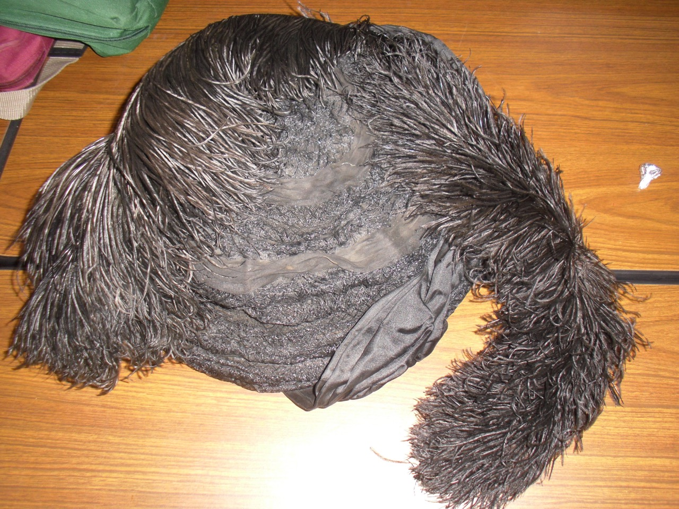

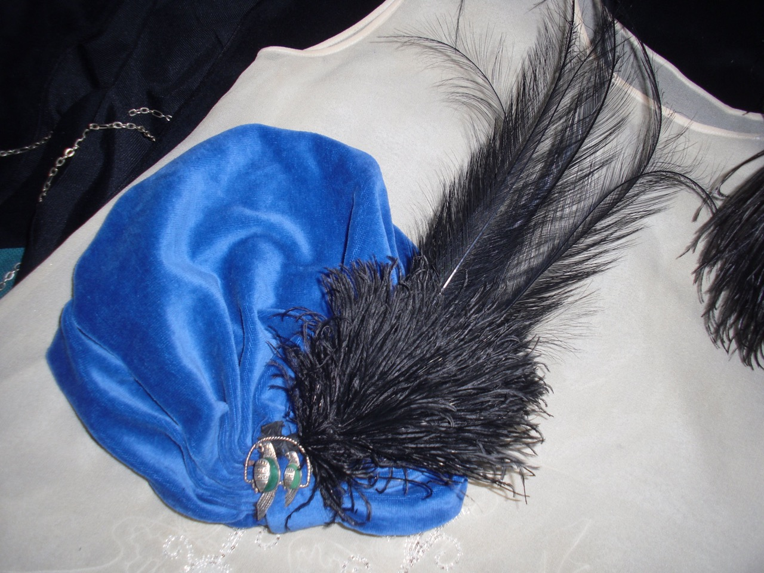

Our exhibit of “Flapper Era” clothing has been augmented with some amazing donations. Shown here are ostrich feather hats from a family that lived in the Tremont area. Milk bottles from a dairy that delivered in Davis are also shown.

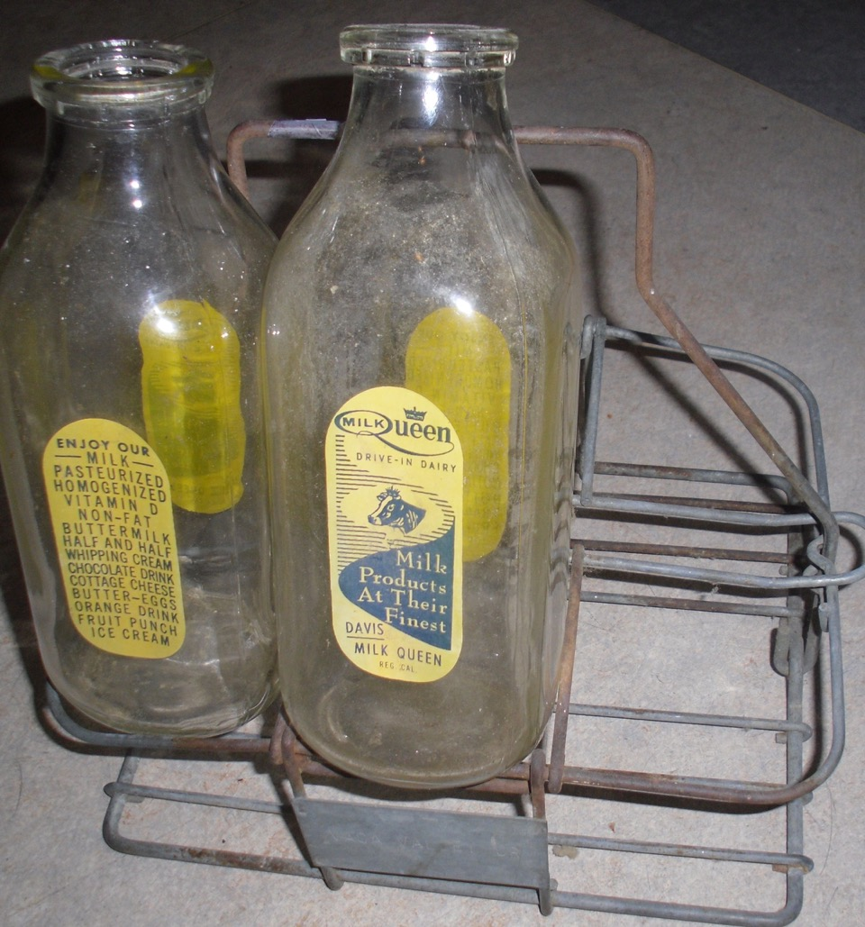

The Museum is open and free to the public on Wednesdays and Saturdays from 10 am to 4 pm. It is at 445 C Street in Central Park.

Yolo County Historical Society
P O Box 1447
Woodland, CA 95776

Address Service Requested

Dated Material

Vision Statement: The Yolo County Historical Society strives to preserve, protect and acknowledge the diverse history of Yolo County through education, communication and advocacy

