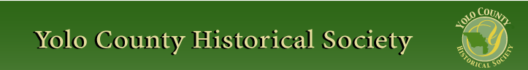

FEBRUARY 2015

PP 2012

Pres Says:

I write this letter with sadness. We lost a wonderful history support person this past month…Jim Beckett was instrumental in establishing the Hatti Weber Museum in Davis. His presence will be missed by all who knew him.

Many thanks to our own member, Elaine Hermle for giving a wonderful presentation in January at St. Agnes Catholic Church. The Church was full and as we left the church, we were greeted by sunshine. What a great way to end the lecture! I personally know a lot more about Black’s Station/Zamora than I knew before. If you do not have a book and would like one, call Elaine. She is in the phone book.

Our next presentation will be at the newly re-opened Leake Room at the Woodland Public Library. It will be on Sunday, February 22 at 2:00. Bill Hollingshead will share his father’s photos with us. Not only will we view the photos but also be in the newly painted Leake Room.

Just a reminder…..if you would like to receive your newsletter via e mail, please let Reva know. Her e mail is rbarzo@yahoo.com. We will not only save on printing, but also on postage.

Remember, History Rules!

Kathy Harryman

Business Buddies

The following businesses in town have financially supported the Yolo County Historical Society. We would like you to
support them and keep your money local:

L & S Printers, Main St.
The House Dresser, Main St.
The Gifted Penguin, Main St.
Corner Drug, Main St.
Dennis Dahlin
Zamora Hills Ranch
Richard Berteaux
Historic Woodland Downtown
Business Association
The Home Improvement Group

If you know of any business that would like to join our support list, contact me. Businesses pay $50.00 per year for advertising.

❖

Woodland Public Library and YoloCounty Historical Society
offer a rare glimpse into Woodland’s historical past

The Woodland Public Library and the Yolo County Historical Society will host a rare screen presentation of the photographs of renowned Woodland photographer Paul W. Hollingshead (1896-1974). The photos and talk by Bill Hollingshead, Woodland native and son of Paul and Vera Hollingshead will be on Sunday, February 22nd at 2:00 p.m. in the Leake Room of the Woodland Public Library. The event is free to the public.

Hattie Happenings

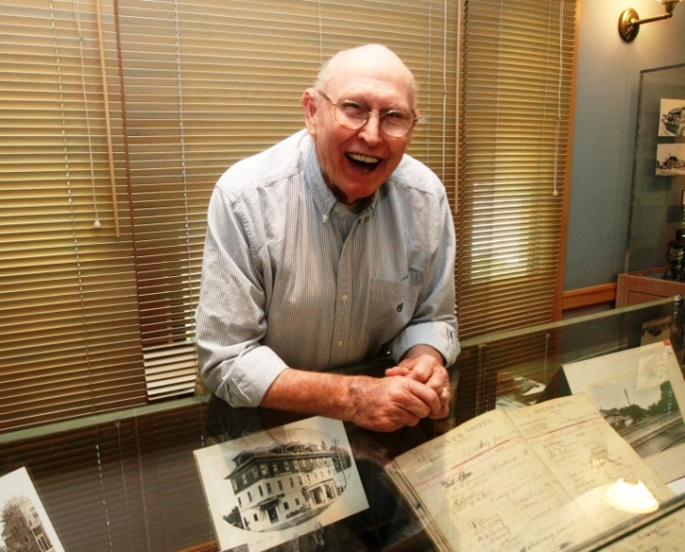

Jim Becket
February 2, 1920 – January 21, 2015

The YCHS and the Hattie Weber Museum, along with many other organizations and individuals, lost

beloved leader and friend when Jim Becket passed away on January 21.

Jim was born and raised on a family farm in Woodland, where he developed a life-long interest in agriculture. He attended UCD where he was known as “Buckets Becket” for his prowess on the basketball court. Interrupting his studies with a stint in the Air Force during the Korean War, Jim graduated from UCD and earned a teaching credential. A gifted teacher, he taught agriculture and fostered the Future Farmers of American in Biggs and Yuba City.

Jim met and married his beloved Marge (Marjorie Marie Cox) in 1956 and in 1958 they moved to upstate New York where Jim earned a PhD in Agricultural Education and the couple welcomed Kathleen (1961) and Mark (1963) into the family.

Returning to Davis in 1964, Jim worked at UCD, the California State Department of Education and several County Offices of Education. His active family life included 4-H projects, Little League, Musicians and Artists Serving the Church and many annual family camping trips. In 1978 he ran for Yolo County Superintendent of Schools; he didn’t win (by just 12 votes) but the campaign was celebrated for the civility and respect between the candidates.

After his retirement from professional life, Jim became even more active in the community. He joined Kiwanis in 1992 and was active in many projects. The Davis Chamber of Commerce honored him as Member of the Year 2000 for establishing the School-Business Partnership Program. Jim was also active in the Woodland Methodist Church where he and Marge were bell-ringers for many years.

At one point Jim and Marge took a cross country trip, searching for “roots” for both their families. When they returned they became active in the Yolo County Historical Society making many valuable contributions.

Although he considered himself an educator and not a historian, Jim devoted much of his energy to the Hattie Weber Museum of Davis in Central Park in

his last years. Under his gentle leadership, the
volunteer staff was expanded, the Museum became more family friendly with a “Kiddie Corner” and hands-on exhibits, the scope of Davis history exhibits was increased, outreach to the community was expanded and a steady source of operating funds was established with the sale of engraved bricks for the Rose Garden patio. Jim also led the campaign to save the 1937 WPA restroom building (which he liked to call “the precious potty”) in Central Park to serve as a Museum Annex. For these and other community services, he was named “Davis Citizen of the Year” in 2010.

Age slowed him down a bit but his enthusiasm never waivered. A week after he moved into a senior facility, Jim was leading historical bus tours of Davis, Woodland and Yolo County for the other residents.

We will all miss him.

❖

Esparto….Another Railroad Town…..
Part 3
Kathy Harryman
It is always amazing to me the number of towns that were created by the railroad and named by someone whose name no longer exists in the historical records. Esparto is such a town. Created in 1888, The Vaca Valley Railroad gave the name Esperanza (hope in Spanish) to the town site. But unfortunately there was already an Esperanza in California. So the name “Esparto” (meaning feather grass) was chosen. **Wikipedia
Esparto has always played a significant place in the history of Yolo County. Esparto High School was one of the first high schools in the county, established in 1892. The area was a thriving bustling town with businesses on both sides of Highway 16. The road through town was a two lane country road with parking on both sides of the street. The parking was done at an angle to allow for easier access out of the space. Right now, in front of the hardware store, cars are parked that way. According to Jon Durst, one of our members, who grew up in the area, “everyone knew everyone
“in town. When he grew up there in the 50’s and 60’s there were about 700 people. One of the businesses was Wyatt’s Dry Goods Store that was our modern day equivalent to a modern grocery store. One could buy clothing, food, and hardware. Karl Giguiere, another member of The Society, remembers that there were doors cut between buildings that allowed the customers access to the entire store. Oggie’s Gas was a great place to buy a coke for only 5 cents. The doctor’s office was next to the bank building. That was where everyone who played sports went for their physicals. Karl remembered that Doc. Johnson automatically gave you a penicillin shot no matter what! And it was always in your rear! Frank Burris had a drug store that sold sodas out of an old fashioned soda fountain and Lindberg’s Tavern had an upstairs dance floor with springs on the bottom. Jon remembers when the boys were on one side and the girls on the other side! There was a bar on the corner next to the post office and there was a Ford Garage. Pat Harrison, a real estate agent in Esparto, remembers that deeds of property in the 1930’s stated that the west side of the town was designated ‘dry’ and the east side of the town was designated ‘wet’. There were 2 churches, Countryside which is still there and a Catholic Church. Karl remembers the “Jolly Cone” which later was named The Burger Barn. It originally sold soft serve ice cream and was a favorite for both the students and the adults. The Scout Cabin still remains. Ben Herbst had a repair shop where he made and repaired farm equipment. And Andy Hess’s Barbershop shared its space with a shoe repair shop. The railroad depot, abandoned for many years, was a favorite place for the kids to play. Later it became a library. That was kind of ironic! What a great town this must have been.
Jon also shared what he did for recreation. Between the months of March through October, he and his buddies swam in the canals which were full of water for irrigation. They also went to Crowder’s Pool in Madison. He said that it is long gone, replaced by the power station south of the town. He said that Crowder’s never used chlorine, but drained and refilled the pool every week. He remembers the jukebox blasting Elvis Presley records to about 30-50 kids in the summer. When he got a little older, he recalled water skiing on the canals coming from Clear Lake. His jeep on the road pulled the skis on the water, but he had to be careful because there were bridges! Karl remembers towing kids with his red Austin Healy Sprite Sports Car. Karl also remembers dragging down Main Street when the part time deputy was out of the area. Those were the days …..
The town does come alive at the end of February when they host the Almond Festival along with several other towns in the valley: Rumsey, Guinda, Esparto, Madison, Brooks and Capay.
Almond Festival
This year marks the 100 year anniversary of the Almond Festival in the town of Esparto. The first Almond Festival was actually held in September of 1915 and was sponsored by the Woodland Farm Bureau Unit. The following Awards were given:
Almond Awards Harvest Awards
Davis 1st Woodland 1st
Esparto 2nd Guinda 2nd
Capay 3rd Esparto 3rd
This year it is estimated that there will be 10-15,000 people attending the Festival. What a legacy!
The following is an article from The Mail of Woodland from Sept 5, 1915.
HUNDREDS ARE ENTERTAINED BY CITIZENS OF ESPARTO
Western Yolo Town Sets Fast Pace for Such Events When It Produces Educational and Interesting Celebration
That a small town is capable of equaling, if not surpassing, the ability of a larger place in the roll of host at such an event as the Esparto almond festival, was forcibly demonstrated yesterday when that place scored a great success in conducting the fete which has for many weeks been heralded about the state. And their task wa made doubly hard by the large attendance at the first annual almond festival of Esparto, there being easily more than 2,000 visitors from all corners of northern California and even bay points to participate in the festivities.
Too Much To See And Do…
From the moment one landed on the scene until he regretfully took his departure there was something in the manner of attractions which claimed his attention and interest. Opened by a spectacular parade in the morning and closed by an enjoyable ball in the evening, this big day for western Yolo was crowded with attractions which took one a day to do justice to. At every turn there was one of these beaming and cordial natives ready to act for one’s comfort and their tireless efforts were well rewarded.
With the success of yesterday still ringing in their ears they are already looking forward to the next opportunity to show the valley that they have one of the livest little towns in seven states and are able and anxious to repeat.
❖
Dingle Elemetery History Club

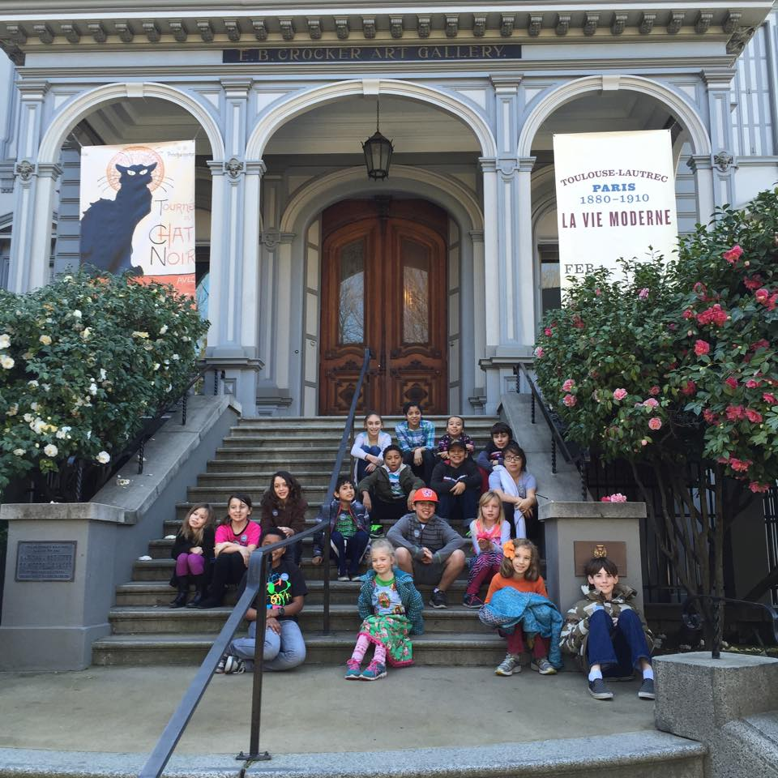

Please extend A BIG THANK YOU to the Yolo County Historical Society for their donation that allowed the Dingle Elementary History Club to take their field trip to the Crocker Art Museum this last week! The students really enjoyed it!

Many of the students had never been to the Crocker-- but now that they know it is there and all it has to offer, plan on coming back frequently in the future (the Crocker gave each student a free pass for one visit that gives the students and four members of their family admittance to the museum.)

Thanks again!
Rachael Zur

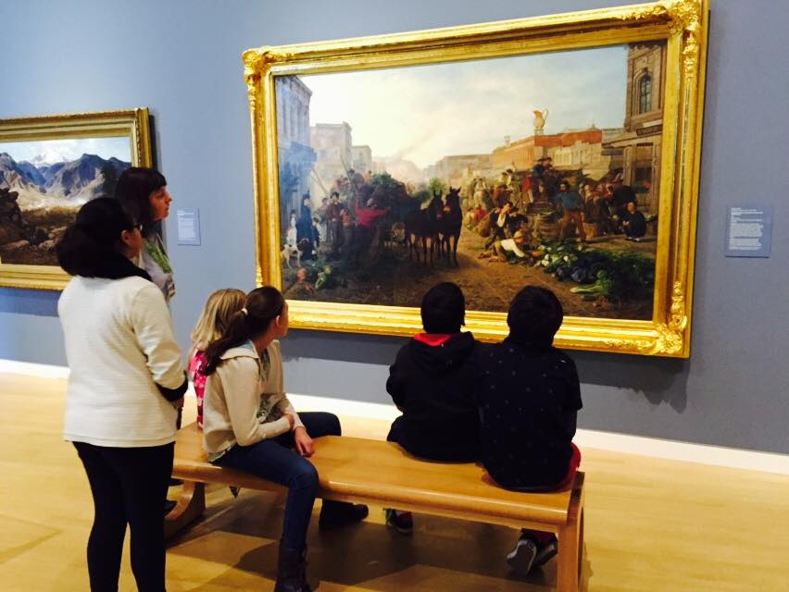

❖

Society publications available for sale at a variety of locations. For more information on book sales, contact Mary Aulman at 666-0743.

Thanks to the following for generously supporting the Society…………. You too can be a Patron by donating $100.00 to help us run our projects

2014-2015 Patrons

- Jeff & Starr Barrow
- Alice Wong & Ryan Baum
- Donald & Pat Campbell
- Michele Giguiere
- Bernard & Lynne Gough
- Betty Van Lew Haines
- John & Kathy Harryman
- Joan Hogan
- Jim & Donna Peoples
- Roger & Ann Romani
- Lon Springer
- Tom & Meg Stallard
- Valerie Vann
- Steve & Lydia Venables
- Marilyn Kregal
- Clair Childers
- Michael King
- Jeanie Sherwood
- Virginia Schwarzgruber
- Albert & Lynn Plocher
- Richard & Evelyne Rominger
- Robert & Judy Simas
- Richard & Joann Larkey
- Bobby Jo Ford
- Dennis Dingemans & Robin Datel
- Steve & Teri Laugenour
- Johnathan & Barbara Durst

Yolo County Historical Society
P O Box 1447
Woodland, CA 95776

Address Service Requested

Dated Material

Vision Statement The Yolo County Historical Society strives to preserve, protect and acknowledge
the diverse history of Yolo County through education, communication and advocacy

