PRESIDENT’S MESSAGE

I don’t know if it is the cold foggy weather that is causing me to think about what the Society will be doing in the Spring, but I am.

The January program featuring the “Freedom Riders” for those of you too young to remember these are the brave gentlemen (all Davis residents) who in 1965 joined Martin Luther King on the historic march from Selma to Montgomery, Alabama. The goal was to make it possible for African Americans living in the South to exercise their right to vote. This was a reminder of how far we have come AND how much more there is yet to be done. Guest Rev. John Pamperin’s wife sat in their car listening to the Green Bay Packers vs Chicago Bears football game. Two honks of the horn if Green Bay scored and one honk if Chicago scored. Approximately 50 people attended and enjoyed the stories that were told until 4:15 p.m.

Programs are being planned for the 4th Sunday of the month through May. More information on these programs will be available next month, but save the dates. And, we are organizing a free Museum Day for a Saturday in April.

Also for our Spring Trip we will be going South, i.e. Lodi, Stockton and maybe a stop in Florin at the restored Victorian home which was the inspiration for dressing up the Gibson Mansion; a task well done by Kathy Harryman and Starr Barrow.

If you have suggestions for programs or would like to be more active in the Society, please give me a call.

Peace,

BJ Ford, President

HATTIE HONORS KING FREEDOM RIDERS

The Hattie Weber Museum of Davis honored Dr. Martin Luther King Jr. and the Freedom Riders at an exhibit opening and reception on January 15th. For the record, we also celebrated the birthday of docent extra-ordinaire Virginia Isaacs. Tansey Thomas, of Davis, provided pictures and information for the exhibit about the March 1965 bus trip to Montgomery where the Marchers joined the Selma march for the last 12 miles. We also mounted a picture of Dr. King and excerpts from his famous, “ Letter from a Birmingham Jail”. Marchers John Pamperin, Dick Holdstock and Terry Turner recounted their experiences in Alabama. The exhibit will remain up until the end of January.

Meanwhile, the Museum is planning to display part of its collection of antique valentines at the Second Friday “HeArtAbout” on February 11, from 6 to 8 pm. The valentines date from the early 20th century and are addressed to either Vernon or Violet Raabe. Maggie Kautz, Violet’s daughter, donated them to the Museum. We will also mount some “factoids” about St. Valentine and the day.

Cataloging and organizing the Museum’s collections continues thanks to the efforts of Stella Dinger, assisted by our newest volunteer Adrian Gabrial. Adrian even has us on Facebook!

Director Jim Becket formally accepted the Covell Award as “Citizen of the Year” at the Davis Chamber of Commerce dinner on January 21st. We hung the plaque in the Museum.

Mary Lee Thomson

JOHN DICKSON STEPHENS

In a November article, I shared the history of the Bank of Woodland from its founder to its merger with the American Trust Company. Since then, I found another amazing thread of Yolo County’s history by researching some artifacts of the Bank of Woodland.

Over the past few months I’ve picked up some nineteenth century envelopes called covers. While most were sent by private express firms of the day, I am always on the look out for any envelopes with a Yolo County connection. Two of the envelopes were with Bank of Woodland lineage and sent by United States Mail.

The older of the two is an envelope from 1873 sent from the Bank of Woodland to a Major I. Wilcoxson of Sacramento. This is the envelope that connects directly to one of Yolo County’s most significant pioneers, John Dickson Stephens.

John Dickson Stephens was born in Missouri in 1826. In 1843 he enlisted in the Army during the Mexican American War but never saw direct conflict. Following his start of medical training he caught gold fever with the first news of California gold. He and his brother headed to Independence where they joined a forty-five person company headed to California and escorted by two of Fremont’s men. The party reached Sacramento in August, 1849.

Stephens tried his hand at prospecting at Mormon Island on the American River but only managed about a quarter ounce per day. By winter he abandoned mining and began plans for raising cattle. He found the Yolo plains extremely fertile and as yet unclaimed. His initial efforts at cattle-raising were near what is today’s Madison.

In the Spring of 1850, Stephens began farming grain for his cattle feed. Although this was aimed strictly for feed, it proved the viability of grains in Yolo County. By 1851 he, his brother, and two partners purchased part of the Rancho Canada de Capay. Over the next several years he made several trips to the Midwest to purchase livestock and drive them to California. In subsequent years he turned his focus to horses and then sheep.

In 1859, he started the Capay Ditch Company to improve water flow to the farms from Cache Creek Valley. The actual work did not start for five years but eventually resulted in a canal to bring water out to the town of Madison.

By 1861, Stephens was successful enough that he and his family returned for a visit to Missouri via Central America and New York. The timing coincided with the start of the Civil War. During his stay in Missouri he witnessed several battles.

In 1864, Stephens followed the call to Washoe and went to Virginia City, NV. Following three years of business, he returned to California. From Nevada he traveled to San Diego with Major I. Wilcoxson. They both were searching for grazing land. Stephens, however, decided that Yolo County offered better opportunities and returned.

As his next venture, Stephens started the Bank of Woodland in 1868 as President. Initial capital of the bank was $100,000---an amazing amount for such a rural location at the time.

Among his other business ventures was his 1871 completion of the gas lighting of Woodland following the withdrawal of the Pneumatic Gas Company of San Francisco. Likewise in 1872 he worked with others on upgrading and improving Woodland’s water supply.

Now back to the first cover. This envelope, with a Bank of Woodland return address, was mailed on May 12, 1873. The manuscript docketing on the left states that this was a check from John Stephens for $14.50. The recipient was Major I. Wilcoxson, the same person with whom he traveled from Virginia City, NV to San Diego six or seven years earlier. Clearly they had maintained some business relationship following the joint travel.

The second cover is an envelope from the Bank of California. The envelope was postmarked October 17th on the front. Amazingly, the letter was received by San Francisco at 9 pm on the same day as shown by the cancellations on the reverse. While the contents of this envelope are long gone, it likely contained correspondence banking communication between the two institutions.

Both of these documents serve as a tangible reminder of Yolo County’s history. They also lead me to research their connection with our past. What documents might you have that could unlock part of our history? If you have any documents that you would like to share, please provide their history to the Yolo County Historical Society so others may enjoy, too!

[Note: Much of the history of John Stephens was from a biography posted online by Cassie Hill, great great granddaughter of John Stephens.]

Ryan Baum

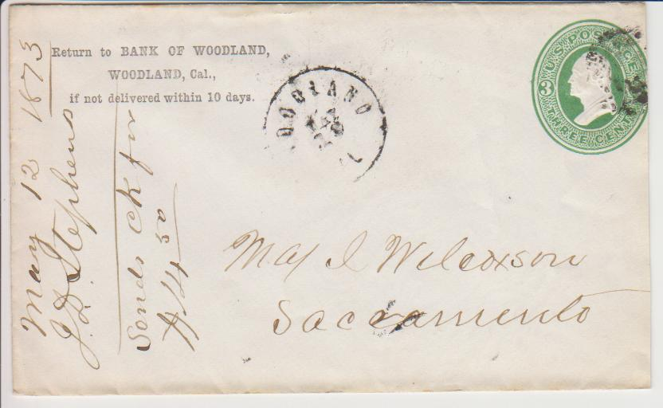

The Historic Woodland Depot Celebrates its 100th Birthday

The Historic Woodland Train Depot is 100 years old this year. It was built in 1911, and was the third of four train depots that were built in Woodland. It is the only one still remaining and is located at the corner of Lincoln Avenue and Sixth Street.

The Sacramento Valley Historical Railways, an all-volunteer non-profit organization based in Woodland, purchased the depot from the Southern Pacific Railroad and moved it to its present location in 1992. Since then, volunteers have spent thousands of hours restoring it for use as a community center, railroad museum, and event venue.

As a part of the depot’s birthday celebration SVHR has posted the Depot Diary, a day-to-day report by the Woodland Daily Democrat of the construction of the depot in 1911, on its website www.SVHR.org . If you would like to help plan the depot’s birthday celebration or give the depot a birthday present contact Mike Adams at SacValRR@gmail.com or call (530) 665-3541.

WINTERS CITIZEN OF THE YEAR

Joann Larkey was honored as the Winters Citizen of the Year for her work with Winters History including the Winters History Project.

ARBOR DAY – March 12 - Plant sale from 8 – 12 noon and the mansion will be open for tours 10 a.m. – 1 p.m. (coordinated by Donna at the Museum Office).

VISION STATEMENT
The Yolo County Historical Society
strives to preserve, protect, and
acknowledge the diverse history of
Yolo County through education,
communication and advocacy.

February 2011

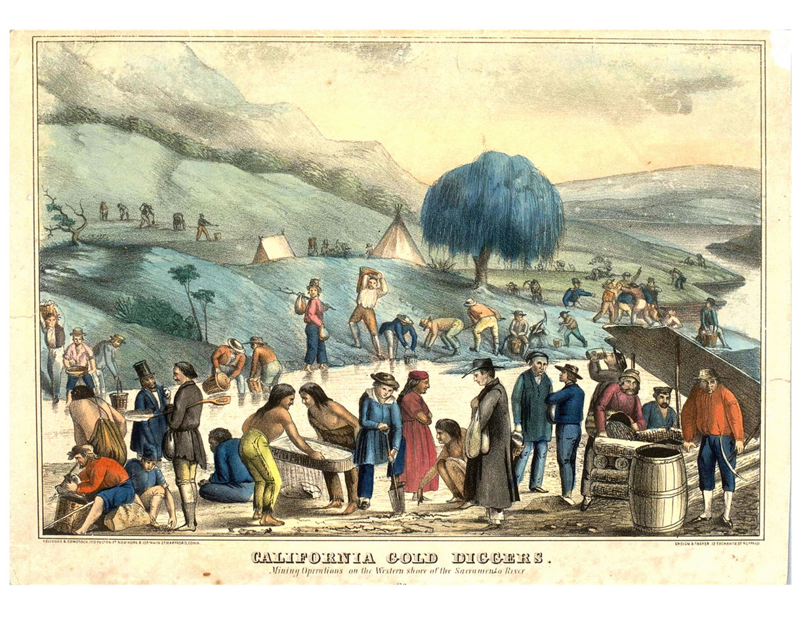

Ms. April Farhnam, local historian and former collections curator of the Maidu Indian Museum, will discuss her research on the history of the Native Patwin (Wintun) people who lived along the western edge of the Sacramento River at the Yolo County Historical Society meeting on Sunday, February 27. The Patwin and their ancestors established permanent villages and large mound sites in the vicinities of West Sacramento, Knights Landing, and other communities near the river. Archaeological and ethnographic records firmly document Patwin ties to this territory. In addition, they document a historical relationship between the Patwin and their tribal neighbors, the Nisenari Maidu, Konkow, Maidu, and Plains Miwok.

This presentation will touch on the prehistory of Yolo County as well as Native history up through the Gold Rush period. Discussion will also touch on early Native encounters/experiences with non-Indian explorers, settlers, and missionaries. Presentation will be accompanied by a slideshow that includes images of rare artifacts, historic photographs, and cultural material (e.g., basketry). Cultural arts and materials by Patwin/Wintun artisans will also be on display.

The presentation will take place at the West Sacramento Community Center at 1075 West Capitol Avenue, in West Sacramento.

All Yolo County Historical Society General Membership meetings are open to the public. The meeting will take place from 2 – 4 p.m.

