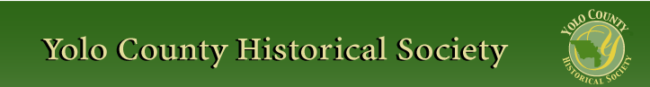

NOVEMBER 2013
PP 2012

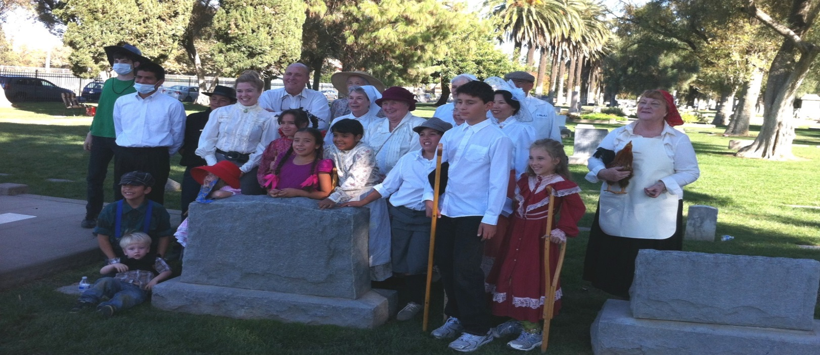

Pres Says:

Many, many thanks to the following people who helped make the Cemetery Tour a success…..our playwright, Chris Dreith, Cleve Baker, Dennis Dingemans, Bob Sommer, Carol Beckham, Karen Lafferty, David Flory, Ann Edmondson, Joyce Smuda, BJ Ford, Carol Rose, The Dingle History Club, (on crutches, doing cartwheels, and wearing flu masks), their sponsors, Rachael Zur and Robert Eckard, our Key Club students from Pioneer High School, and Reva Barzo. Also, thanks to Jim Smith, Daily Democrat for your publicity, David Stewart, City of Woodland in charge of the cemetery, Corner Drug for the wooden crutches, and Katie Kelsch, BSN,RN,PHN, and her crew who ran the flu shot station. YOU ARE ALL SUPER!!!! Now we can all stay healthy and begin to think about next year…….
Just a few notes to update the membership…The Board met in Winters in October and were able to visit the wonderful county library. This next month, we will be in Clarksburg visiting their library. All
are welcome to attend our Board meetings. If you know of someone there, please extend the invitation. The Board is reviewing the By Laws of the Society. We reviewed Numbers I,II,III,IV at the last meeting. My plan is to review a section of the Bylaws at each meeting. Our goal is to update them. We will also review the policies. The membership will get a copy of the By Laws/policies
in May for a membership vote and ratification in June.

Fall is a time where we see activity at the Spring Lake Schoolhouse. Students and teachers begin to make reservations for the Fall and the Spring. Martha Brashear and Marilyn Scholz are busy scheduling classes and arranging teachers to be the schoolmarms and schoolmasters. Teachers dust off their outfits and ready themselves to welcome the third grade students of our county. Because the Schoolhouse is an important part of who we are, this newsletter will focus on Spring Lake Schoolhouse and on our living history program. I’ve included a brief history of the Schoolhouse, for those of you who are new and would like some information. We are also including some student work (artifacts) that were given to some of our teachers. It is difficult to describe the pure joy that is derived from seeing the students interact with the curriculum of 1890’s as well as play the games of that same period. It is difficult for students to realize that students of the past had to be self sufficient and find ‘things’ to play with during recess. There was no playground equipment except a swing and only if the school was lucky enough to have a tree. Marbles, a simple game that could be carried in your pocket, no longer exists in schools. It is also difficult for them to realize that the teacher had tight control over the class. Students were expected to stand and bow or curtsey to the teacher when speaking. But the really fun part occurs during the county fair when the students bring their parents and siblings back to the schoolhouse and explain all about it. They become the guide and the parents and siblings listen attentively. It makes it all worth it; passing history and our heritage on to our youth. A big Thank You to our teachers who volunteer and those who coordinate the program. You are treasurers. Remember…..

History Rules!!
Kathy Harryman, President

Artifacts on loan from Gibson Museum

The collection committee at the Gibson Museum recently loaned the Springlake Schoolhouse a principal’s briefcase with a key donated by Sylvia Dilgard, and a folder with papers from 1913 from the Office of the County Superintendent of Schools. Being a retired teacher, I was very interested in the student evaluations that were used in the past. Since we are focusing on Spring Lake Schoolhouse in this issue, I thought it would be appropriate to share with you. We scanned in the copies of the original that were apparently used by the teachers and given to the Office of the County Superintendent. There is also a form that teachers filled out at the end of the school year. Finally there was an examination page distributed by the Secretary to the Yolo County Board of Education, May Dexter-Henshall. On this page the teacher graded the students in the following areas: Reading, Writing, Spelling, Grammar, Composition, Written Arithmetic, Mental Arithmetic, Geography, History, Physiology and Hygiene, Word Analysis, Literature, and Drawing. The following were the directions to the teacher: The teacher was given instructions to prepare examination questions with the approval of the principal. All promotions must be based on the passage of at least two exams plus a final at the end of the year. The average must equal 80 per cent. “Teachers should see that no pupil is promoted who is not prepared to do good work in the next higher grade.”

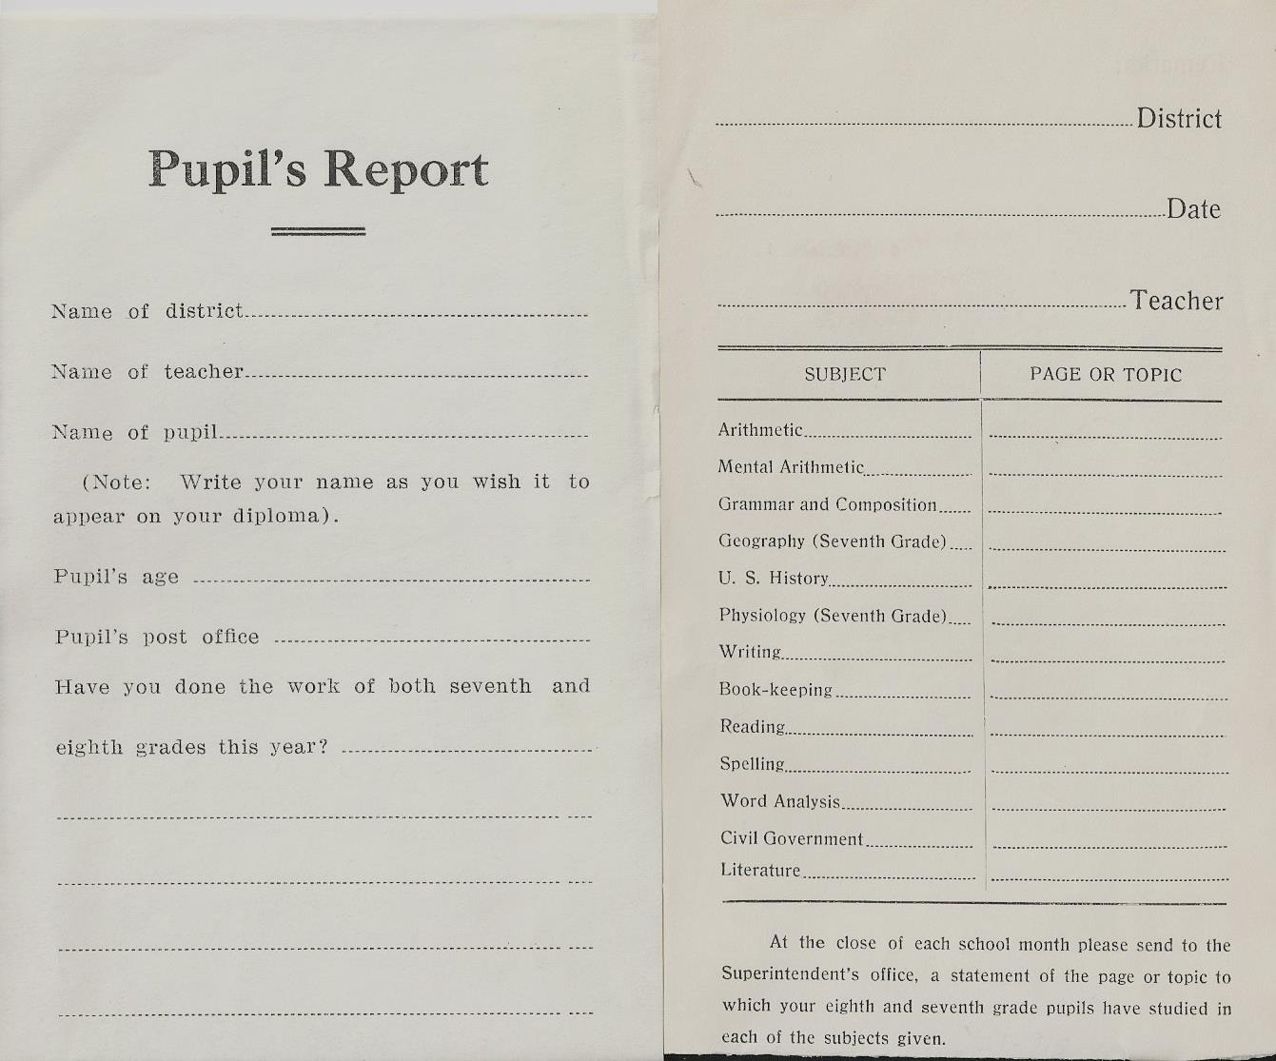

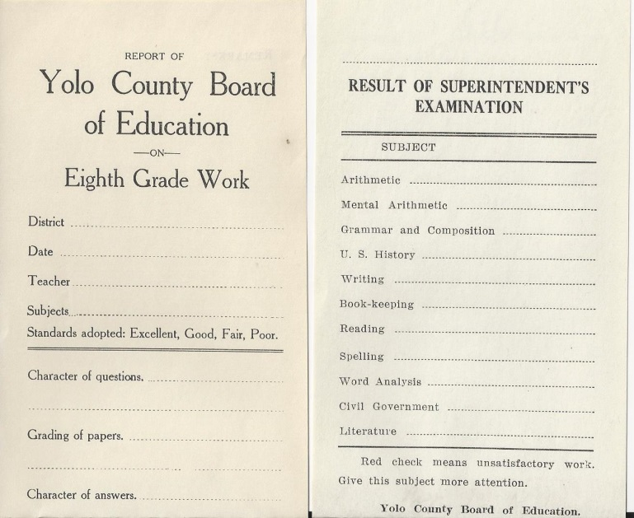

Just a brief note about Mrs. Mary Dexter-Henshall*. On November 8, 1910, Mrs. Henshall was elected as county superintendent of schools. She did not have an opponent. She was the nominee of the Republican, Democratic, Prohibition and Socialist parties and received the full voting strength of the county. During her term many forward steps have been taken, and Yolo county schools have attained a standing second to none in the state. She lengthened the school year to nine months, she shortened the course of study in elementary to eight years, she raised teachers’ salaries from $5 to $35 per month, enabling Yolo county to secure the best talent available. She merged school libraries with the county library….this work has been so successful that Yolo county is admitted to lead the state in this latest development of educational progress. She was responsible for Fillmore school district, new school houses in Pleasant Prairie, Fairfield and Union districts. She oversaw the new Woodland high school building, costing $90,000 and accommodating 300 pupils. She introduced manual training and domestic science into the public school curriculum and for the first time in the history of the county, an automobile has been used by the county superintendent for the purpose of visiting schools. She believed that the educational problem is the most important of all problems. *Source: “History of Yolo County California with Biographical Sketches of The Leading Men and Women of the County Who Have Been Identified With Its Growth and Development From the Early Days to the Present” pg 222-227 by Tom Gregory. Published by the Historic Record Company, 1913

YOLO COUNTY HISTORICAL SOCIETY
BOARD OF DIRECTORS 2013-2014
President Kathy Harryman 662-2189
Vice Pres Dennis Dingemans 753-5959
Secretary Bob Sommer 756-7553
Treasurer Reva Barzo 867-5800
Directors
Mary Aulman BJ Ford
Roberta Stevenson Enid Williams
Beth Wettergreen Joann Larkey
Jeannette Molson Al Plocher
Pat Campbell Dennis Dahlin

❖

Winters History Project
Learn how to preserve your family's old photographs and documents at a special workshop being planned by the Winters History Project Committee for Thursday, November 6 from 6-8 p.m. in the Community Room of the Winters Community Library, 708 Railroad Avenue. Current preservation techniques will be given by Meredith Sarmento, Yolo County's new Archivist.

❖

Hattie Happenings
By MaryLee Thomson

Hattie is Kid Friendly
The Hattie Weber Museum of Davis welcomes kids with reproductions of antique toys, group tours and special events during the year.
The “Kiddie Korner” was invented by Jim Becket to amuse kids while parents viewed the exhibits. Virginia Isaacs donated a child size table and chairs which had belonged to her granddaughter. Jim bought books, Tinker Toys, Lincoln logs, a dial telephone, rocking horse and a “Snoopy Sniffer” pull toy he had had as a child. Dennis Dingemans contributed some riding toys, a large rocking bear and a dog sized pony the volunteers dubbed Gunrock after the famous UC stallion. Mary Lee Thomson added teddy bears she dressed in knitted sweaters.
Snoopy is by far the most popular toy and often makes a good lesson in sharing. The volunteers have learned to keep an eye on him as he has headed home with kids on several occasions!
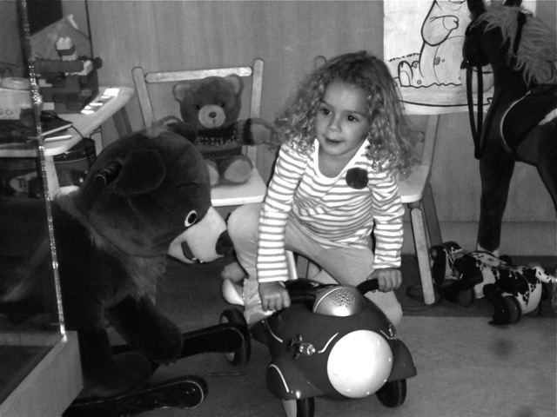

A number of kids regularly bring their parents to the Museum. One even drew a “thank you” picture which the volunteers proudly display. One parent has become so familiar with the exhibits that he serves as an adjunct docent during busy times on Saturdays while his daughter plays with the Tinker Toys.
Scout groups and third grade classes visit the Museum for special tours. Assistant Director Adrian Gabriel is especially adept at making Davis history come alive for them. The kids are also fascinated by Jim Becket’s account of his grandfather’s attendance at the very first Picnic Day. And, of course, all of the boys gravitate to the “Buffalo Gun” and the story of its discovery during a construction project. From the look in their eyes, there’s some post-visit digging going on in Davis.
Holidays attract kids to the Museum too. There are eggs (plastic ones filled with jellybeans) to find at Easter, pumpkins to decorate at Halloween and the traditional Christmas “goodie bags” replicating the bags of fruit and candy distributed to Davisville children at Christmas in 1898. Perhaps most popular, however, is Pig Day in March when the Museum joins the Farmers Market celebration by displaying ceramic, fabric, wooden, inert and mechanical pigs, most from the extensive collection of Senior Docent Roberta Stevenson.

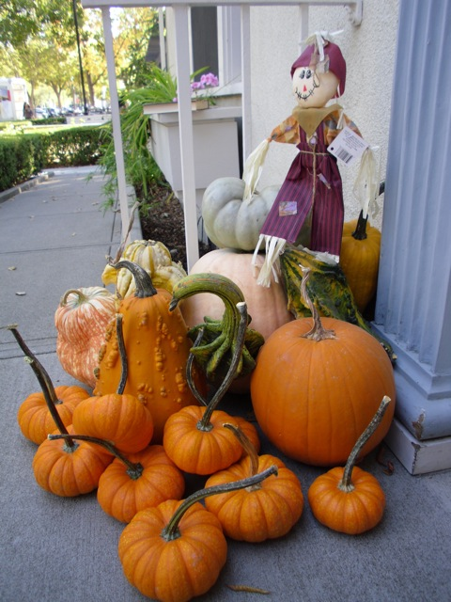

The Museum is located at 445 C Street in Davis and is open from 10am to 4pm on Wednesdays and Saturdays. Members are especially welcome. Don’t forget to bring a kid!

❖

History of Spring Lake School House*

Spring Lake Schoolhouse is a real one room country schoolhouse that was built in 1869, a mile east of the Yolo County Fairgrounds. The parents who farmed near Gibson Road and Country Road 101 wanted their children to learn to read and write, so they worked together to build this school themselves with donated lumber and materials.
The Schoolhouse has been moved two times when it finally landed in 1889 at present day 1585 East Gibson Road, the location of Willow Spring School (abandoned now).

In 1950 the Yolo County Historical Society campaigned to raise $350 to buy the building and move it to the Yolo County Fairgrounds, where you see it today.

In the first seventeen years of the school history, there were fifteen different teachers, four of them men. The teacher often lived with a student’s family, sometimes moving from one family to another during the year.

The Spring Lake Schoolhouse Museum is a Yolo County historical resource owned and operated by the Yolo County Historical Society. It is open during the Yolo County Fair held every year from Wednesday evening through Saturday in August.

During the fall and spring the schoolhouse hosts third grade classes from throughout the county for a living history experience. Over 20 retired teachers, both male and female, staff the schoolhouse using the curriculum from 1890 researched by Mrs. Marilyn Kraegel. Over 600 students visit the schoolhouse every year.

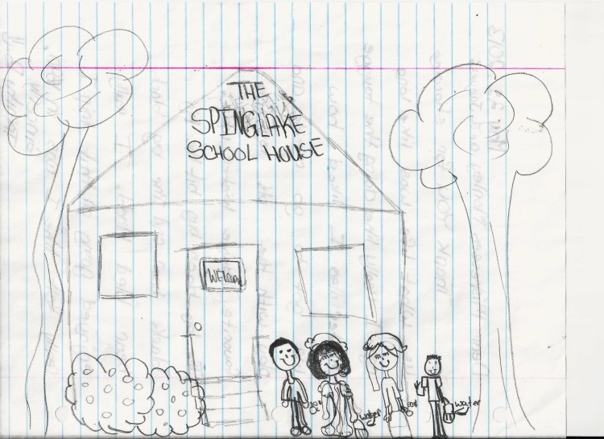

*Information taken from YCHS brochure “Spring Lake School Historic One Room Country Schoolhouse”
SCHOOLMARMS AND SCHOOLMASTERS

The following is a list of the retired teachers who have volunteered to become schoolmarms and schoolmasters for the Spring Lake Schoolhouse. These retired teachers have undergone a two day observation to prepare themselves for the experience. They then are paired with an experienced schoolmarm/master. These are the individuals who make our living history program happen: Martha Brashear, Marilyn Scholz, Joyce Sahara, Germaine Hupe, Frank Blakeman, Virginia Salley, Jackie Scott, Barbara Anderson, Donna Jaques, Cathy Fleming, Enid Williams, Pat Turner, Karen Lafferty, Donna Peoples, Peg Monley, Margaret Leahy, Kathy Cobb, Kathy Harryman, Karen Mercante, Connie Crandall, and Patty Honbo. We are always looking for more teachers to complement our list. If you would like to be part of this vibrant group, please call Marilyn Sholz at 662-0671.

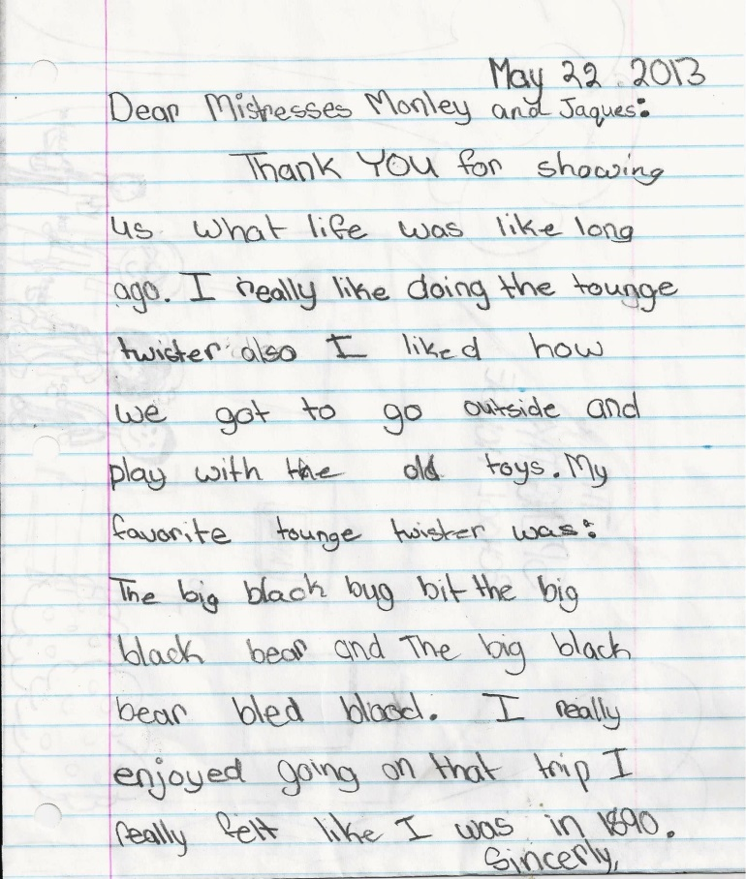

Dingle Elementary History Club
Submitted by Rachael Zur

I started the Dingle Elementary History Club about a year ago when I began to notice how many young people seemed unaware that they live in a town with such a rich history. I wanted the children to understand that they were growing up somewhere special, to help them cultivate a sense of preservation for the past and to also experience what an adventure learning about the history of things can be. All children seem to love a good story, and once they begin to see history as the story of what actually happened, they find that they have tapped into a fantastic source of entertainment. When the children learn what was going on in the hearts and minds of people in the past, it gives them a new framework for understanding how different events connect to each other; then they feel more invested in the outcomes of these historical events.
We don't follow a curriculum, since their teachers already give them a solid foundation in the classroom, and we don't worry about memorizing dates. Instead the children pick an area of interest and we dig to find out the how and the why of what people where doing in the past. Sometimes their interests lead us to learning about events that happened in Woodland, other times they want to reinvestigate something that they have already learned in the classroom with their teacher but on a more global scale.
With young children, it's important to keep things fun and interactive. Kids need to move around, so we take lots of walking field trips around town to enjoy the many architectural gems that make up Woodland. Historical reenactment is also a very useful tool for keeping their interest; it's one thing to talk with young children about the civil war and a completely different experience to first complete a puzzle of the United States and then take toy soldiers and place them on the map where the states were divided, (the kids just feel like they are playing and having fun while this is going on).
This fall students learned how to play games from the Victorian Era (graces, rolling hoop, marbles, etc.) and then taught other children how to play these games during the Stroll Through History this Fall. They also participated in the Cemetery Tour and learned a great deal about epidemics of the past (and gained a great deal of appreciation for the ease of living we enjoy today). Yolo County Historical Society has given the History Club copies of scripts from past Cemetery Tours which has been another useful tool; children love dressing up in Victorian clothes and acting out the lives of Woodlanders from the past. One script is about the life of Charles E. Dingle whom our school was named after-- this has been a fantastic tool for the children, not only in understanding why our school was named after Mr. Dingle, but also in that they have this wonderful man to look up to and role model themselves after.
I am deeply grateful to Yolo County Historical Society for allowing the Dingle Elementary Club students to participate in their events. Not only has this been so very valuable in teaching kids about Woodland History, but by participating in these events, the children can see that this love of learning about the past doesn't end once their years as students are behind them-- it can last a lifetime.

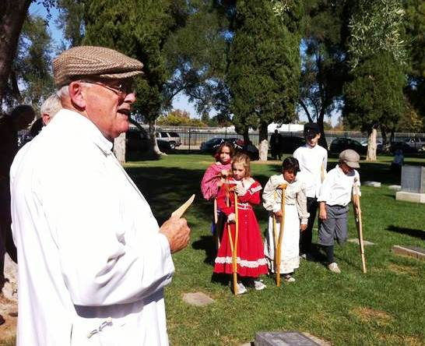

UPCOMING LECTURE

Our next lecture will be presented by our new Archivist, Meredith Sarmento on Sunday, November 24 at 2:00. We will meet at the Library Central Services Building at 226 Buckeye St. in Woodland. Meredith brings her enthusiasm and expertise to this county. I am very excited to have her.
7th Annual Gibson House Christmas Gala!
The Gibson House Christmas Gala will be held on Thursday, December 5th, from 6 - 9 p.m. at the historic Lowe-Hohenwarter home, 458 First Street, Woodland. It will be a festive holiday setting for the Gala!
The Gala will feature an auction of decorated trees, wreaths, centerpieces, ornaments and gift baskets created by local crafters and decorators. There will be holiday music, hors d'oeuvres and local wine poured by Route 3. It's a delightful way to kick off the holiday season and get a little shopping done as well.
Tickets for the Gala are $35/person. They can be purchased at The Gifted Penguin, 716A Main Street or at the Gibson House, 512 Gibson Road (open Tuesday - Friday from 10 a.m. to 4 p.m.; 666-1045), Woodland. You can also call Meg Stallard (666-0154) for tickets.
The Gibson House Museum is also known as the Yolo County Historical Museum. The mission of the museum is to preserve and protect the historical heritage and culture of Yolo County. Income from the Christmas celebration supports the museum’s programs. School tours for students from throughout the county are a key part of the museum's programming. Each year, more than 1200 students tour the house and grounds, learning about life in early Yolo County.

Meet your Board of Directors

My name is Kathy Harryman and I live in Woodland. I have been in Yolo County since 1975. I am a transplant from Hayward, in the Bay Area. I have been retired for 5 years. Time does fly! I taught at Holy Rosary School, Plainfield Elementary, Douglass Jr. High, and finished teaching only history to 10th graders at Woodland High School. I was trained in U.S. History, early Puritans fascinated me, and I taught California history, early U.S. History, late U.S. History and ended teaching World History. My favorite....all of it! I have been on the board for 5 years.

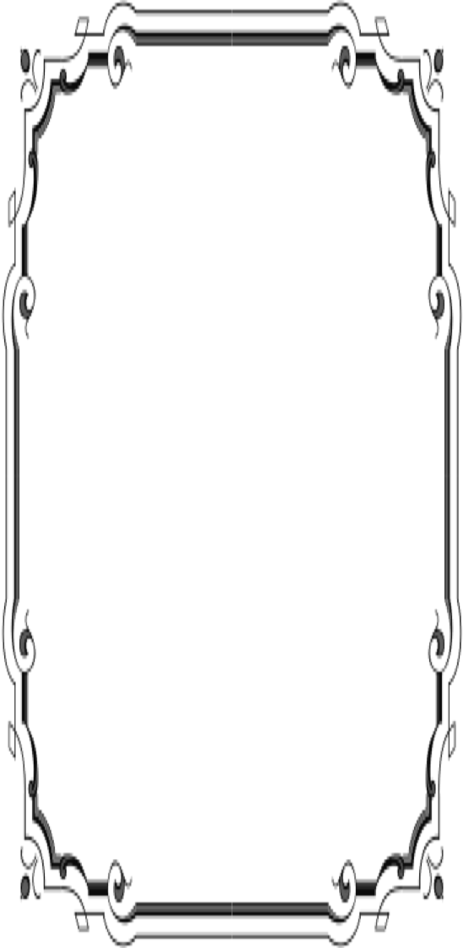
Patrons
Thanks to the following for generously supporting the Society for 2013-2014. You too can be a Patron by donating $100.00 to help us run our projects
- John and Helen Daniels
- John and Kathy Harryman
- Pamela Pearl
- Frank and Virginia
Schwarzgruber
- Stella Dinger
- Robert and Lynn Campbell
- Leroy & BJ Ford
- Jon & Barbara Durst
- Dennis Dingemans & Robin Datel
- Jeff & Starr Barrow
- Donald & Pat
Campbell
- Albert & Lynn Plocher

Yolo County Historical Society
P O Box 1447
Woodland, CA 95776

Address Service Requested

Dated Material

CHRISTMAS GIFTS!!!

If you are buying gifts for someone who has everything, then you might want to consider giving a gift that lasts forever. We have many history books that are for sale. They make a great gift for someone who is new to Yolo County, someone who has returned to the county, or someone that you might want to say ‘ThankYou”. The prices range from $15.00-$25.00. We have books for all of the major towns in the county. If you are interested in purchasing books for gifts, please give Mary Aulman a call. 666-0743

❖

We found a house for our wonderful California History magazines that we receive 4 times per year. They are wonderful publications full of interesting information about California . They will now be housed at the Hatti Webber Museum in Davis . If you would like to look through them, the museum is open on Wednesdays and Saturdays. Call them.

Vision Statement The Yolo County Historical Society strives to preserve, protect and acknowledge
the diverse history of Yolo County through education, communication and advocacy

