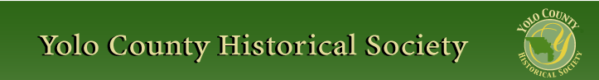

October 2015

PP 2012

Pres Says:

For those of you who missed our first meeting at the Reiff/Pollock Ranch, you missed a great presentation. The day was cool and wonderful. We sat under the spreading trees on the Pollock lawn and Dennis Dingesmans shared a great presentation on the history of Wells Fargo and the stage stops they erected throughout California. The presentation was more special because the research was done by Turpentine Jackson, a history professor at UC Davis and an official historian of Wells Fargo. We then toured the Wells Fargo Stage Stop and Herb and Lynell showed several wagons from the Gibson Museum. We had approximately 40 people and several individuals expressed interest in joining the group. Thank you again Herb and Lynell for sharing your ranch with us.

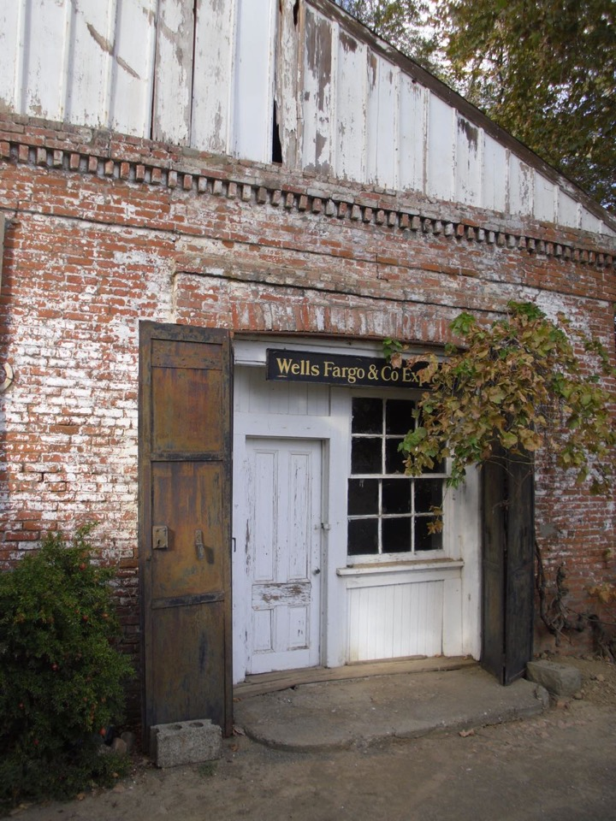

Our next outing will be on Thursday, November 19 from 1-3:00 in the town of Yolo. We will visit the Blacksmith Shop and be treated to one of the few 100 year plus operating blacksmiths left in California. This is a treat for all of us because the building is an actual time line of history. It is not too often that we can actually see a timeline. Please make it a point to come. We will have chairs there, but if you could put a few chairs in your car, that would be great. …just in case we need them.

Our schoolhouse is in operation for the Fall term. We have several new teachers who are in training and will go to work in the spring. ….Kathy Godding and Sue Johnson. Thank you ladies. On Tuesday, I was a school marm for a class from Zamora Elementary School. I played Dominoes with one of the students. She beat me twice! She looked at me with a giant smile on her face and said “This is the best field trip I will ever go on!” I thought to myself…Wow! This is the impact we have when we support our living history program at the School House.

Along the same vein….As many of you know we have many books on the History of Woodland. The Board has agonized over what to do with all of them. Several suggestions have been made and followed. One suggestion surrounded donating books to each of the schools in the county, both public and private. We feel that this is a great way to spread county history and perhaps the format might encourage students to write their own city histories. Who knows! We will be working with the County Office of Education in distributing the books to each of the schools throughout Yolo County.

Remember, History Rules!
Kathy Harryman

❖
Selections from Turrentine Jackson’s essay “Wells Fargo: Symbol of the Wild West” (Western Historical Quarterly, V. 3, April 1972, pp. 179-196.
Preliminary note. This is a condensation of the last of Professor Jackson’s dozen scholarly works on the history of Wells Fargo. It provides context to the YCHS field trip in October to the Express Office operated from 1861 to 1872 on the rural property owned successively by the William Gaston Hunt, the Jane and Paul Reiff, and the Lynnel and Herb Pollock families who valued the building’s historic significance. Note especially that the concluding paragraphs reveal Jackson’s perceived need to defend the seriousness of his work to his skeptical colleagues during an era when a first run movie (Wells Fargo, 1937), a prime time television show (Tales of Wells Fargo, 1957-1962), and a hit Broadway song (The Wells Fargo Wagon, 1957) suggested that Wells Fargo was a popular culture fad.
During the gold rush, banking was unsupervised and when Wells, Fargo & Co. appeared on the scene in 1852, fourteen firms and individuals were doing banking business, but no less than a dozen others, despite the gold flowing from the foothills and the resultant boom, had already found the going rough and had withdrawn, failed or sold out to others.. . . Henry Wells journeyed to California to assess the situation. Wells liked what he saw, became enthusiastic about the firm’s prospects and strongly endorsed the recommendations of the company’s local agents who had repeatedly begged for more resources to expand banking activities and trading for gold.
From San Francisco and gateway trading centers in the Central Valley, express service was launched, and pony riders fanned out over diverse trails to the mining camps delivering packages and mails and bringing the gold dust to the cities. From the beginning an aura of romance was associated with the name of Wells Fargo, combining the excitement of man’s successful search for gold with the symbol of the daring rider on horseback. Wells Fargo (also) established agencies on main street in numerous towns.
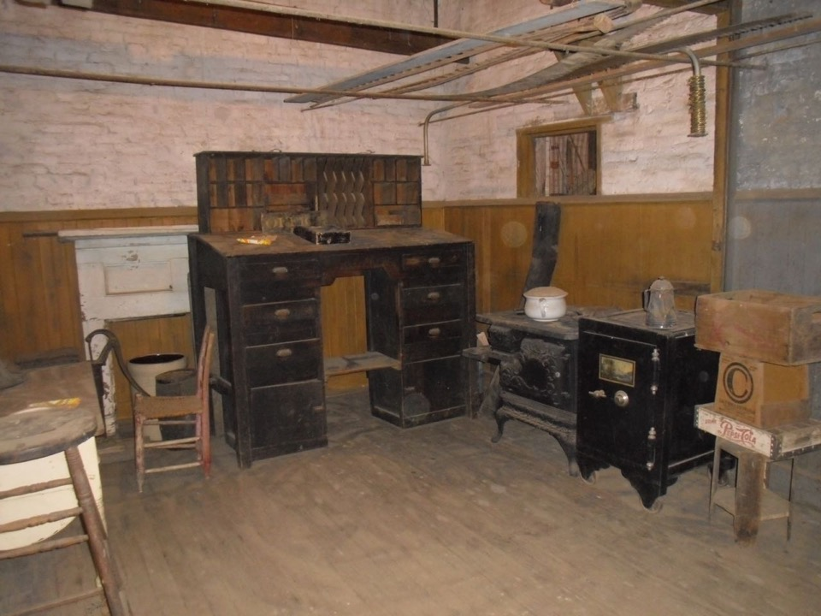
There were occasional accidents in the extensive traffic by pony, wagon, stage, and steamer that caused excitement and received abundant publicity. Far more important in establishing Wells Fargo as a symbol of the Wild West were the activities of thieves and knights of the road. Express offices as well as stages were vulnerable to attack. One night as the agent in Sonora was retiring to bed, he heard a noise in the back room. He took a light and examined the room closely. Under the bed he saw a man with an ax by his side. The desperado crawled out and escaped. Later, the editor of the Stockton Argus suggested “perhaps the fellow intended to ax Canfield for his money.”
In 1865 as the stage from Helena to Boise passed through Port Neuf Canyon, seven highwaymen sprang out of the thick brush and demanded that the driver stop. Passengers made the mistake of firing pistols and the robbers responded with volleys of buckshot. Two men fell dead as they jumped from the stage. A third was dragged down by the hair and shot. He lived only a few minutes. The driver was mortally wounded. One passenger successfully hid. Another played dead, let the robbers kick his prostrate form, and survived.
The period of highway robbery is symbolized by the career of Black Bart who struck the Wells Fargo express box twenty-nine times between 1875 and 1883. Is there any wonder that Wells Fargo & Co. found it necessary to establish its own detective bureau and employ James B. Hume to head it in 1872?
The men who worked for Wells, Fargo & Co. endured physical hardship in the continuous struggle of man against nature which was a part of the frontier experience. Crossing the Sierra Nevada was particularly difficult during winter. Heroic events in the Sierra Nevada were duplicated in the Wasatch and the Rocky Mountains. In December 1868 a Wells Fargo driver abandoned his stage at Fort Bridger and hitched his horses to a bobsled in hopes of making it through the snow to Muddy Station. A search party found him almost frozen and later both his feet were amputated.
In 1866 two boxes in San Francisco newly arrived from New York apeared to be damaged and leaking. A Wells Fargo porter was attempting to open them when a mighty explosion occurred. The leaking liquid was nitroglycerin.
Indians did attack the stagecoaches, burn the way stations, disrupt the mails, and harass the passengers. The United States cavalry rode to the rescue and often punished the red men mercilessly if circumstances permitted. Just as Wells Fargo was a symbol of the Wild West to the white man, the company’s stagecoaches were symbols of westward expansion and cultural disruption to the Indians. In 1867 in eastern Colorado thirty Indians concealed behind an old deserted station opened fire. The stage driver fell to the ground and was scalped on the spot. His body was found riddled with bullets and arrows.
Events such as these established the image of Wells Fargo in the wild and romantic West – a West of easy wealth and in a hurry; of rugged manhood and the dangerous life; of lawlessness; treacherous bloodthirsty Indians; and the vengeful, ever-ready U.S. cavalry.
There is a less sensational but equally important side of the Wells Fargo story. The businessmen associated with the company proved themselves adept in building and managing a large-scale organization under conditions of rapid growth and change. Wells Fargo executives understood the logic of working out agreements and contracts with other companies to use each other’s lines rather than push through overlapping services. The value of cooperation was made evident when four express companies established the Overland Mail Company in 1857. The device of creating subsidiary firms was utilized by Wells Fargo very early. The climax in Wells Fargo’s empire in delivering mails, express, and passengers came in 1866 with the “grand consolidation” taking over the Great Overland Mail Route.
Wells Fargo, aware of the importance of public relations, followed the practice of gathering up the newspapers along it routes and delivering them free of charge to editors elsewhere.
The company grew rapidly with offices increasing in every decade, from 436 in 1871, reaching 3,500 at the turn of the century. By 1884 Wells Fargo’s express was being carried on twelve railroads.. . .
Thus, Wells, Fargo & Co.’s history is an integral chapter in any study of pre-railroad transportation, of the United States mails and the post office, of the railway express, of banking, and the economic history of the United States. Investigations of any segments of the firm’s growth will throw revealing light on the development of natural resources and the spread of population, the growth of commerce and industry, the evolution of business organizations and methods, successful and unsuccessful management patterns, the relationship between business and government, law and order, legislation and regulation, as well as the ethics, ideals, and philosophies that were the motivating spirit in any decade.
The Wells Fargo story also illustrates the bifurcation in the history of the American West that has plagued some and challenged other historians of my generation. We have felt called upon to apologize for the popularity of our field among historical buffs, the television audience, segments of the business community, and students in colleges and universities. We have strived mightily at the same time to convince our colleagues and ourselves that the western saga is a part of the sacred mainstream of U. S. history. Even the Wild West did not exist in a regional vacuum. If life was hard reality for those who lived through it, it was often the stuff dreams were made of for those who lived in the staid parts of the East. On a psychological as well as on an economic level, western history, as symbolized by Wells, Fargo & Co., was a part of the national experience.
❖

Business Buddies

The following businesses in town have financially supported the Yolo County Historical Society. We would like you to support them and keep your money local:

L & S Printers, Main St.
The House Dresser, Main St.
The Gifted Penguin, Main St.
Corner Drug, Main St.
Dahlin & Essex Inc.
Chamberlain Farms
Bill Marble
Michele Giguiere
Bernard & Lynn Gough
Larry Shapiro

If you know of any business that would like to join our support list, contact me. Businesses pay $50.00 per year for advertising.

❖

School House Memories
By Kathy Harryman

I thought it might be fun to share a publication that I found in the Spring Lake Schoolhouse when I was there as a school marm. It was fascinating to see what resources were available to teachers in the past. Rather than reprint all of the articles, I thought I would print the titles and maybe a few words of wisdom.

The paper book is entitled Normal Instructor and Primary Plans (For Teachers of All the Grades and Rural Schools). It was published in January of 1926 and sold for 25 cents per copy. The front page had a colored reproduction of “All’s Well” by Winslow Homer with the text on page 42. “The number of copies of this issue printed is in excess of 170,000”. The book size is about 11.5 x 14 inches with a total of 80 pages.

The Normal Instructor was first published in 1891. The Primary Plans were added in 1903 and the two journals were consolidated in 1914. It was published in Dansville, New York by the F.A. Owen Publishing Company.

The first several pages are filled with ads selling resources to teachers: maps, flags, song books, inexpensive books for reading, and items such as The Talkamine, a bamboo handle tooth brush. There were also ads for other jobs. Uncle Sam tried to entice individuals with a job as a Railway Clerk earning $1900 to $2700 per year. What a deal!

Then there were the traditional programs to purchase to assure instant success. You could “purchase techniques to learn any instrument in a few months with this delightful new easy way,” presented by the U.S. School of Music in New York, “with instruments supplied as needed , cash or credit.” You could also “learn to speak French the way the French speak it, with Hugo’s Famous ‘French At Sight Lessons’. You could also purchase “Complete Guide to Dressmaking for the Teacher and the Woman who Sews”, using the Mary Brooks Picken Method of Modern Dressmaking.

On page 21, the actual lessons begin. On the first page was a picture of Benjamin Franklin and a paragraph on the topic of “Thrift” by A. H. Chamberlain. This is worthy of reprinting…..

“Thrift is that habit or characteristic that prompts one to work for what he gets; to earn what is paid him; to invest a part of his earnings; to spend wisely and well; to save but not hoard. To be thrifty means not merely the proper making and saving and investing and spending of money. It means also the proper use of time and talents; the observing of the common laws of health and hygiene; the practice of moral and social virtues. It means the needed conservation of all natural resources. In a word thrift is use without waste.”

Then the lessons begin with the first article dealing with The Progressive Movement in Education. After that article, there are January window decorations, examples of school menus, full page instructions on Designs for Collars and Cuffs, Designs for Bird Feeding

❖

Thanks to the following for generously supporting the Society …………. You too can be a Patron by donating $100.00 to help us run our projects

2015-2016 Patrons

- Robert & Lynn Campbell
- Donald & Pat Campbell
- John & Helen Daniels
- Jonathan & Barbara Durst
- Robert & Judy Simas
- Ron & Marilyn Scholz
- David & Ann Scheuring
- Claire Childers
- Jeff & Starr Barrow
- Michael & Debra Truitt
- Alphe Springer
- Steve & Teri Laugenour
- Richard & Joann Larkey
- Ramon & Karen Urbano
- Thomas Crisp
- Ryan Baum & Alice Wong
- Richard & Evelyne Rominger
- Lynn & Penn Wilen
- Steve & Lydia Venables
- Cleve Baker
- Louis & Jane Niehues
- Charles & Claudia Owens
- Marilyn Kregel
- John & Kathy Harryman
- Roger & Ann Romani
- Patricia Nickell
- Jim & Wilda Shock
❖

Stories from Dingle Elementary School History Club

Woodland Opera House, For You and Me
By Jenna Eckard

The preservation of the Woodland Opera House has helped shape me into the outgoing and more confident person that I am now, giving me the opportunity to be part of theater as both a performer and as part of the audience. If the Woodland Opera house had not been preserved and rebuilt after the fire of 1892, I might not have found out about quite a few things that are very important to me. These things are: that I love to act, to watch how everyone works together as a team in theater, and to watch performances. Since I was in kindergarten, I have seen plays at the Woodland Opera House, and it has become very special to me, even now as a sixth grader. When I look back on my childhood in Woodland, I can see that the Woodland Opera House has been a very positive and exiting part of my life; I know that many of my classmates feel the same way about this place that has impacted their childhood.

Even before my classmates, my teachers, or I were born, people have been going to see plays at the Woodland Opera House, as it was a center of attraction in the late 1800s. Today the Woodland Opera House is still a center of attraction. I enjoy walking to the Opera House to see plays with my classmates. I have also walked to the Opera House with the History Club that I have been a member of for the last three years. The History Club gets to tour this historical building and learn more about its history. One time my family and I went to see the play Mary Poppins, because one of our friends was in that play. The Opera House has featured singing groups, actors, and musicians, and if you look around during a performance, you can see that people of all ages are enjoying themselves.

When I participated in Show Biz Kids in the summer before 6th grade, I got to see how everyone worked together to make a good show. (Show Biz Kids is a way for kids to get involved in the Woodland Opera House.) After that, I noticed that it takes team effort to do amazing things. For example, after the first Woodland Opera House burnt down in 1892, it was a public effort to build the second Woodland Opera House and keep it in good condition. Something that I noticed is that the Woodland Opera House is still running because the people of Woodland are working together as a team to keep it running, just like actors have to work together in a play. When my classmates and I grow up, it will be our turn to be part of the team that keeps Woodland Opera house running, so that children in years to come can have the thrill of acting and the joy of local theater.

Even though the second Woodland Opera House is not as fancy as the first, it is still very important to Woodland. Not only has it been used for shows, but also for political gatherings, lectures, community affairs, religious gatherings, and school affairs. Woodland Opera House was made a state park in 1989. Another thing that makes the Woodland Opera House special is that it is a historical building and a historical landmark. So, the Woodland Opera House is important to me and the community, because it a center of attraction for the people of Woodland, one of Woodland’s many historical buildings, and a place for the community to participate. The preservation of the Woodland Opera House is not only important for understanding our past, but also it is an important part of our community’s future.

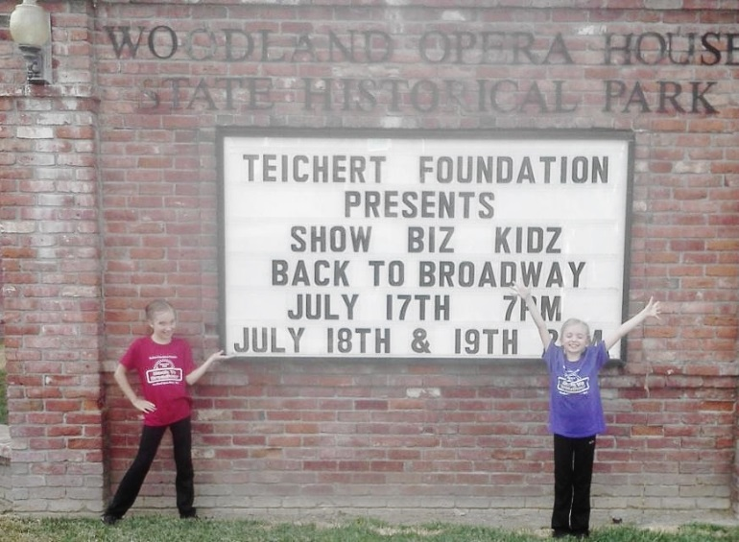

❖

My Life As A Victorian Child
By Nathaniel Murphy

In my experience of getting ready for Stroll Through History (at Dingle Elementary’s Hands on History for Kids) and Cemetery Tour, the complicated part was trying to act and think about stuff as if I were a Victorian child. I have participated three times in Stroll Through History and two times for Cemetery Tour, and after each one, I feel as if I learned more and more about the Victorian era. I feel that the first time you do Stroll can be embarrassing because of your costume, but at the end of the day you feel proud of yourself for sharing Woodland and Dingle Elementary School’s history of how children would act and behave in the Victorian era.

I have been in History Club for over three years now and I am extremely proud of that. Every fall, other History Club students and I get our costumes ready. Some History Club students have their parents make their costume, go to stores and buy them, let them borrow clothes they have, etc. I got my suspenders at Party City, my mom let me borrow her newsboy hat, and I looked for a button down shirt and perfect jeans. It is fun to put on your costume but I think that it would be uncomfortable to wear that style of clothes every day. It’s really not that hard to look like a Victorian child.

The hard part for me is getting into character because of how hard their life was and how different it was from life today. In the Victorian era, the rich kids had nannies and the nanny would teach the kids manners, words, and pretty much raise the child. Rich kids would not see their parents often because their parents were too busy entertaining people and it wasn’t normal for rich adults to raise their kids. For poor children, life was better in some ways and worse in some ways. The way that it was better was that they got to see their parents a lot unlike the rich kids, but the worse way was that they had to get real jobs such as chimney sweep, sell newspaper, work on a farm, and work in a factory. This made me sad thinking about it because the kids could have gotten hurt and some did. What was even worse was that some children had to get jobs when they were four years old.
Comparing my life to a Victorian child’s life, I can see that we have very different lives. One way our lives are different is that we get to see our parents a lot and we don’t have to work in a factory. Another way our lives are different is that we have phones, tablets, computers, television, and comfortable clothing. It’s fun to act like a Victorian child for three hours but not to stay like one for the rest of your life. Learning about what happened and how people acted back then is fun because you get to be someone else for a little while and see what it was like and appreciate how our lives are today.

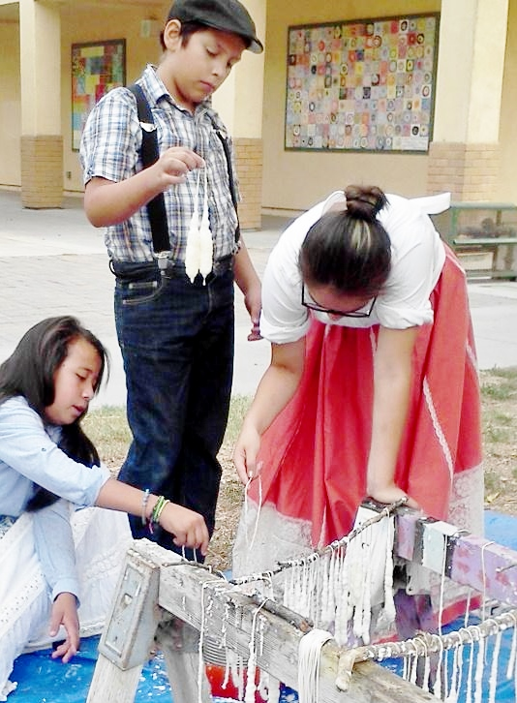

❖

Next Lecture

Medicine throughout History
When: Sunday, November 29
Time: 2:00 pm
Sierra Sacramento Museum of Medical History
Where: 5380 Elvas Ave. Sacramento 95819

Yolo County Historical Society
P O Box 1447
Woodland, CA 95776

Address Service Requested

Dated Material

Vision Statement The Yolo County Historical Society strives to preserve, protect and acknowledge
the diverse history of Yolo County through education, communication and advocacy

