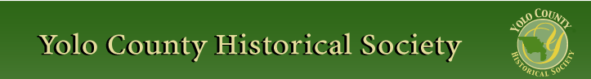

JANUARY 2015

PP 2012

Pres Says:

Wow….Here it is 2015….One hundred years ago, Europe was fighting the “War to End All Wars”. The United States would remain on the sidelines until 1917. Ducks were being shipped out of Clarksburg to San Francisco, probably to feed the large Chinese population in Chinatown. Do things really change? We are still on the sidelines while Eastern Europe is fighting a war and duck hunting still exists for sport and food.

Our society’s new year has already begun. On Sunday, January 25, we will have a presentation by our own Elaine Hermle on the community of Zamora. We will meet at St. Agnes Catholic Church at 2:00 in Zamora. I am looking forward to this historical look at this unique community. Come and bring a friend.

We are also looking forward to the start of the renovation of the WPA building in Davis. It has been a year since this renovation has been in the works. I want to thank the members of the Hatti Weber Museum, especially Dennis Dingemans, our Vice President, for taking the ‘ball’ and running with it. Your persistence is awesome. We should nickname you “The Frank Gore” of the Yolo County Historical Society. (I had to ask my husband to give me a name!)

Fair time is coming….I know it’s only January, but look how quickly January came. This year we are going to do a few different activities in the school house. A few of our school marms are going to give a mini-lesson to fairgoers. We are hoping to generate interest in the museum as well as all the projects we do in the Society. I think it will be an exciting addition to the schoolhouse.

I have been approached by Betsy Monroe about saving the schoolhouse in the Capay Valley.
Wouldn’t it be great to have a schoolhouse there? Just think …. The students in the valley could participate in their own living history program. I have already offered her our help in planning curriculum. More about that later.

I am still looking for dedications to World War I soldiers from Yolo County. If you know of any plaque, monument, statue, etc., please let me know….January is my serious investigation month!

Just a note---Jeannette Molson, our expert historian, needs all our good thoughts. She has been in and out of the hospital for about 2 months. Let’s give her our positive thoughts.

Remember, History Rules!

Kathy Harryman
❖

Business Buddies

The following businesses in town have financially supported the Yolo County Historical Society. We would like you to support them and keep your money local:

L & S Printers, Main St.
The House Dresser, Main St.
The Gifted Penguin, Main St.
Corner Drug, Main St.
Dennis Dahlin
Zamora Hills Ranch
Richard Berteaux
Historic Woodland Downtown
Business Association
The Home Improvement Group

If you know of any business that would like to join our support list, contact me. Businesses pay $50.00 per year for advertising.

❖

Hattie Happenings: Say Hello Dolly at the Museum

The new exhibit at the Hattie Weber Museum features dolls from many countries and eras. There are 19th century beauties with small heads and elaborately embroidered underwear, a “Toni” doll from the 50’s, a Native American crafted doll from Arizona, a 1944 lovely from France during WWII and a modern Russian lass among others.

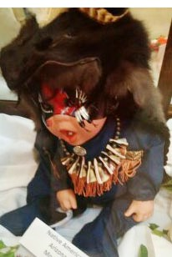

Also on display are panels showing the history of Central Park, several cases of quilted, crocheted, knitted and embroidered heirlooms, and a selection of the Museum’s collection of books showing how they are used to educate, entertain, record etc. There’s even a new camel toy auditioning in the toy corner.

In the works is a set of maps showing the locations and dates of subdivisions since Davis was incorporated in 1917. Visitors will be asked to mark their residences with a pin. This exhibit will be followed by one featuring some Davis neighborhood information compiled by residents in various areas of the city.

The Museum is located at 445 C Street in Central Park. It is open Wednesdays and Saturdays from 10am to 4pm. There is no admission charge; donations to the fund to restore and repurpose the next door WPA building are welcomed.

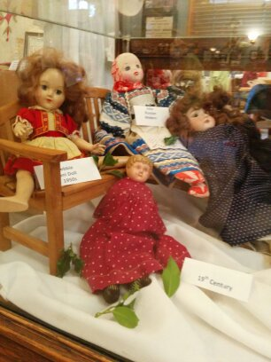

❖

Spotlighting………Clarksburg
Second in the Series

How many new ideas come and go? Here is a new idea -----again!!!

Clarksburg was once a sleepy spot in the Sacramento River that was a favorite hunting spot for duck hunters. The grizzly bear and elk that once roamed there in the 1860’s had all but disappeared. The ten mile stretch of land along the river was filled with tules, sometimes
reaching 7-8 feet tall. By 1915, 20,000 ducks were shipped to San Francisco in gunny sacks. Farming in Clarksburg was limited and only occurred on the higher ground. Flooding was always a major concern. The Chinese immigrants who came to California to mine for gold and later worked on the railroads were the first group of individuals to reclaim the land. They brought their expertise from their native land in China. They were hired to reclaim the land using only hand tools and horse drawn scrapers to build the levees. But that was tedious and very labor intensive. Around 1875, the clam shell dredge was invented and began to be widely used to reclaim the land.

In 1911, The Netherlands Farms Company bought the land and began to reclaim it. In 1913, the state legislature created Reclamation District 999, or the

Holland District. By 1918, the area consisted of 35 miles of levees, 150 miles of canals, 75 miles of graded roads and 100 bridges. There was one pumping plant with 18 subsidiary pumps where excess water was drained into the low lying areas including Elkhorn Slough and the Yolo Bypass. The total cost of this project was $2,500,000.

The Holland Land Company later acquired the land and assumed the debts of the Netherlands Farms Company. They were now ready to make money. Their goal was to establish “a model farming area, taking into consideration the agricultural abilities and stability of the prospective buyer.”* According to our local historian, Shipley Walters, the company sought to attract university-educated, experienced farmers who would farm their own land and contribute to community life. Therefore, many families associated with the University of California, Davis (then the University Farm) settled in Clarksburg.**

According to an advertisement, the company does not desire to sell to the inexperienced farmers, nor should the unprogressive or poor farmers apply for a site….there are rigid restrictions designed to protect the good farmer and desirable citizen who wants shade trees, painted buildings, proper sanitary conditions and who desires to see the district kept free from destructive factions and hang back pessimists and who does not want to be menaced by his neighbors’ weeds or carelessly started grain fires.” ***

Land was sold for $250-350 per acre with the largest holding 1000 acres. There were no foreclosures. The buyers put 10% down and had 10 years to pay. The Holland Land Company gave land to the community for a park, church and school. They were serious about their commitment to the community.
Today, Clarksburg remains unspoiled with beautiful landscapes, country roads and a sense of rural life of yesteryear. Although agriculture remains the focus, it has become popular as a premier wine growing area with 12 wineries.
So, a new idea???? Or is it an old idea that has been adapted to fit the circumstances?

*McGowan, II, pg. 177-78
** http://socialarchive.iath.virginia.edu/xtf/view?docId=holland-land-company-calif-cr.xml
***Yolo in Word and Picture, 1920

❖

Looking for an old article published in the newsletter or upcoming events? Check it out on our website. www.yolo.net/ychs
There is also a list of publications available and information on how to become a member or patron.

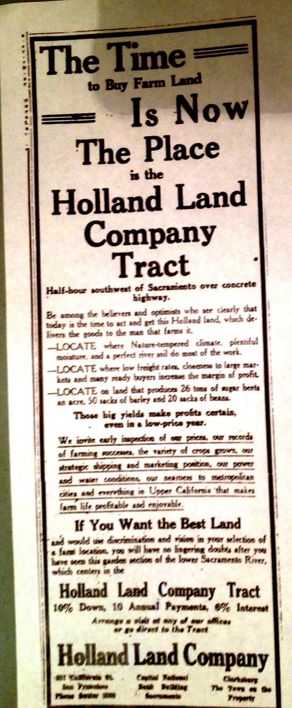

“A Run Around the Block” by Veta Griggs
Contributed by Mary Aulman

This Christmas I received a gift that everyone would enjoy. The book “A Run Around the Block” has been mentioned in previous newsletters, and my husband ordered a copy for me from Amazon.

The author, a niece of the Gable family, grew up across the street from her relative’s home, the Gable Mansion. She has many stories about 1890’s Woodland. She watched in horror from the upstairs window of a “two story house on College St” as the owners dog thoroughly licked the silver bowl full of ice cream that a maid had brought out for a birthday party. Not knowing what she should do, she said nothing, and sat at the table nibbling on birthday cake and trying not to throw up as all her fellow party goers ate the ice cream.

Another of her College Street stories concerned “the only windmill in town” in the back yard of a College Street home. She loved to hear it clank when the wind blew, but it turned out the windmill was a fake. It was attached to the city waterpipes and tapping city wells. An indignant city council made the owner pay the rates for back years.

She attended many plays at the Opera House, where the “gallery gods” in the cheapest seats, kicked the balcony rail and shouted “get the hook” at any actor they didn’t like. And her own little sister, upset over a fight onstage, leapt up on her seat and shouted “I want to go home”.

Props for plays were scarce back then, and a red Victorian sofa and two chairs turned up in almost every play. One night they furnished an imperial palace in “A Russian Intrigue” and the next night they could be seen in the parlor of “East Lynde”. And any stock company presenting “Hamlet” (a very popular play) had to bring their own skull for the famous soliloquy.

In the early 1900’s front yard fences in Woodland had become unfashionable and most people took them out. Green lawns were the style, and flower beds retreated to back yards that were still fenced. But spending time outside had its drawbacks, especially in a time when almost everyone had a horse and stable. Flies were everywhere, and the author was very proud of her swatting skills. She was shocked when a visitor from Berkeley, instead of praising her, asked her mother “For God’s sake, why don’t you get some fly paper?”

Veta Griggs book is full of these little stories, and once I started reading it, it was hard to put down. The full title of her book is “A Run Around the Block, A Victorian Idyl” and she brings Victorian era Woodland alive, with a population of 2500 people all going about their busy, and often very funny, lives.

New Year’s Wishes

Beginning a new year always brings thoughts of starting over...whether that be that age old wish to diet, save money, get organized or a myriad of other wishes that will change our lives and make them better. This year brings wishes for the Society too. One wish is to work on our fair presentation at the Springlake Schoolhouse in August. Thanks to Tom Chrisp who has come in and catalogued all our photos in the cabinet, we now have an accurate accounting of all the items. We are in the process of giving them to the Yolo County Archives so they will be available to all the residents of Yolo County as well as anyone who is doing research. We now need to choose some of the items to use in a power point presentation during the fair. I am looking for someone who will work with me to put together the presentation of all the schoolhouses and the students who attended classes there. I think it will be an exciting way for adults and students alike, to see what school life was like in Yolo County.
The second item I would like to work on is redoing our plaque brochure to include mileage

for our growing bicycle population. If you are a bicyclist and would like to help, please let me know. My number is 662-2189 or khwoodland@aol.com

❖

Thanks to the following for generously supporting the Society…………. You too can be a Patron by donating $100.00 to help us run our projects

2014-2015 Patrons

- Jeff & Starr Barrow
- Alice Wong & Ryan Baum
- Donald & Pat Campbell
- Michele Giguiere
- Bernard & Lynne Gough
- Betty Van Lew Haines
- John & Kathy Harryman
- Joan Hogan
- Jim & Donna Peoples
- Roger & Ann Romani
- Lon Springer
- Tom & Meg Stallard
- Valerie Vann
- Steve & Lydia Venables
- Marilyn Kregal
- Clair Childers
- Michael King
- Jeanie Sherwood
- Virginia Schwarzgruber
- Albert & Lynn Plocher
- Richard & Evelyne Rominger
- Robert & Judy Simas
- Richard & Joann Larkey
- Bobby Jo Ford
- Dennis Dingemans & Robin Datel
- Steve & Teri Laugenour
- Johnathan & Barbara Durst

Yolo County Historical Society
P O Box 1447
Woodland, CA 95776

Address Service Requested

Dated Material

Vision Statement The Yolo County Historical Society strives to preserve, protect and acknowledge
the diverse history of Yolo County through education, communication and advocacy

